Sr. No | Particular |  |  | Nos. |  |  |  |  |  |  | Area (Sq.m.)
Sr. No |  |  |  | Required |  |  |  | Available |  |  | Required |  | Available
1.Instructional Area
 |  |  | Class Rooms (UG) |  |  | 21 | 24 |  |  | 66*21=1386 |  |  | 1584
 |  |  | Tutorial Rooms (UG) |  |  | 7 | 9 |  |  | 33*7=231 |  |  | 297
 |  |  | Class & Tutorial Rooms (PG) |  |  | 5 | 6 |  |  | 33*5=165 |  |  | 198
 |  |  | Laboratory (UG) |  |  | 34 | 34 |  |  | 66*34=2244 |  |  | 2244
 |  |  | Laboratory (PG) |  |  | 02 | 02 |  |  | 66*02=132 |  |  | 132
 |  |  | MBA Class Room |  |  | 02 | 02 |  |  | 66*02=132 |  |  | 132
 |  |  | MBA Tutorial Room |  |  | 01 | 01 |  |  | 33*01=33 |  |  | 33
 |  |  | MBA Seminar Hall |  |  | 01 | 01 |  |  | 132*01=132 |  |  | 132
 |  |  | Workshop |  |  | 01 | 01 |  |  | 66*01=66 |  |  | 162.04
 |  |  | Drawing Hall |  |  | 01 | 02 |  |  | 132*01=132 |  |  | 358.97
 |  |  | Computer Centre |  |  | 01 | 01 |  |  | 132*01=132 |  |  | 500
 |  |  | Seminar Hall (UG&PG) |  |  | 03 | 03 |  |  | 132*3=396 |  |  | 396
 |  |  | Library+ Reading Room |  |  | 01 | 01 |  |  | 570 |  |  | 570
 |  |  | Language Laboratory |  |  | 01 | 01 |  |  | 33 |  |  | 33
 |  |  | Open Auditorium |  |  | 01 | 01 |  |  | Adequate |  |  | 279
2.Administrative Area
1. |  | Principal/ Director Office |  |  |  | 01 | 01 |  |  | 33*01=33 |  |  |  | 33
2. |  | Board Room |  |  |  | 01 | 02 |  |  | 10*01= |  |  |  | 20
3. |  | Office all inclusive |  |  |  | 03 | 03 |  |  | (100+100+100)*1=300 |  |  |  | 300
4. |  | Cabin for Head of the Department & Department of Office |  |  |  | 08 | 08 |  |  | 20*08=160 |  |  |  | 160
5. |  | Faculty Rooms |  |  |  | 73 | 74 |  |  | 5*73 |  |  |  | 365
6. |  | Central Stores |  |  |  | 01 | 01 |  |  | 30*01 |  |  |  | 30
7. |  | Maintenance |  |  |  | 01 | 01 |  |  | 10*01=10 |  |  |  | 10
8. |  | Security Cabin |  |  |  | 01 | 02 |  |  | 10*01 |  |  |  | 10
9. |  | Housekeeping |  |  |  | 01 | 01 |  |  | 10*01 |  |  |  | 10
10. |  | Examination Control Office |  |  |  | 01 | 01 |  |  | 30*01 |  |  |  | 30
11. |  | Placement Office |  |  |  | 01 | 01 |  |  | 30*01 |  |  |  | 30
3. Amenities
1. |  | Toilets |  |  | 17 |  |  |  | 17 |  |  | 350.00 | 428.96
2. |  | Boys Common Room |  |  | 01 |  |  |  | 01 |  |  | 100.00 | 150.00
3. |  | Girls Common Room |  |  | 01 |  |  |  | 01 |  |  | 100.00 | 100.00
4. |  | Cafeteria |  |  | 01 |  |  |  | 01 |  |  | 150.00 | 200.00
5. |  | Stationery Store and Reprography |  |  | 01 |  |  |  | 02 |  |  | 10.00 | 20.00
6. |  | First Aid cum Sick Room |  |  | 01 |  |  |  | 01 |  |  | 10.00 | 17.26
7. |  | Gym |  |  | 02 |  |  |  | 02 |  |  | 50*02=100.0 | 100.00
8. |  | Boys Hostel |  |  | Adequate |  |  |  | Adequate |  |  | Adequate | Adequate
9. |  | Girls Hostel |  |  | Adequate |  |  |  | Adequate |  |  | Adequate | Adequate

Total Building Area Cadre Wise
Sr.No | Name | Carpet Area Sq.m.
 | Total Instruction | 7051
 | Total Admin | 998
 | Total Amenity | 917(Excluding Boys and girls Hostels)

Total Building Area
Sr.No | Name | Carpet Area Sq.m
1. | Main Building Ground Floor | 2926
2. | Main Building First Floor | 2926
3. | Main Building Second Floor | 2926
4. | Main Building Third Floor | 2926
5. | Main Building Fourth Floor | 2508
6. | Labs Building | 1347
7. | Central Store | 27.9
8. | Reading Room | 70
9. | Other Building | 595
Total Area Major Bldges
 | Total Available Area Under Admin, Instruction & Amenities
1. | Cafeteria | 200
2. | Sick Room | 20
3. | Generator Room | 14
4. | Parking | 465
5. | Security Cabins | 40
Area under Facilities Available
Particular | As per Norms | Existing (Sq.m)
Boys Hostel | Adequate | Adequate
Girls Hostel | Adequate | Adequate

4.1.1: The Institution has adequate infrastructure and physical facilities for teaching-learning. viz., classrooms, laboratories, computing equipment etc.
Department of Civil Engineering
Sr. No | Name of the class room/ Lab No | Class Room/ Lab No | Size as per AICTE  Norms | Carpet Area (Sq.mtr)
1. | Class Room-I | B 201 | 66 | 78.03
2. | Class Room-II | B 203 | 66 | 72.83
3. | Class Room-III | B 205 | 66 | 78.03
4. | HOD Cabin | B 204 | 10 | 20.00
5. | Staff room | B 202 | 5 sq.m per room | 39.01
6. | Surveying & Environmental Engineering Lab | C102 | 66 | 72.84
7. | FM & HM Lab | S104-B | 66 | 162.60
8. | Geotechnical Engineering Lab | S104-A | 66 | 139.92
9. | Concrete Technology & Transportation Engineering Lab | S103-B | 66 | 141.57
10. | Geology lab | B 204(B) | Adequate | 17.16

Geotagged Photos Department of Civil Engineering
Class Room-I  B 201 | 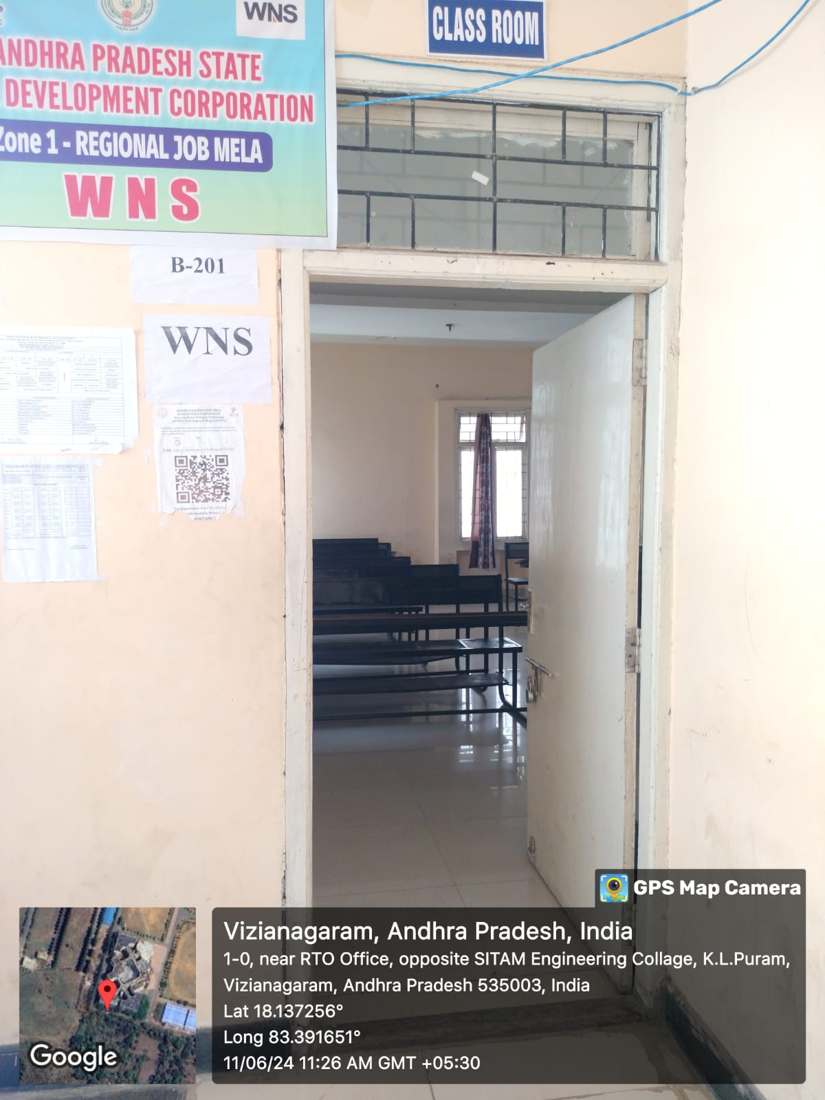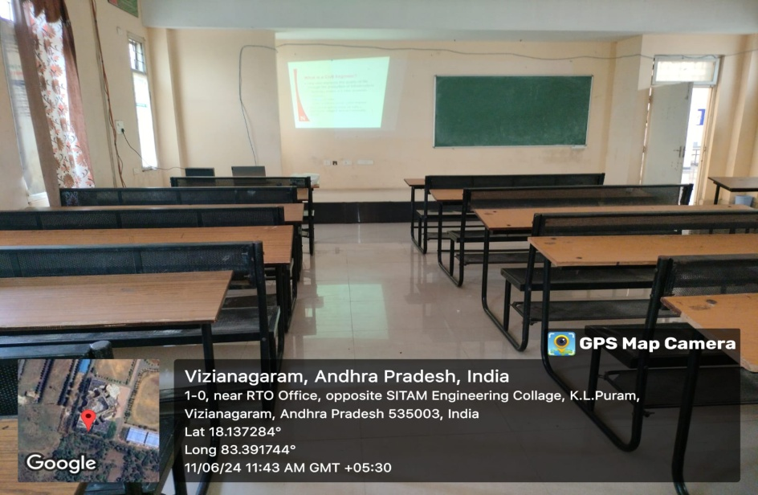
Class Room-II  B 203 | 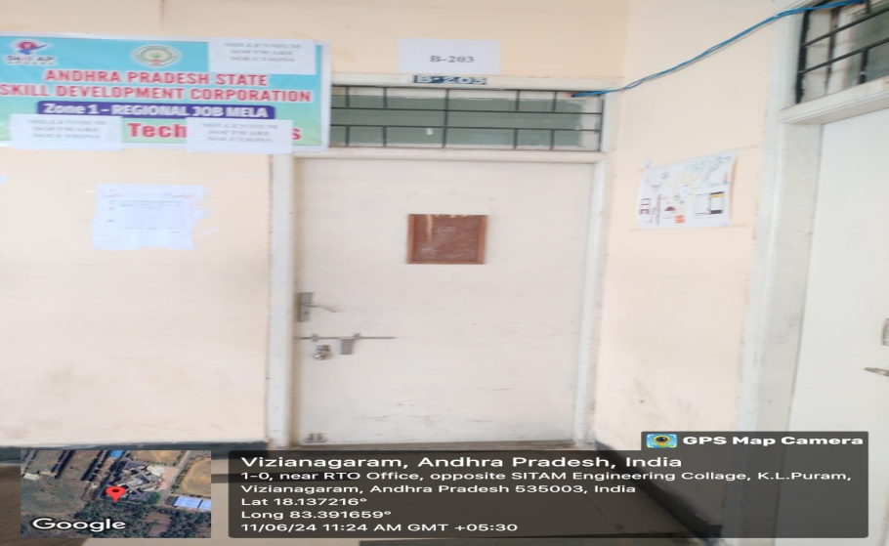  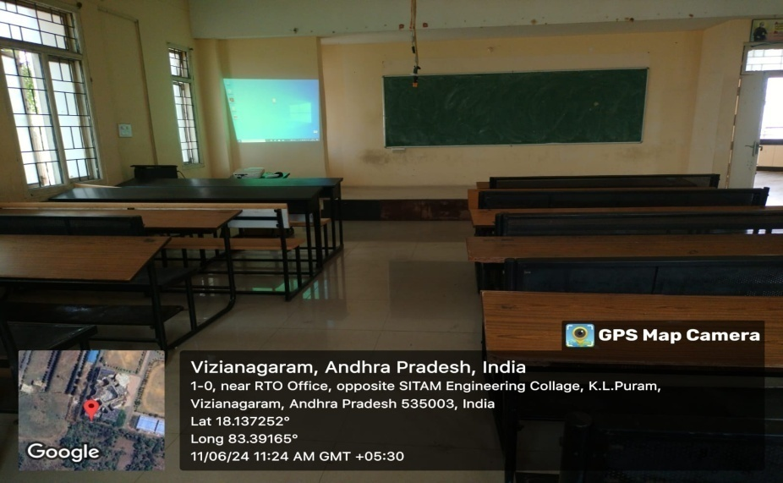
Class Room-III  B 205 | 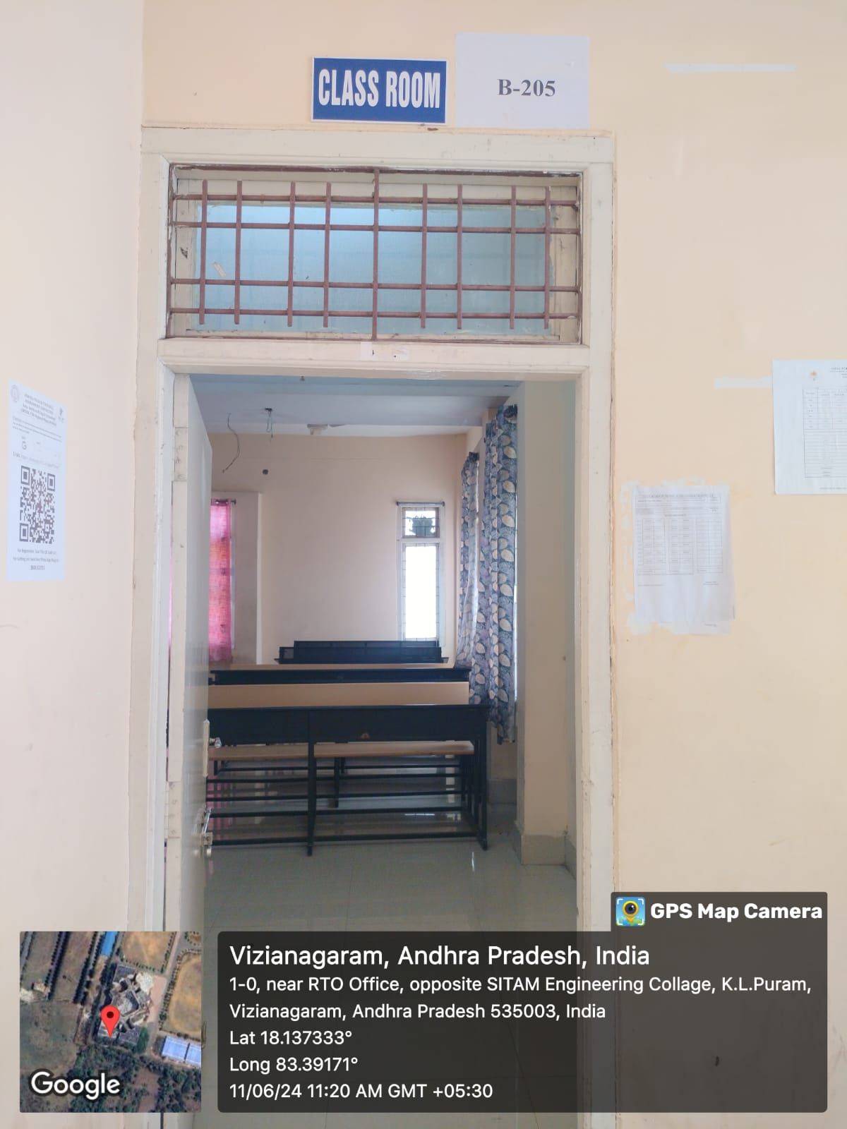  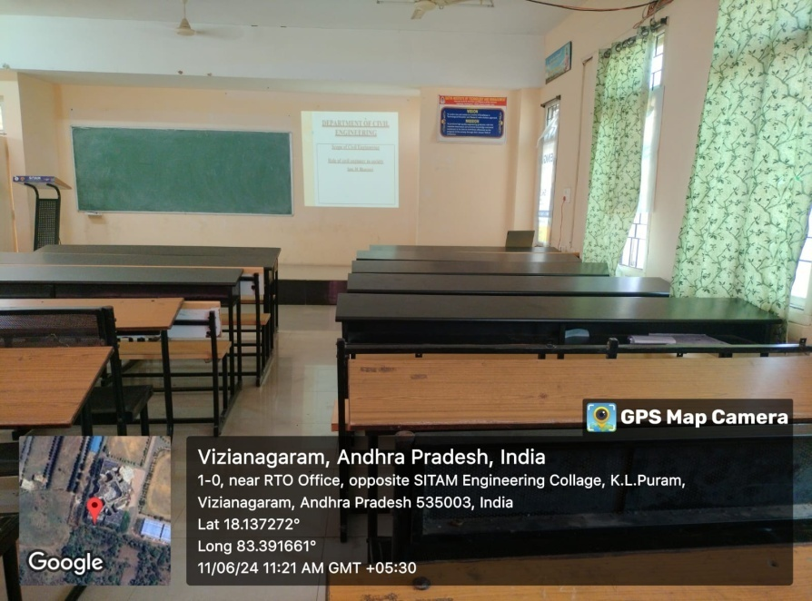
HOD Cabin  B 204 | 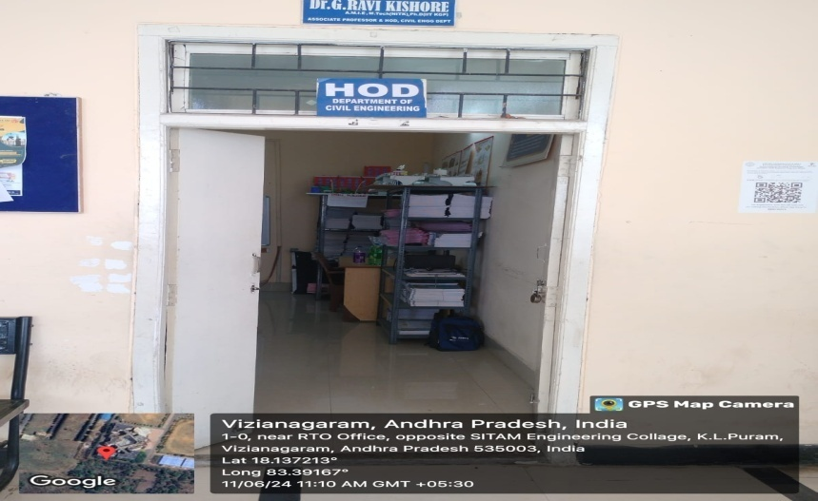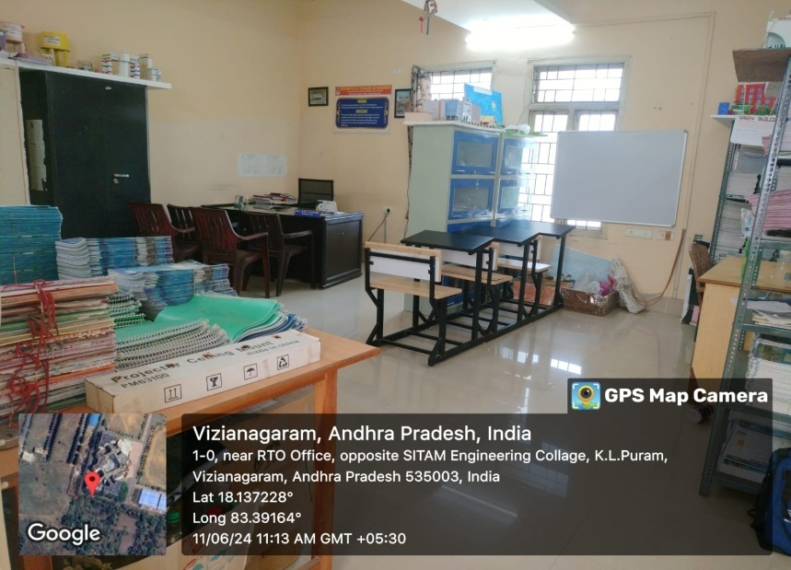
Staff room  B 202 | 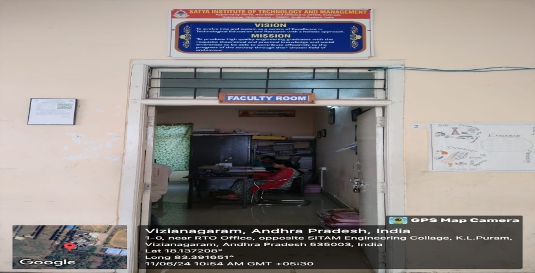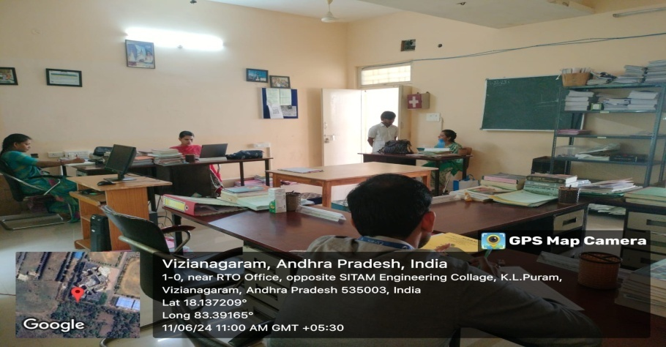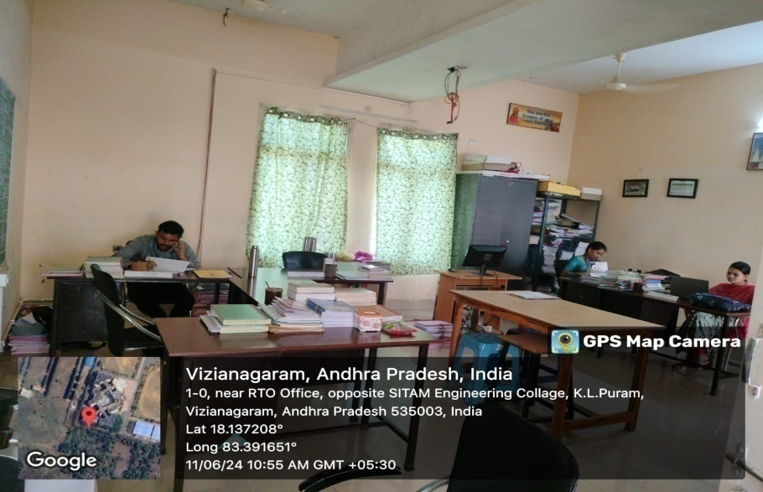
Surveying & Environmental Engineering Lab  C102 | 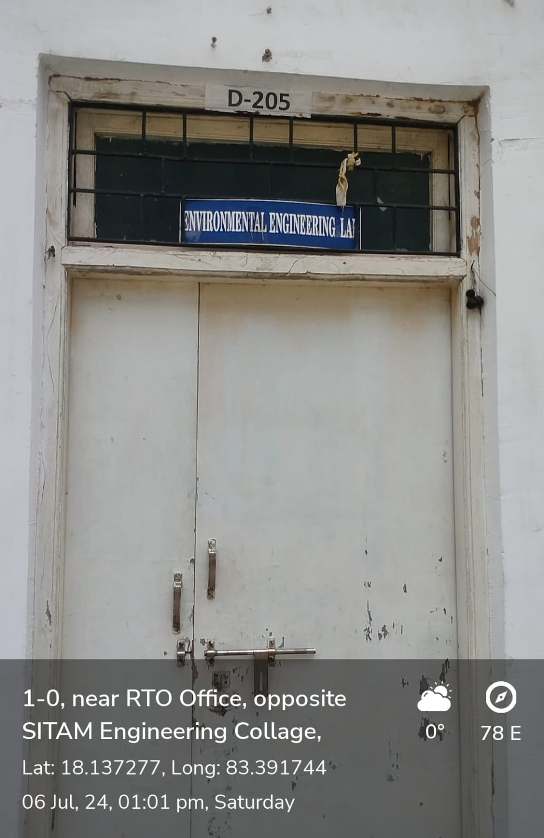  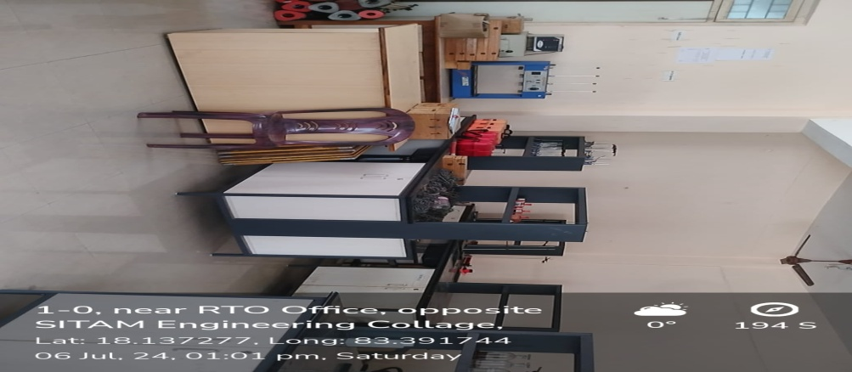  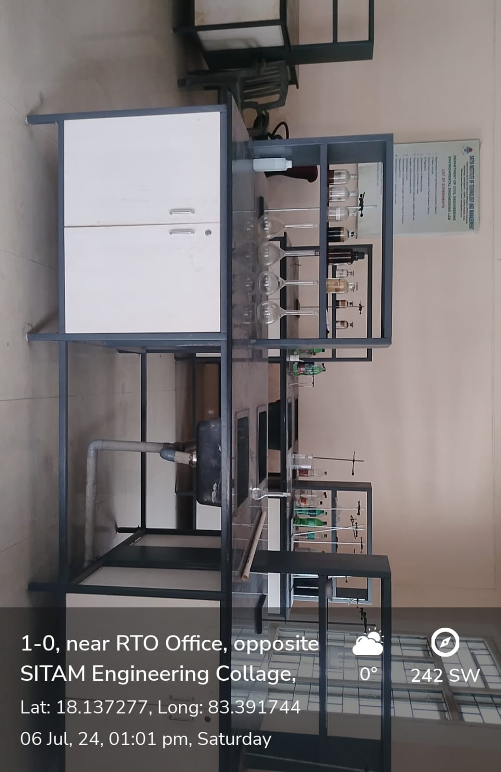
FM & HM Lab  S104-B | 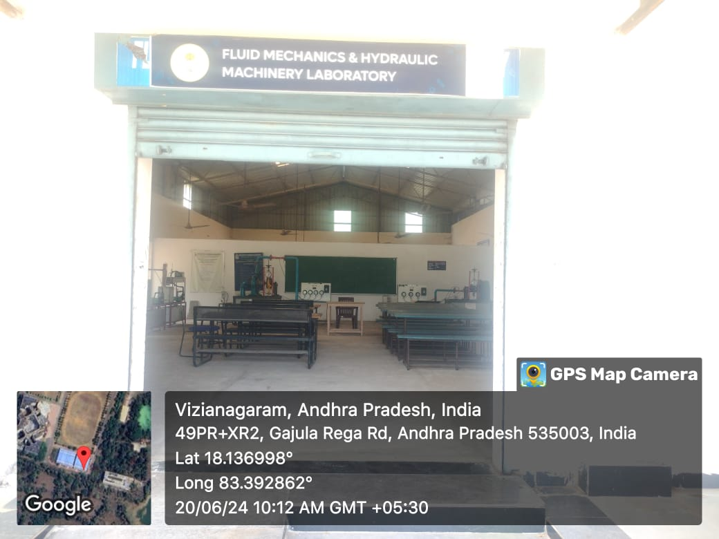  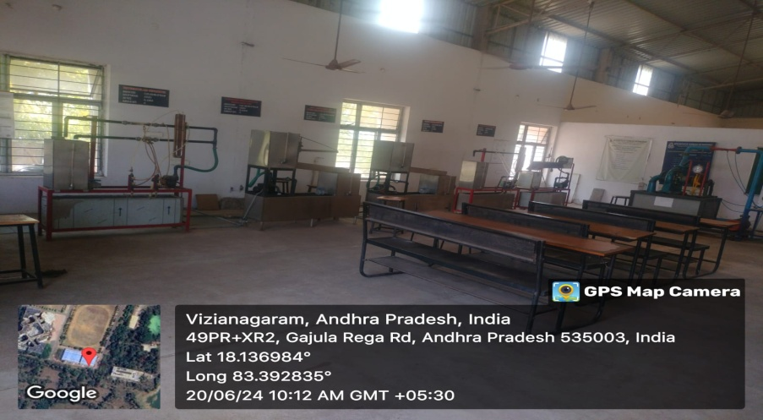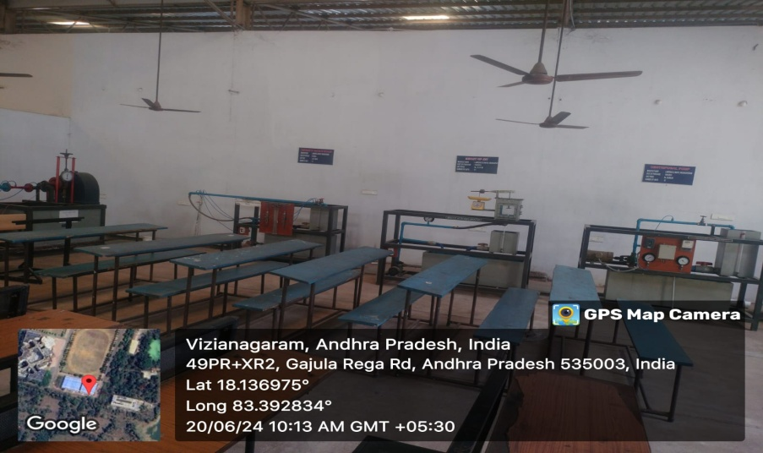
Geotechnical Engineering Lab S104-A | 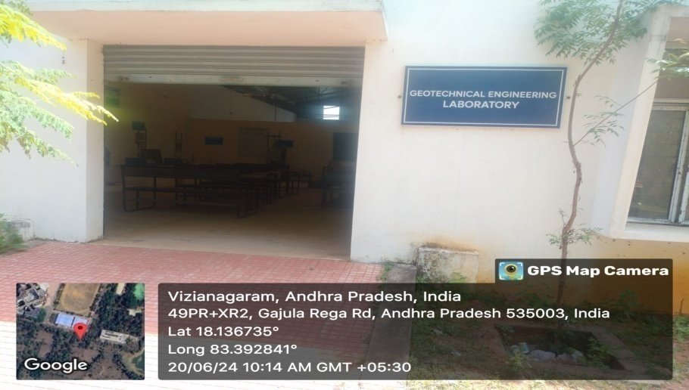  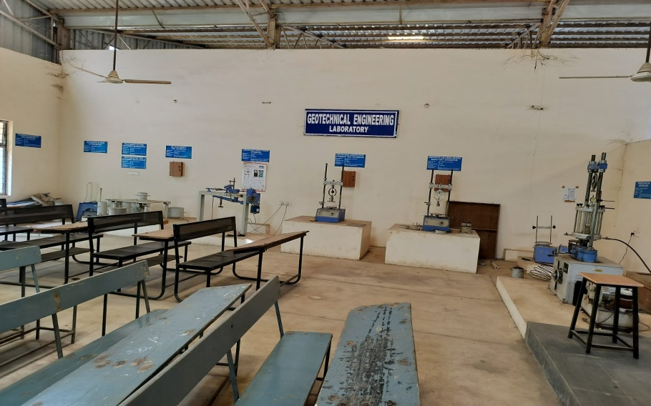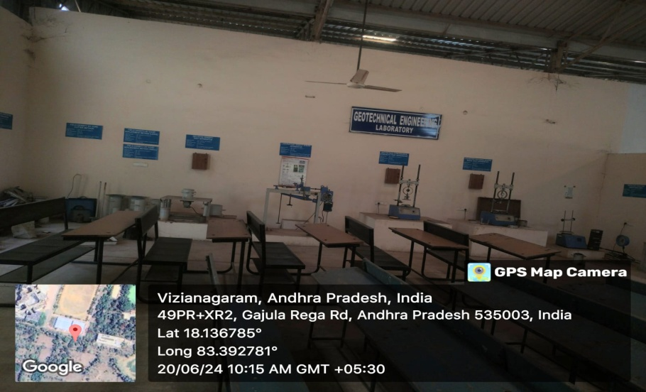
Concrete Technology & Transportation Engineering Lab  S103-B | 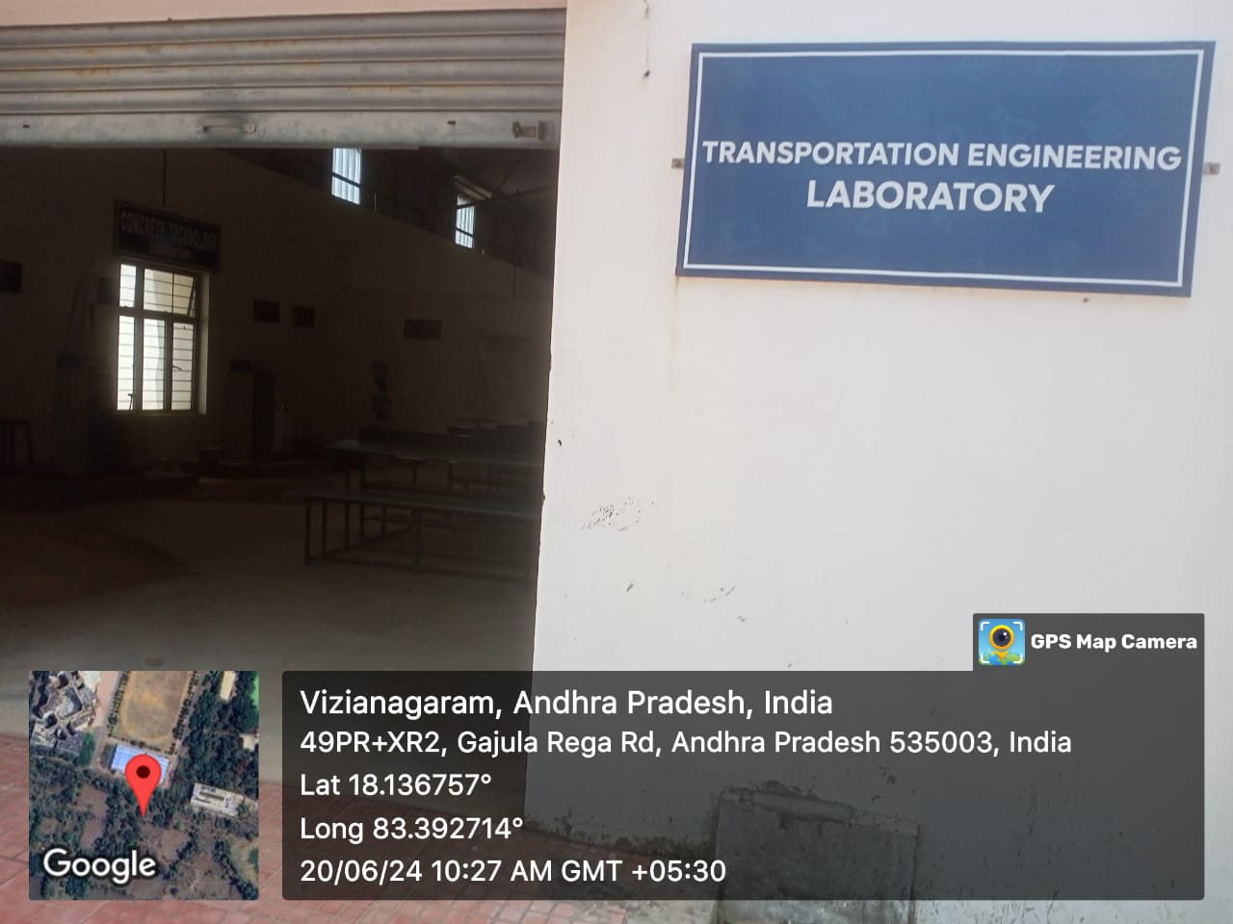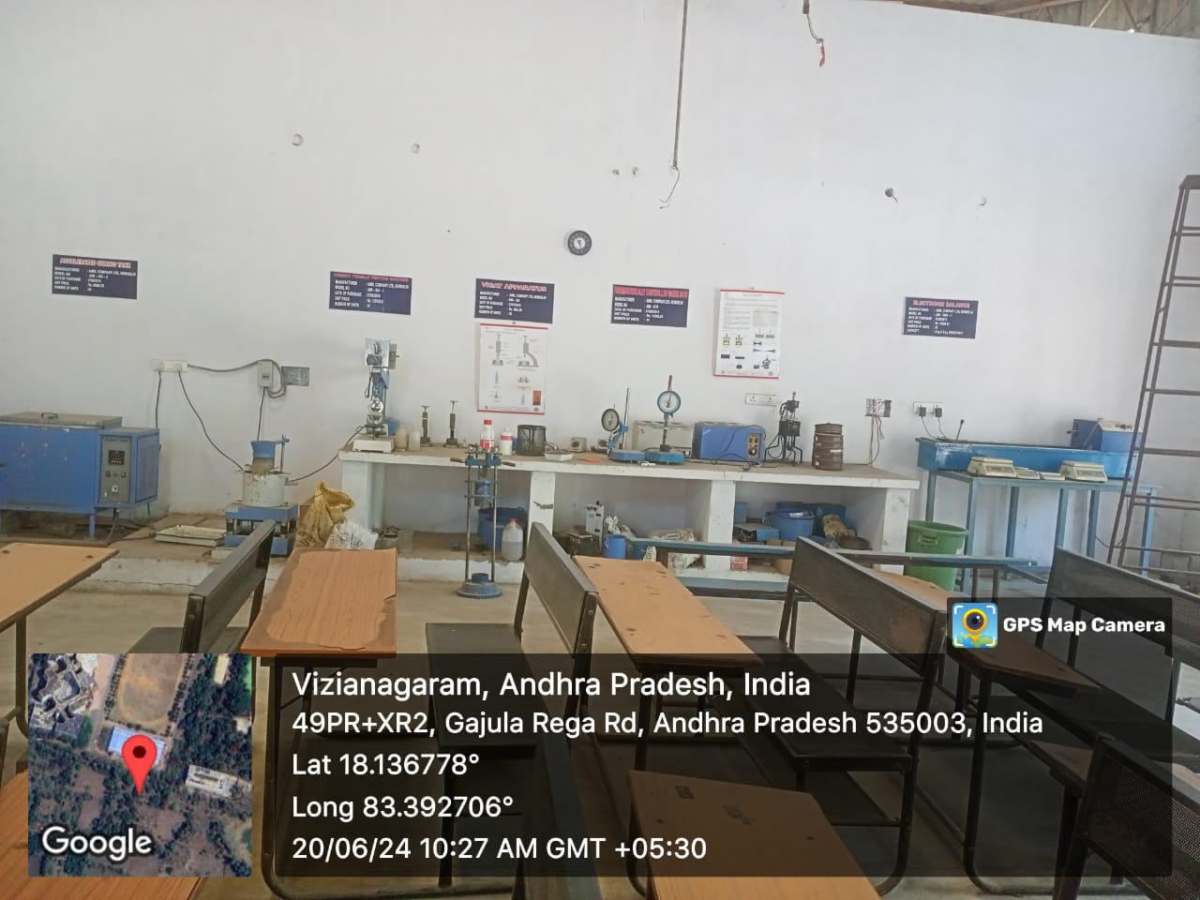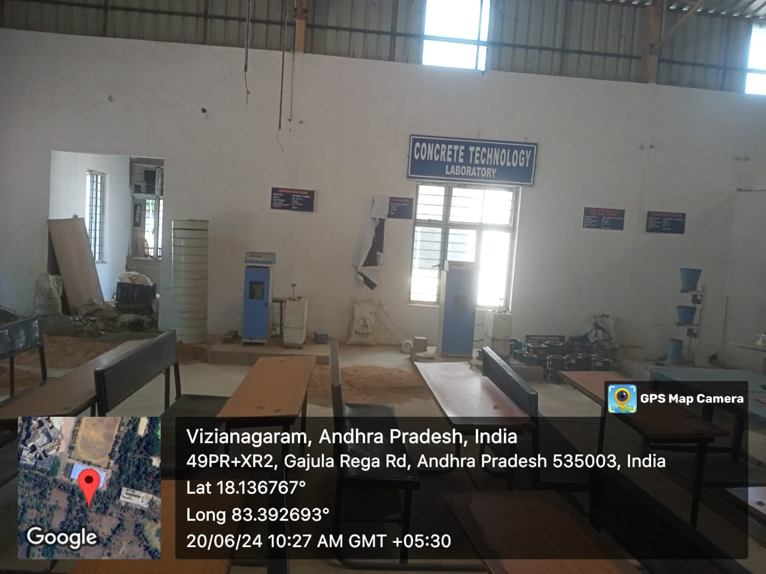
Department of Electrical and Electronics
Sr. No | Name of the class room/ Lab No | Class Room/ Lab No | Size as per AICTE  Norms | Carpet Area (Sq.mtr)
1. | Class Room-I | A 401 | 66 | 75.43
2. | Class Room-II | A 403 | 66 | 75.43
3. | Class Room-III | A 405 | 66 | 83.61
4. | HOD Cabin | A 404 | 10 | 48.30
5. | Staff room | A 402 | 5 sq.m per room | 40.13
6. | Electrical Measurements Lab | C402 | 66 | 96.61
7. | Power Systems and Simulation Lab | C404 | 66 | 86.95
8. | Electrical Circuit  Lab | C304 | 66 | 72.83
9. | Power Electronics Lab | C301 | 66 | 70.23
10. | Electrical Machines Lab | S102 A | 66 | 233.25

Class Room-I  A 401 | 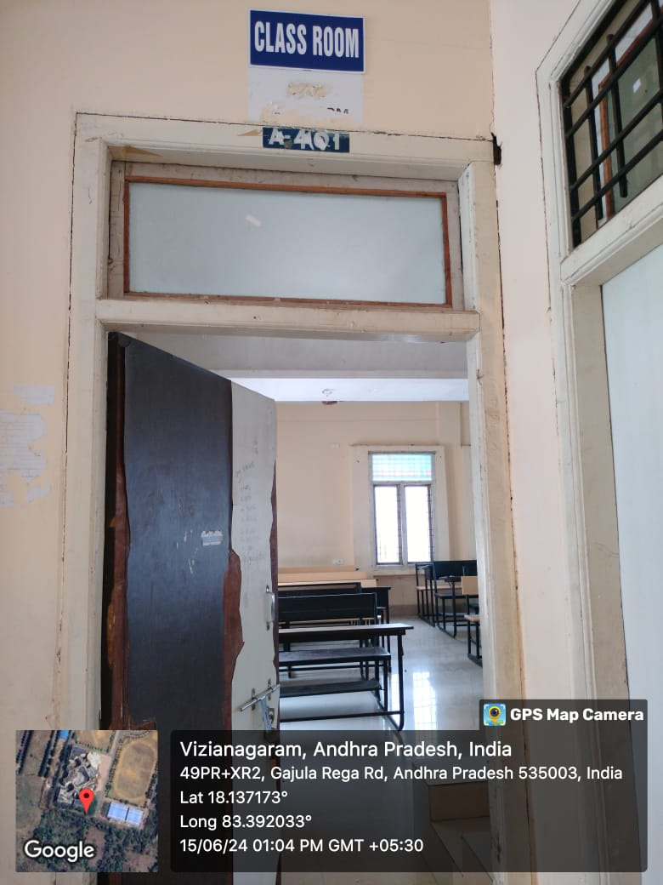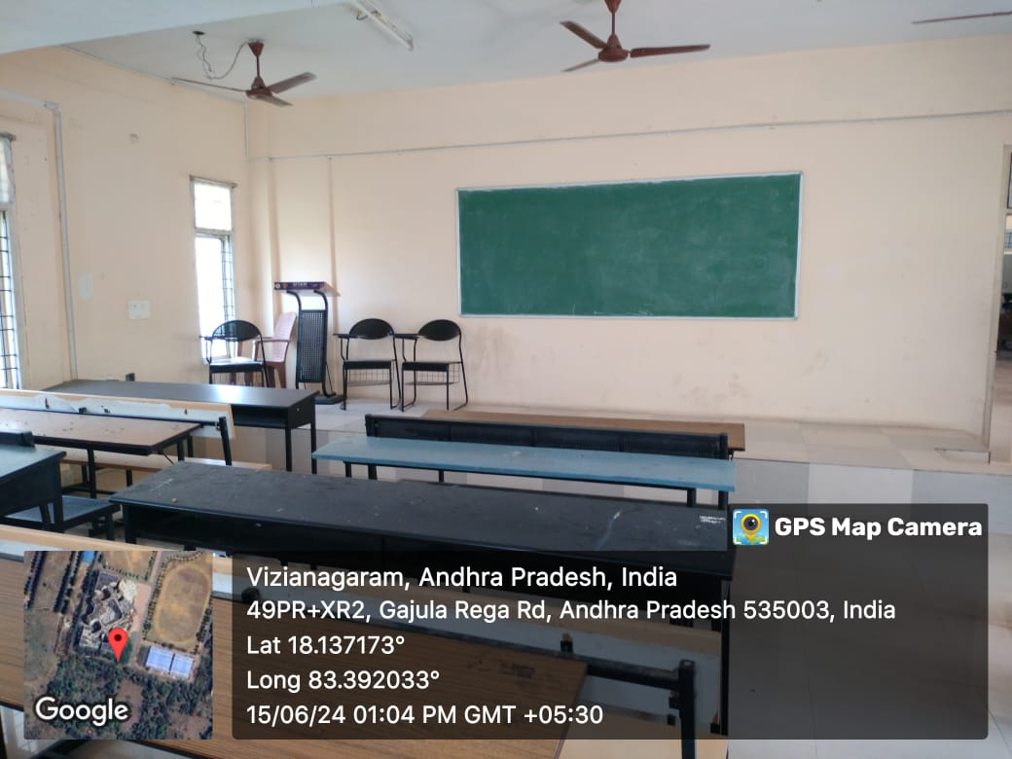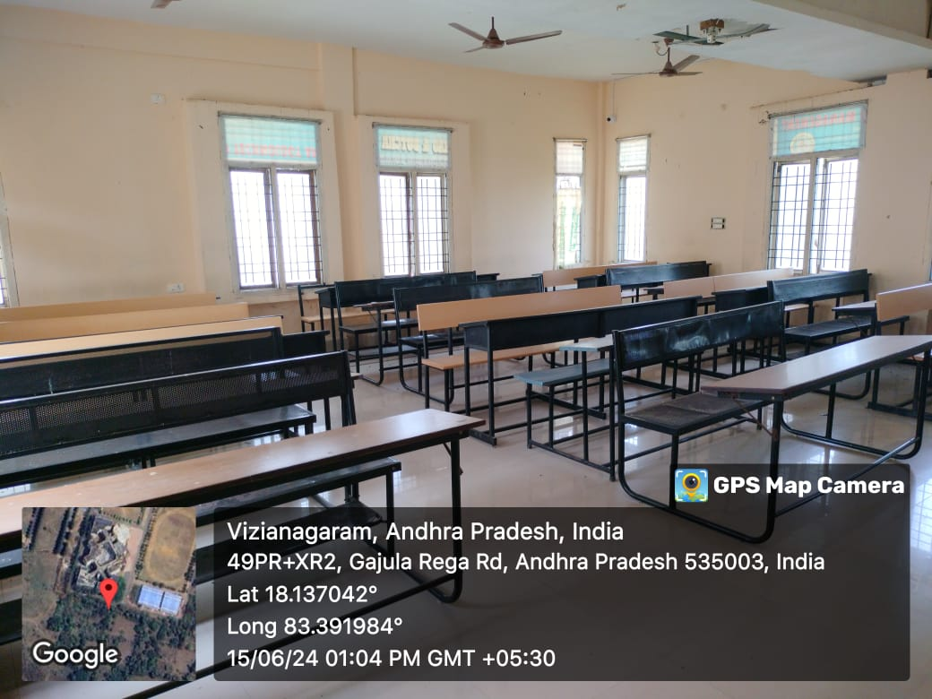

Class Room-II  A 403 | 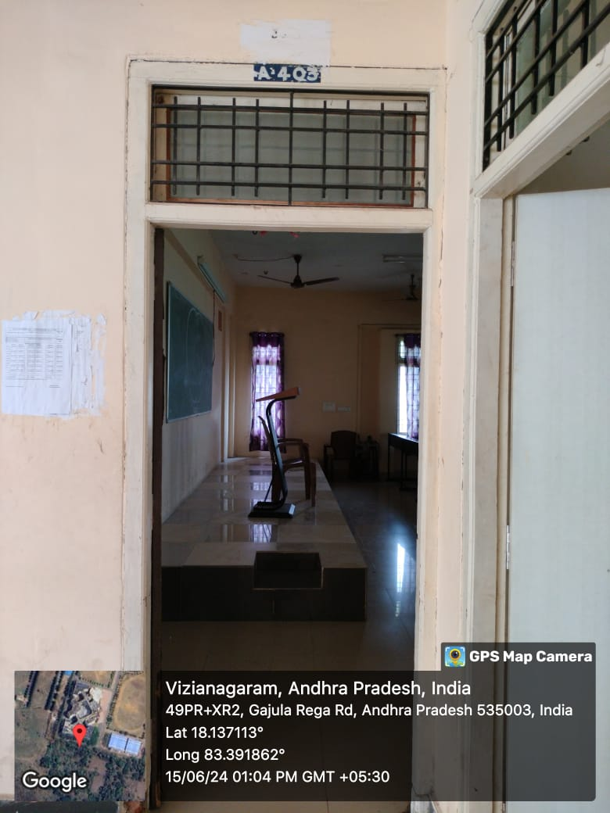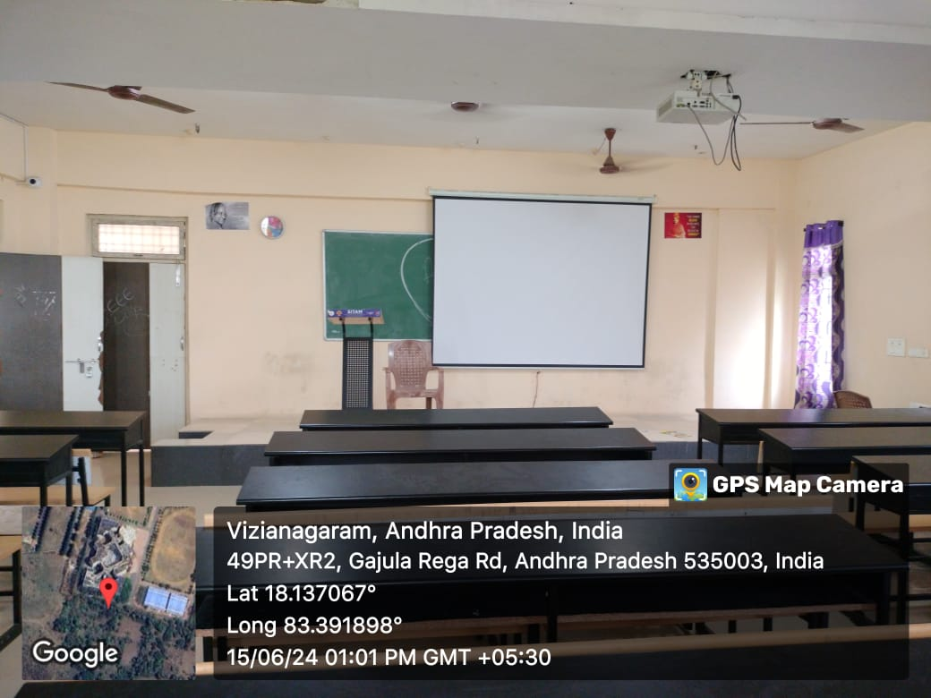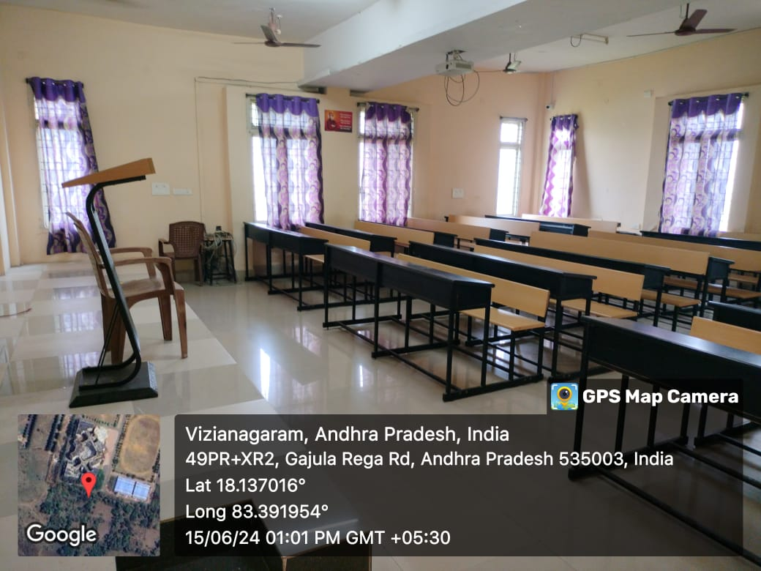

Class Room-III  A 405 | 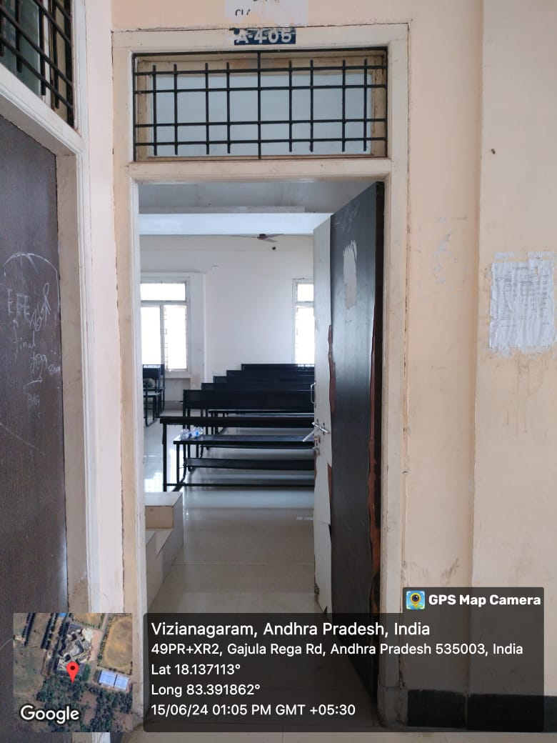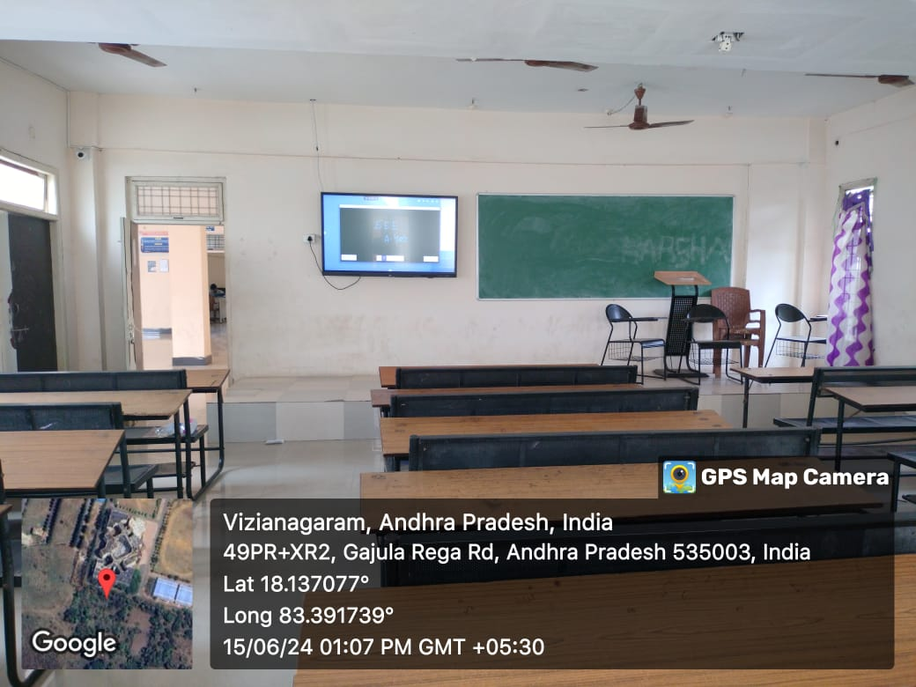

HOD Cabin  A 404 | 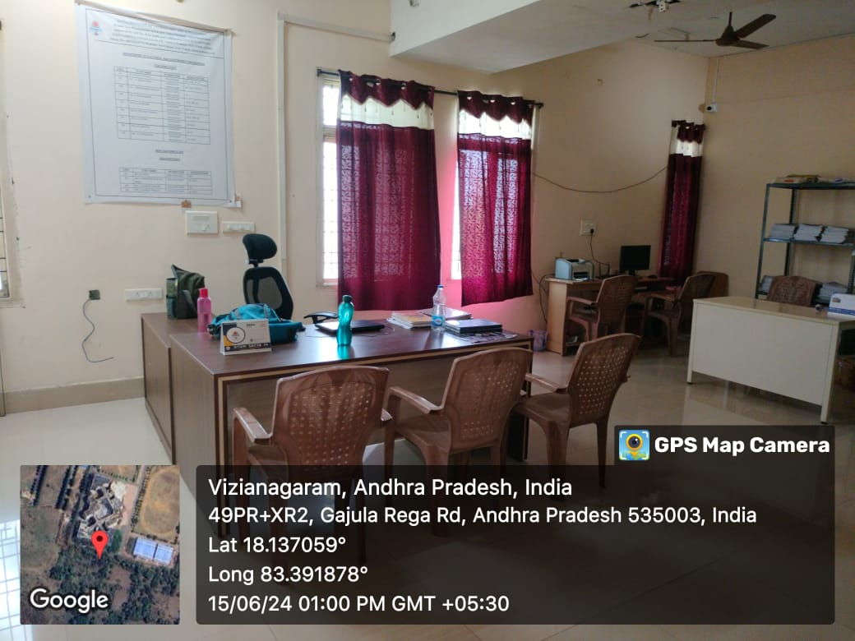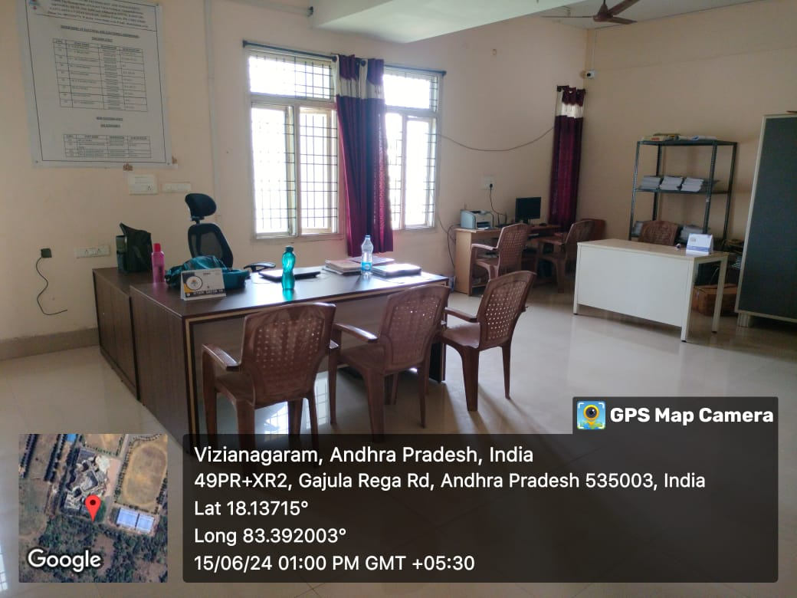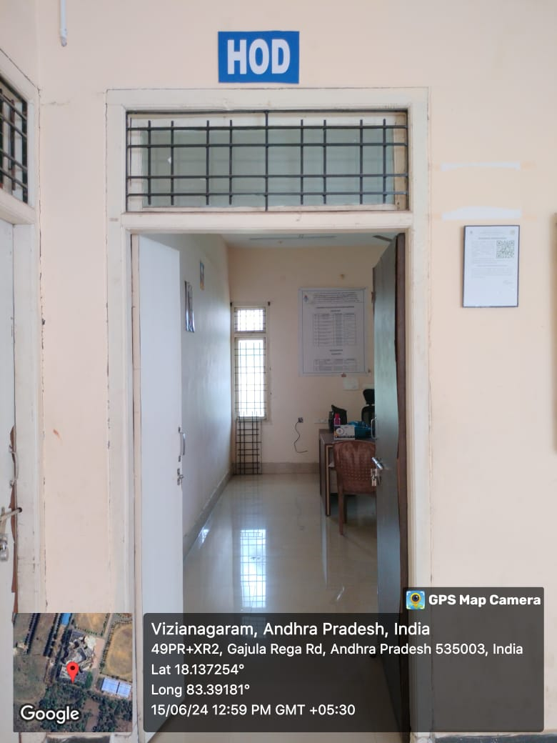

Staff room  A 402 | 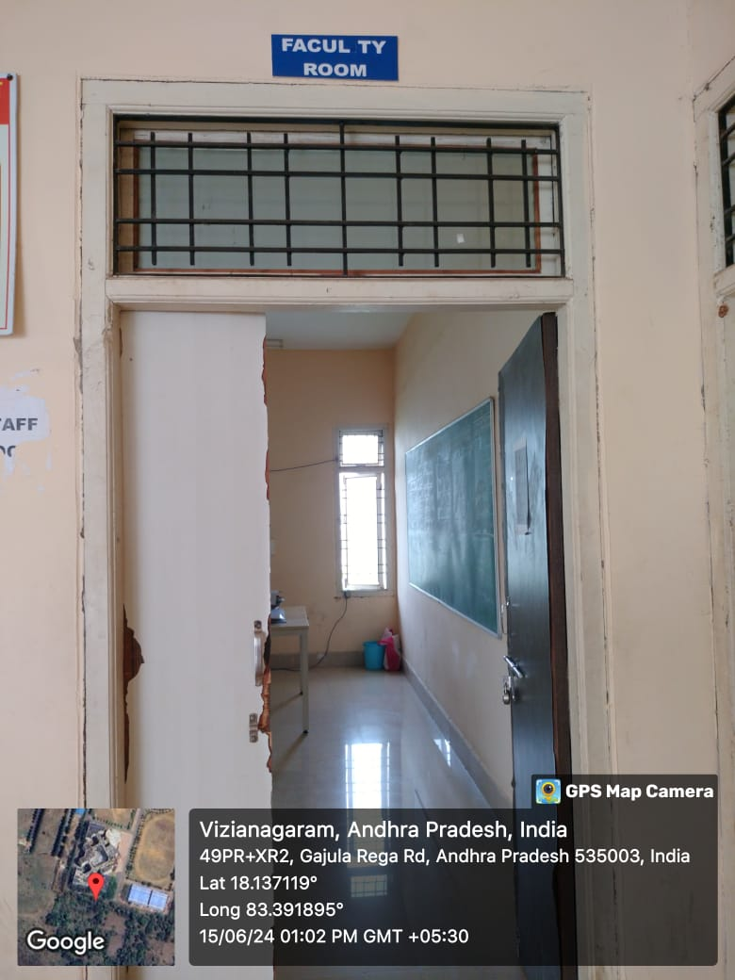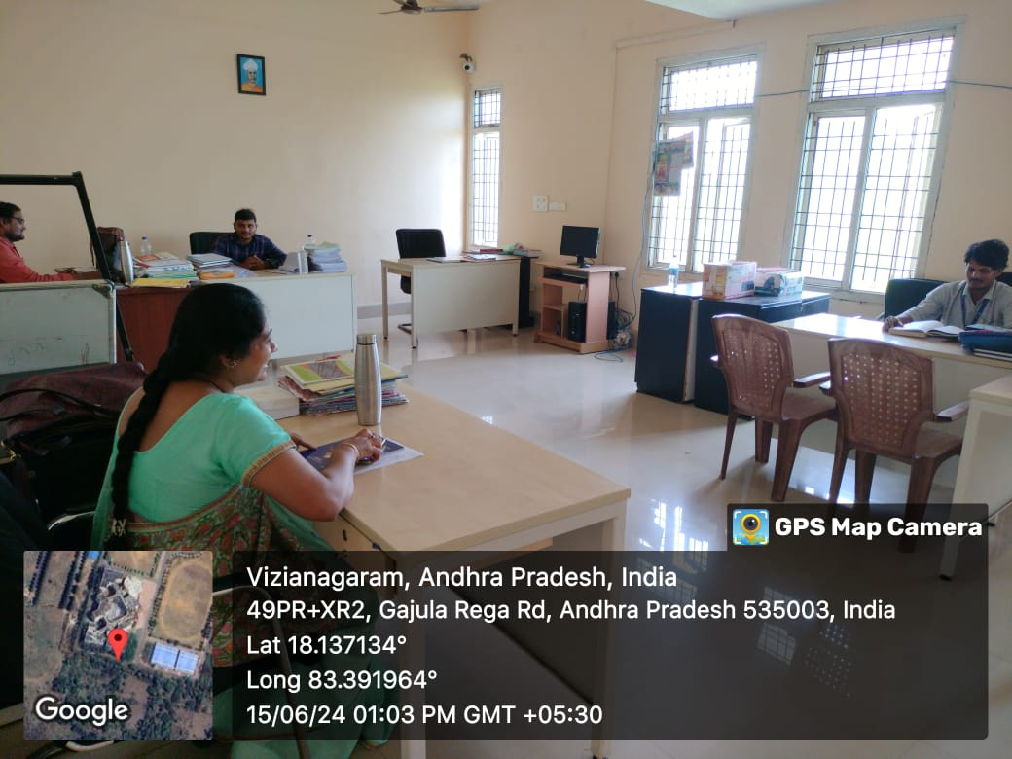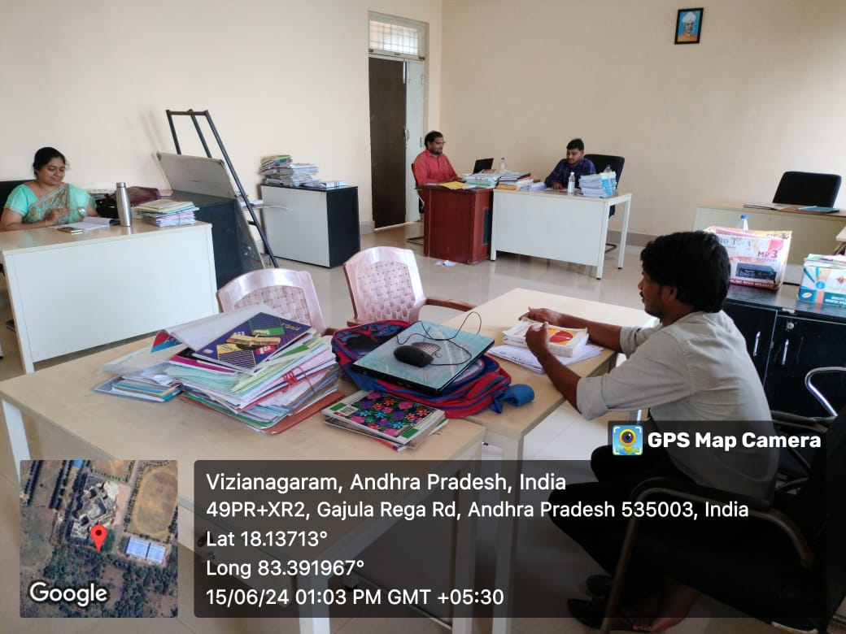

Electrical Measurements  Lab  C402 | 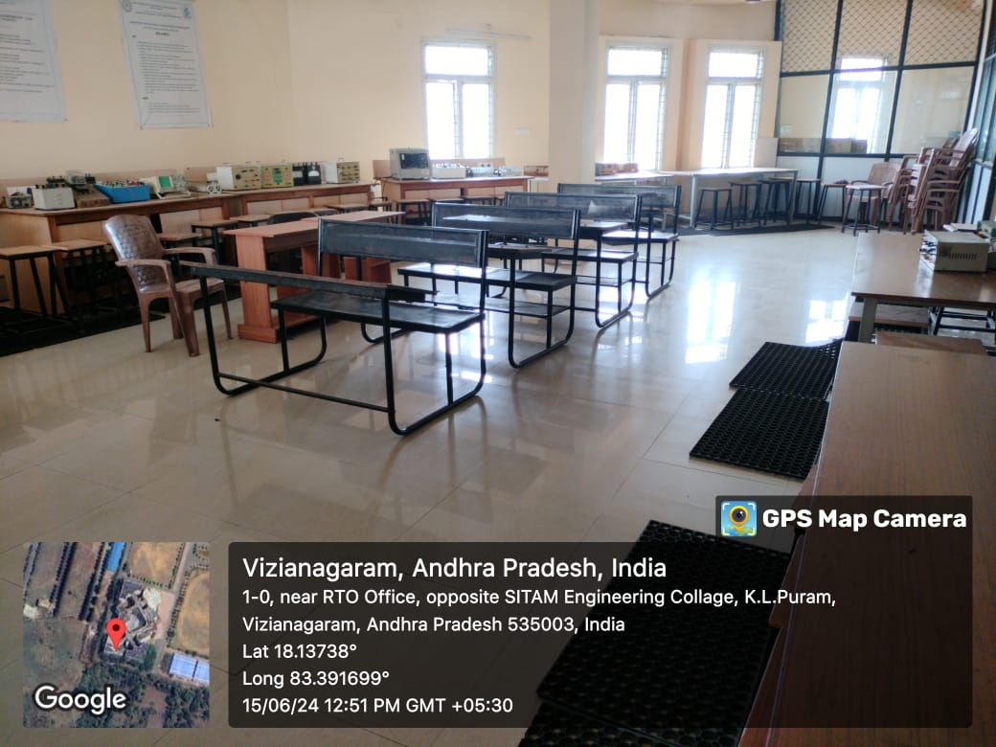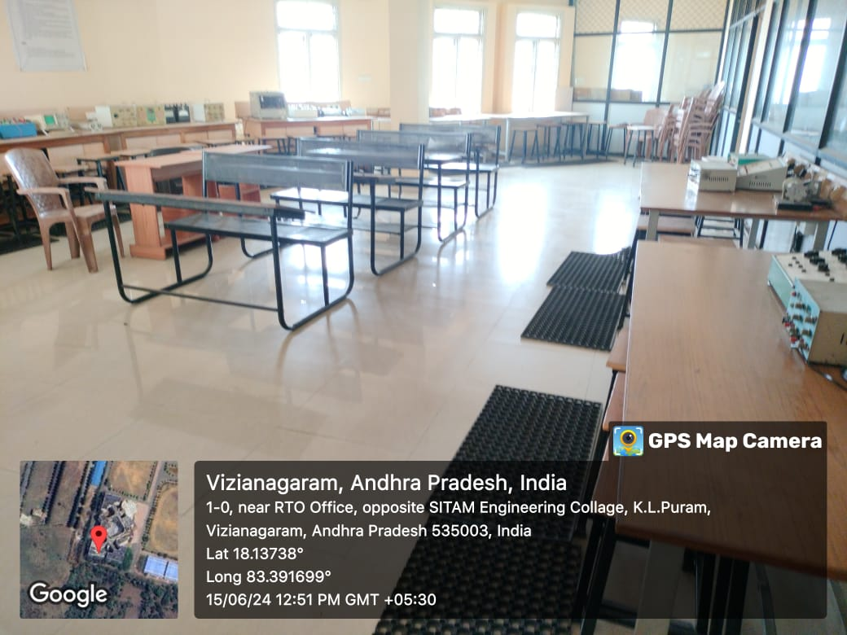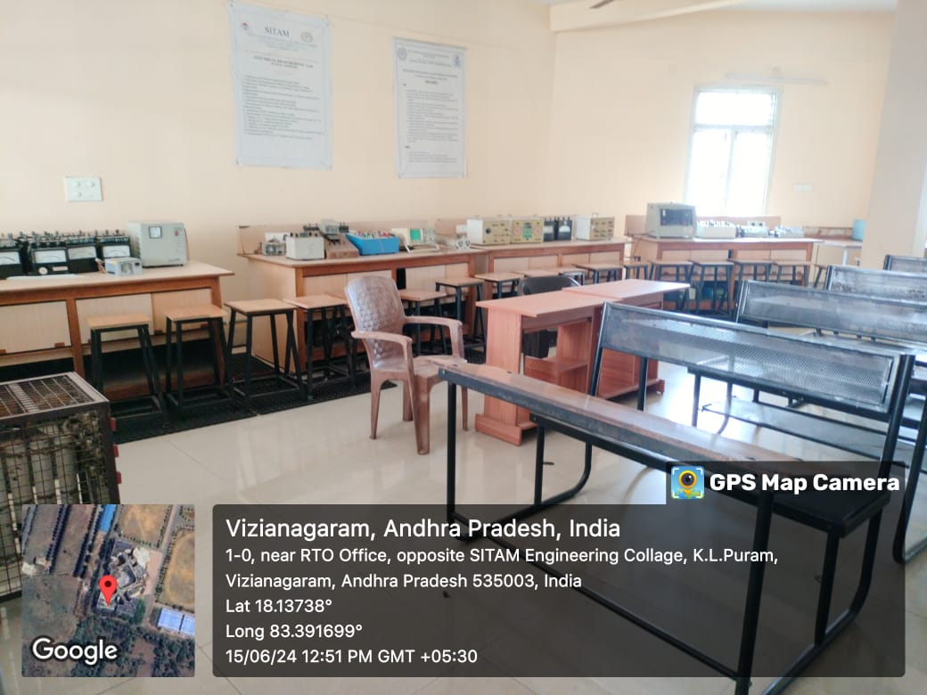

Electrical Simulation Lab  C403  Power Systems and Simulation Lab  C404 | 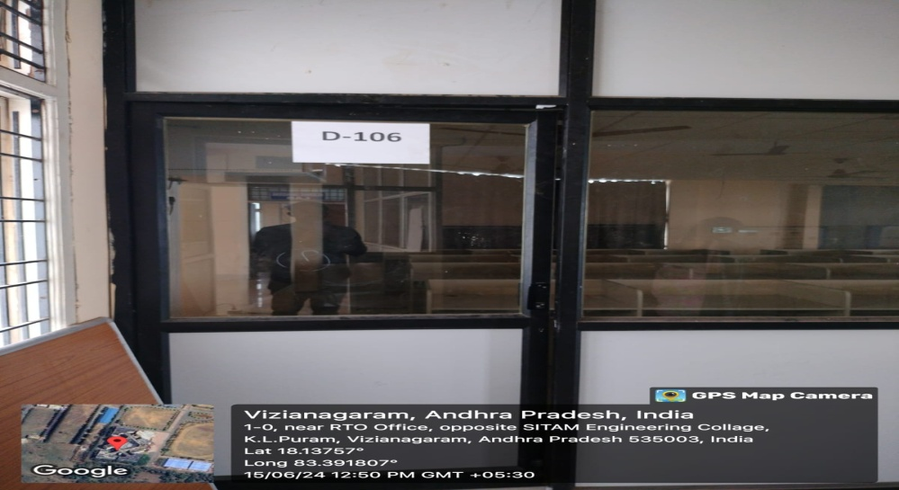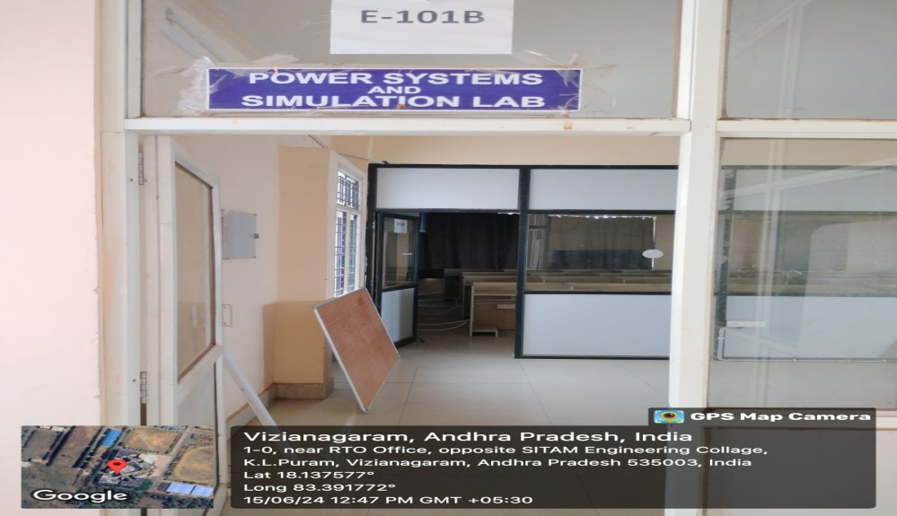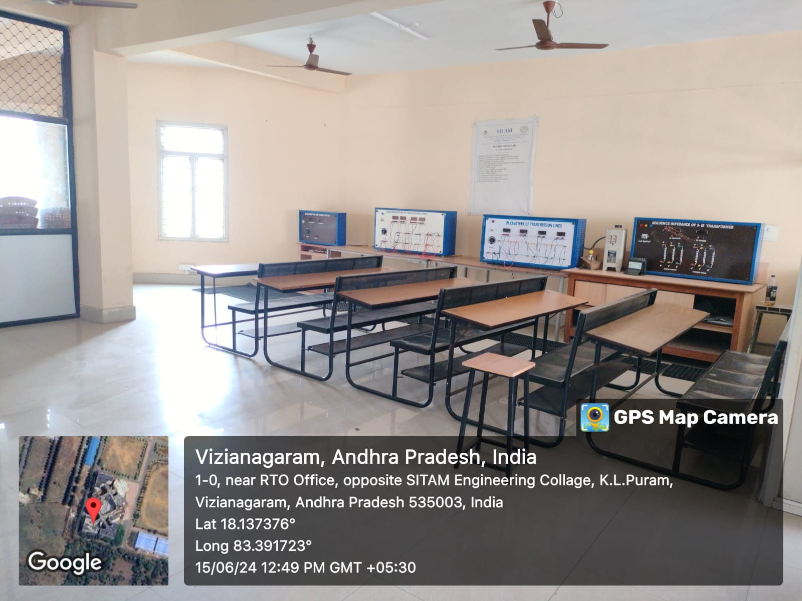

Electrical Circuit Lab  C304  Power Electronics Lab  C301  Electrical Machines Lab S102 | 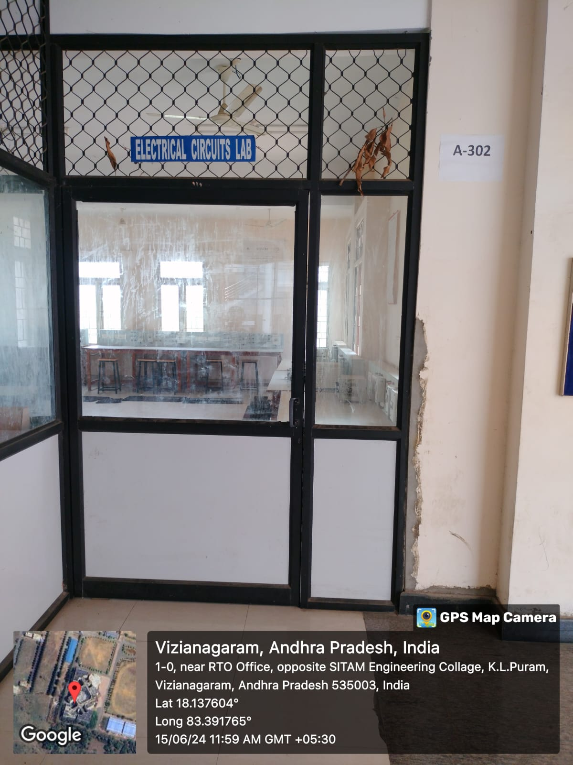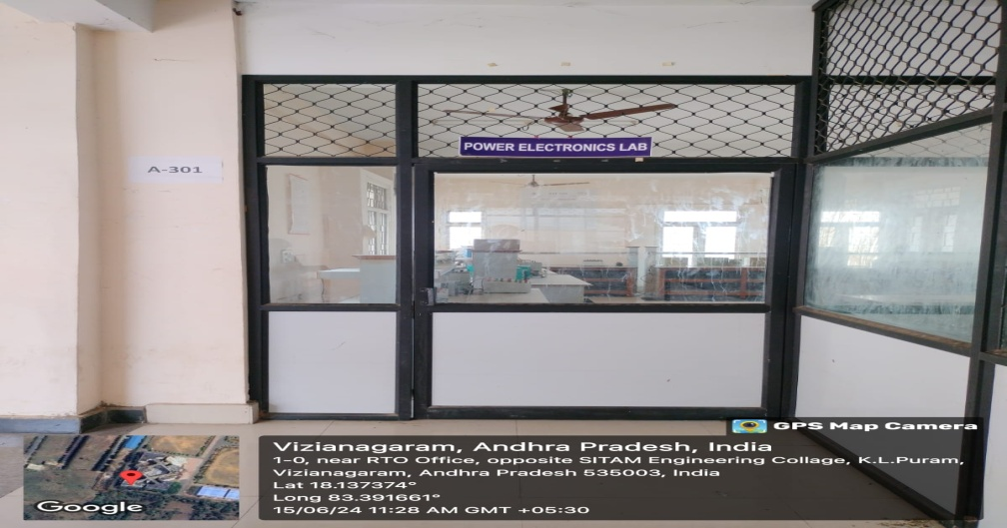  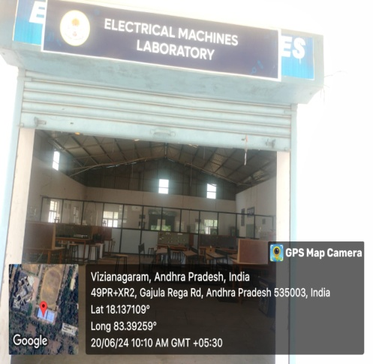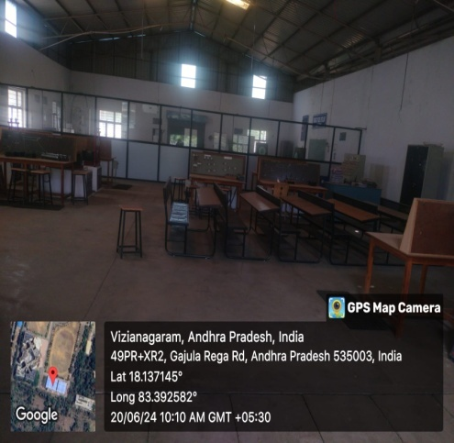

Department of Mechanical Engineering
Sr. No | Name of the class room/ Lab No | Class Room/ Lab No | Size as per AICTE  Norms | Carpet Area (Sq.mtr)
1. | Class Room-I | A 201 | 66 | 72.83
2. | Class Room-II | A 203 | 66 | 75.43
3. | Class Room-III | A 205 | 66 | 75.43
4. | HOD Cabin | A 204 | 10 | 48.30
5. | Staff room | A 202 | 5 sq.m per room | 40.13
6. | Engineering Mechanics lab | - | 66 | 96.61
7. | Heat Transfer Lab | - | 66 | 67.63
8. | Machine Tools Lab | S101 A | 66 | 161.57
9. | Theory of Machines  Lab | S101 B | 66 | 66.30
10. | Production Technology Lab | S101 C | 66 | 251.49
11. | Thermal Engineering Lab | S101 D | 66 | 75.75
12. | Mechanics of Solids Lab | S102 B | 66 | 148.05
13. | Engineering Workshop | S103-A | 66 | 162.04
14. | CAD / CAM Lab | F 302 | 66 | 145.67

Geotagged Photos Department of Mechanical Engineering

Staff Room  A 202 | 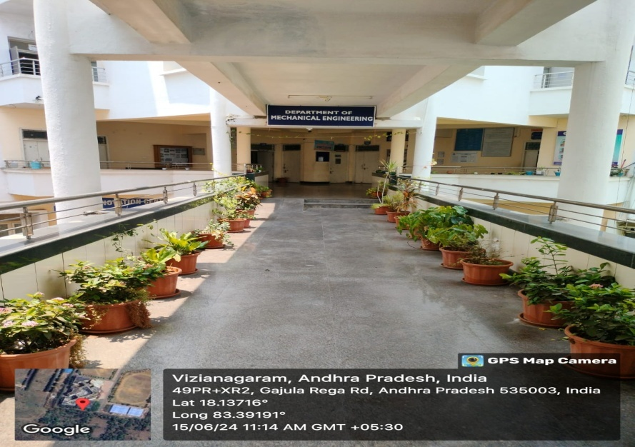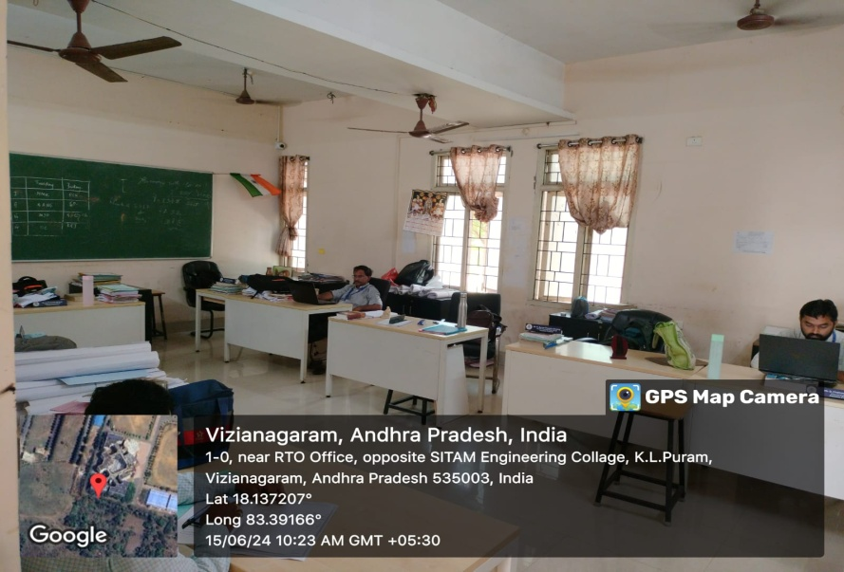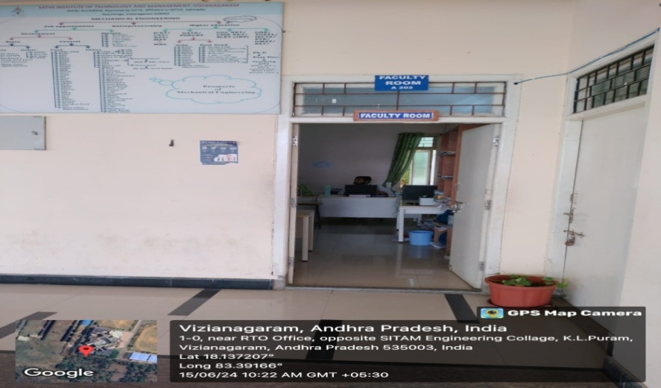

Class Room-II  A 203 | 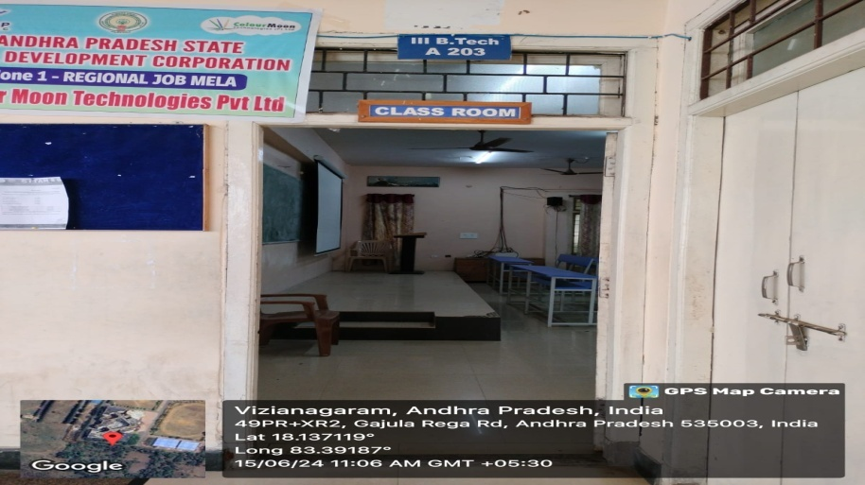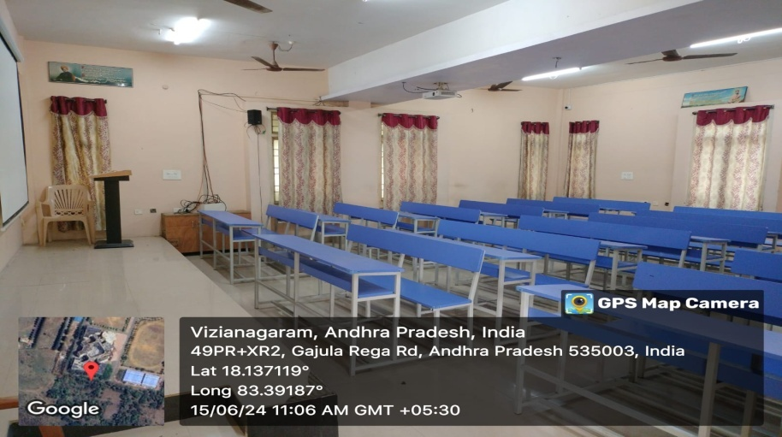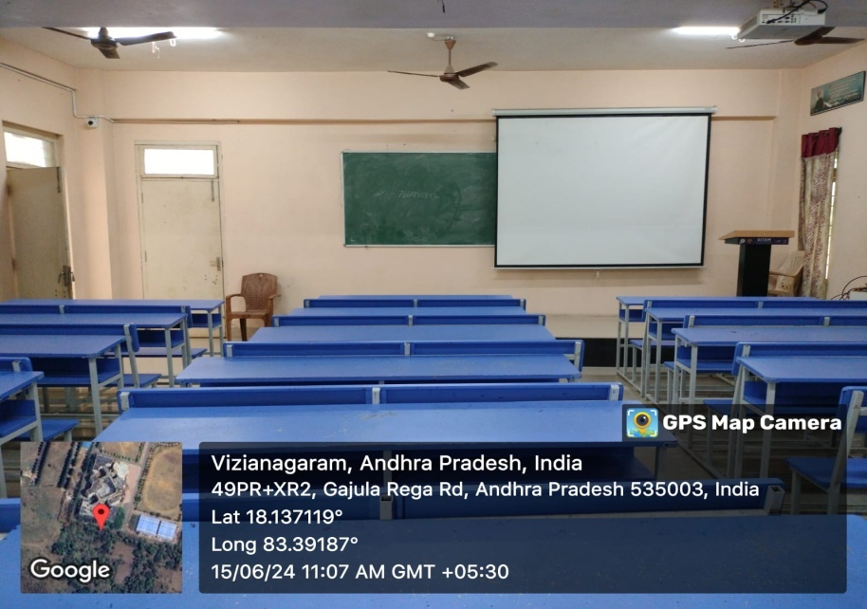

Class Room-I  A 201 | 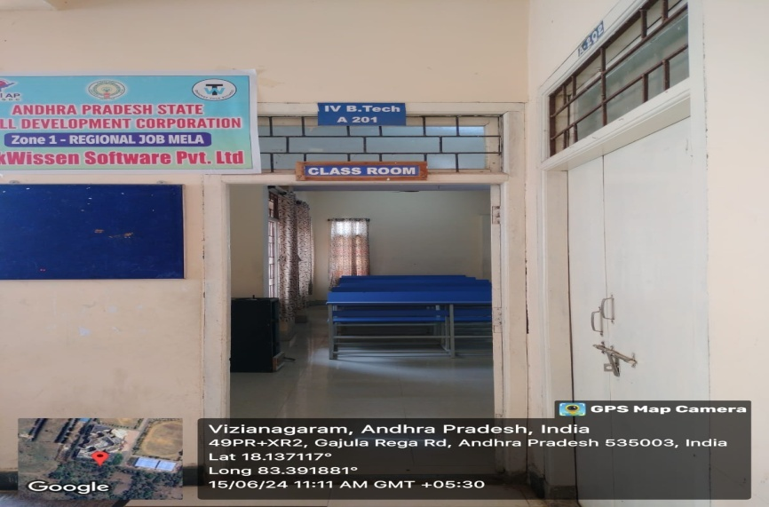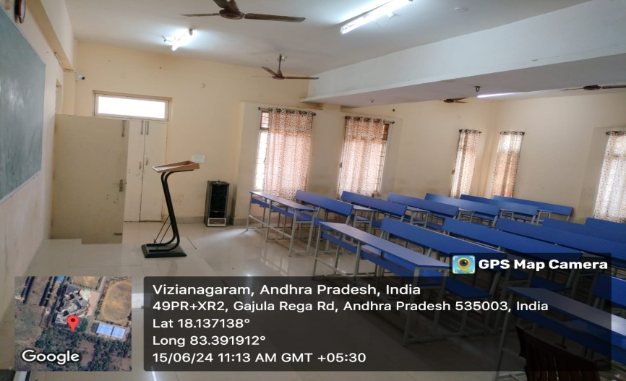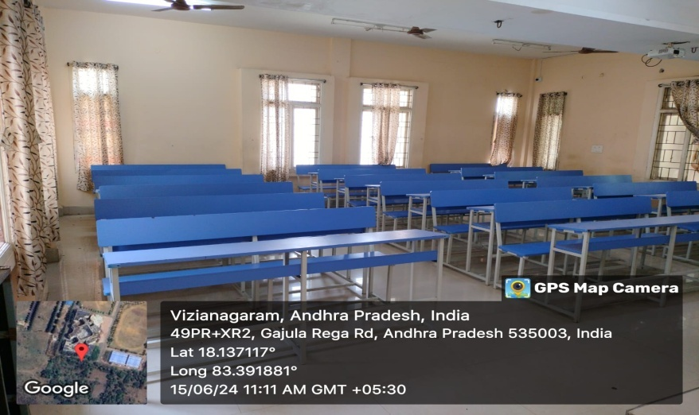

Class Room-III  A 205 | 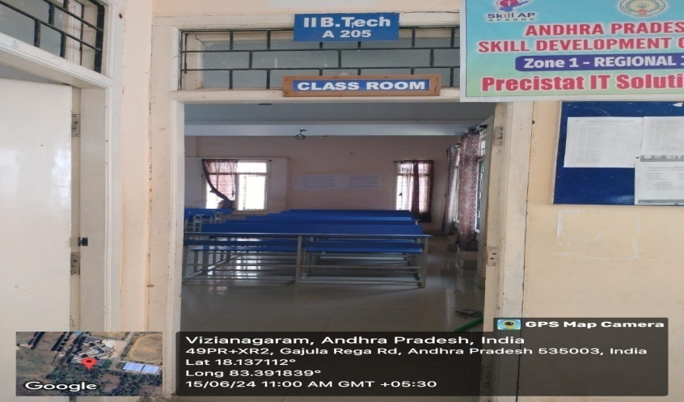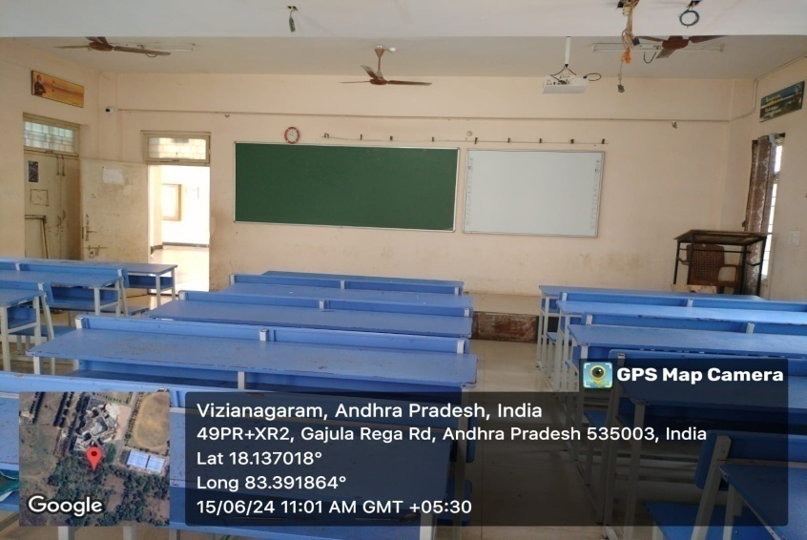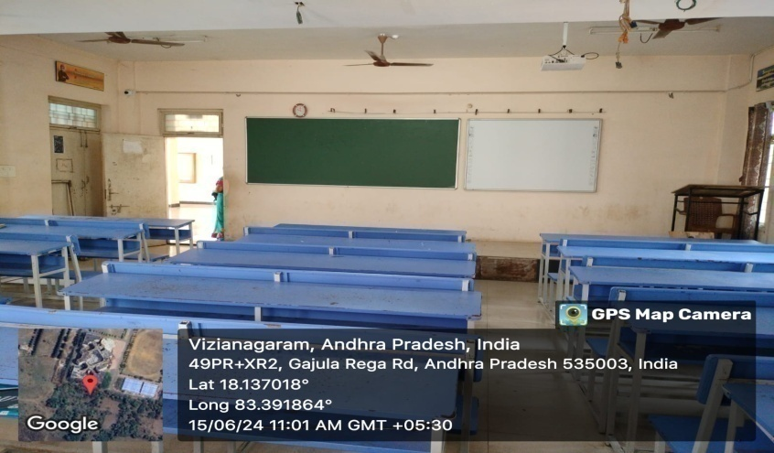

HOD Cabin  A 204 | 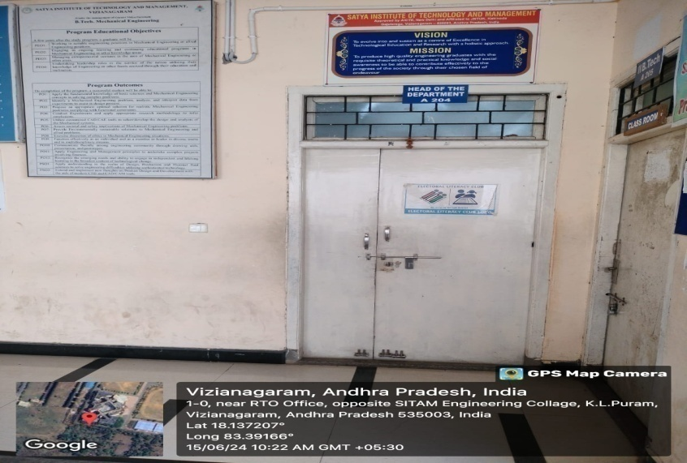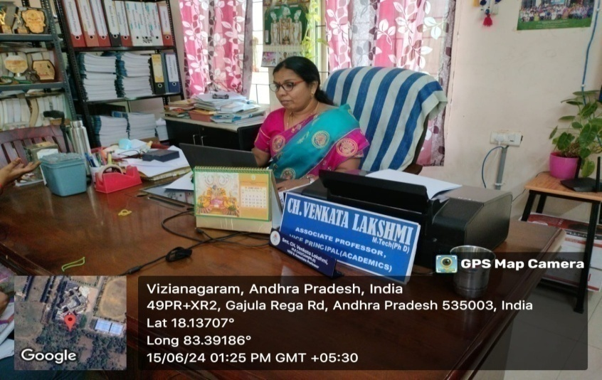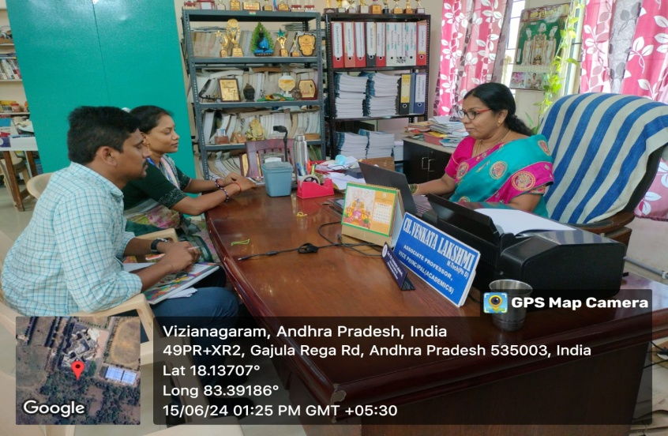

Engineering Mechanics lab | 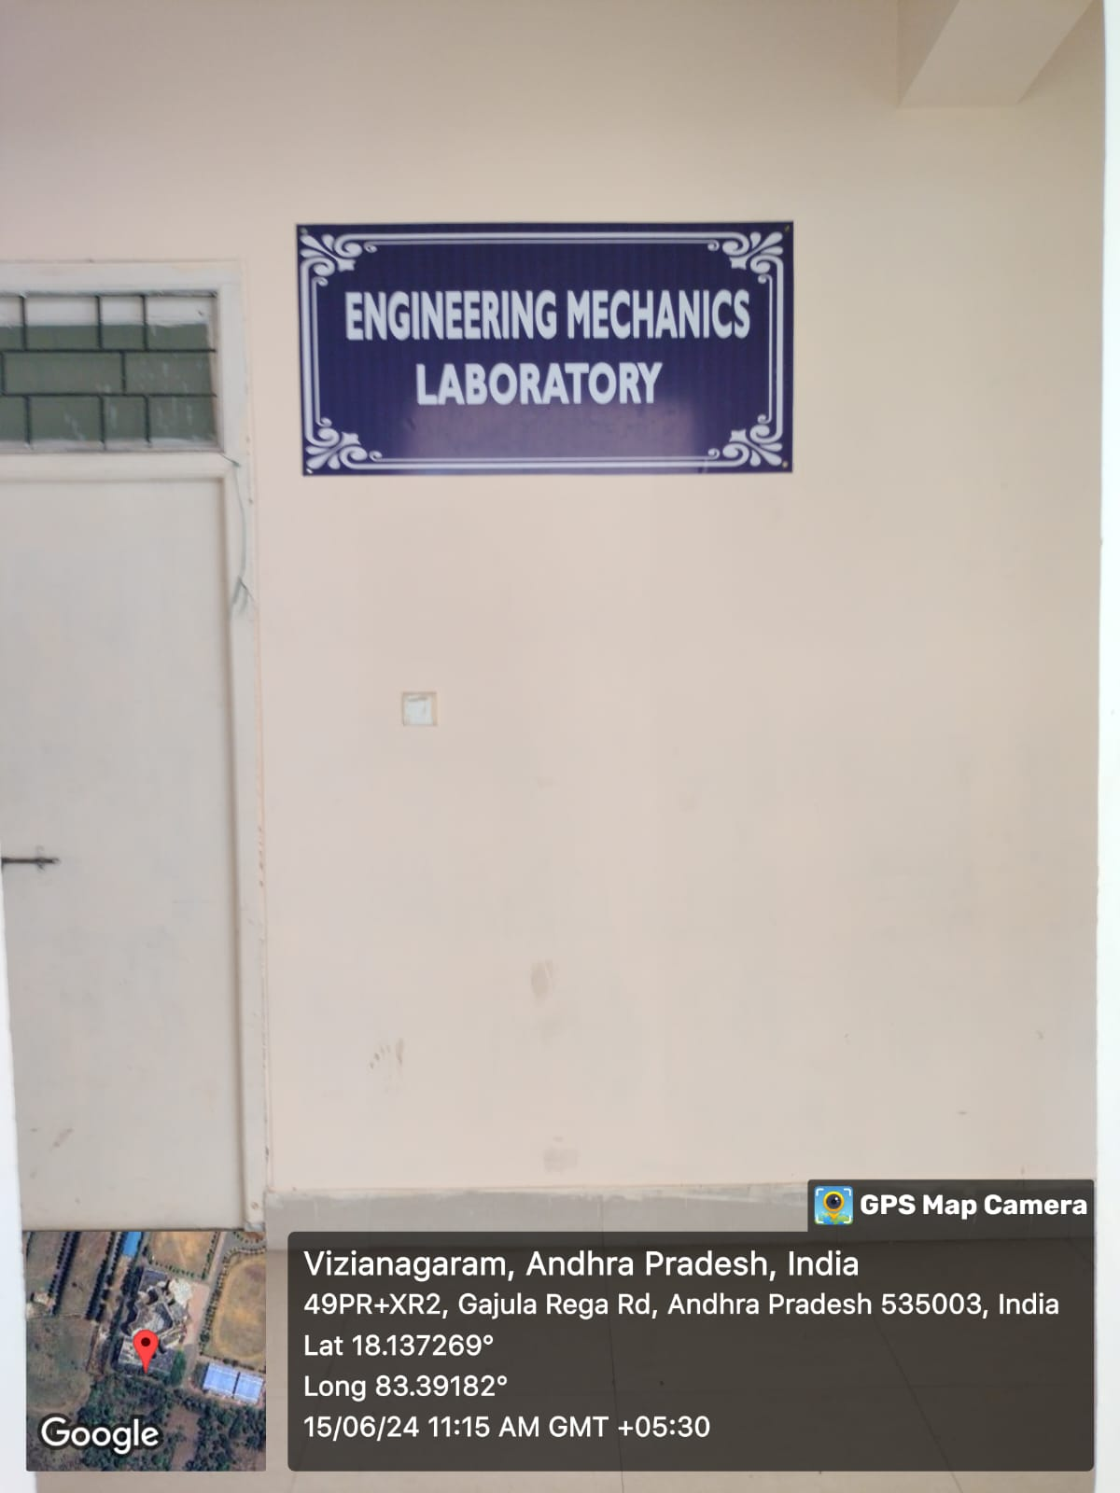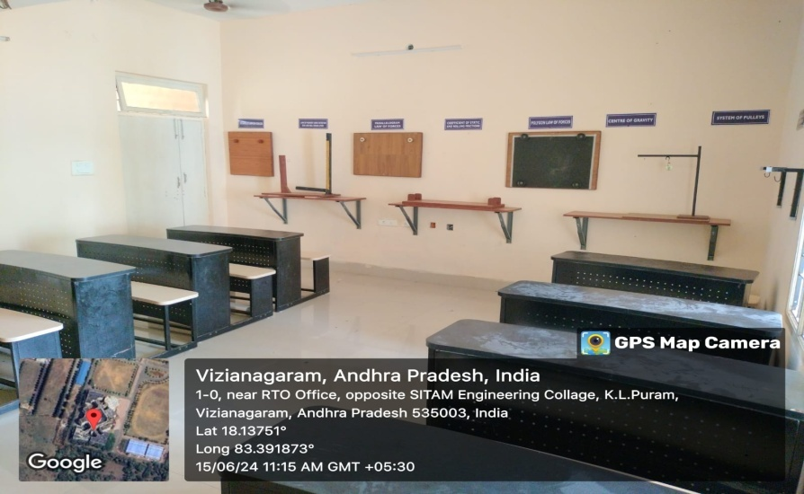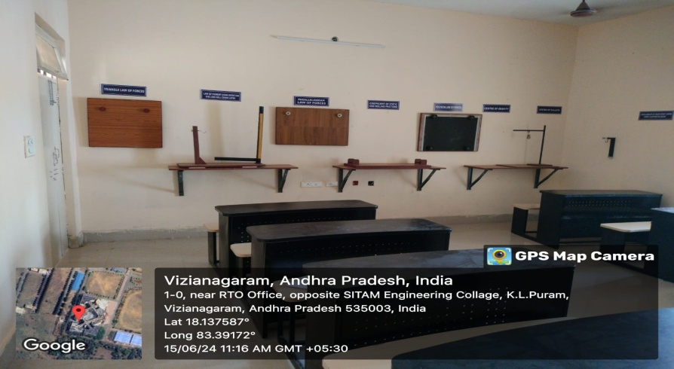

Heat Transfer Lab  C203 | 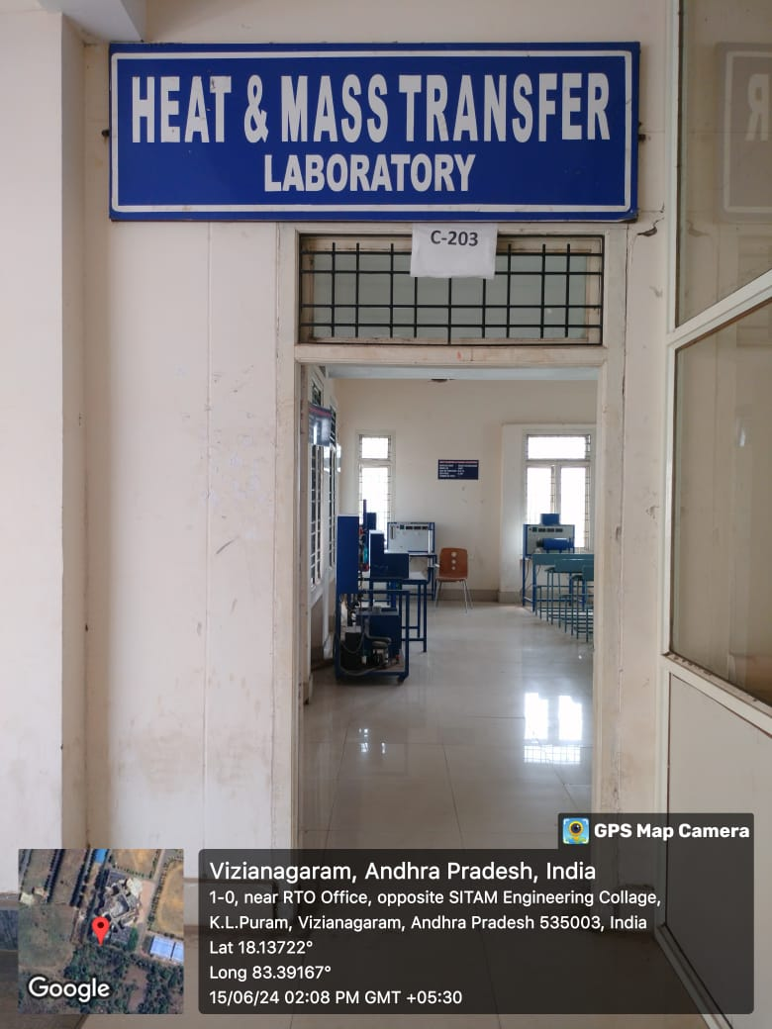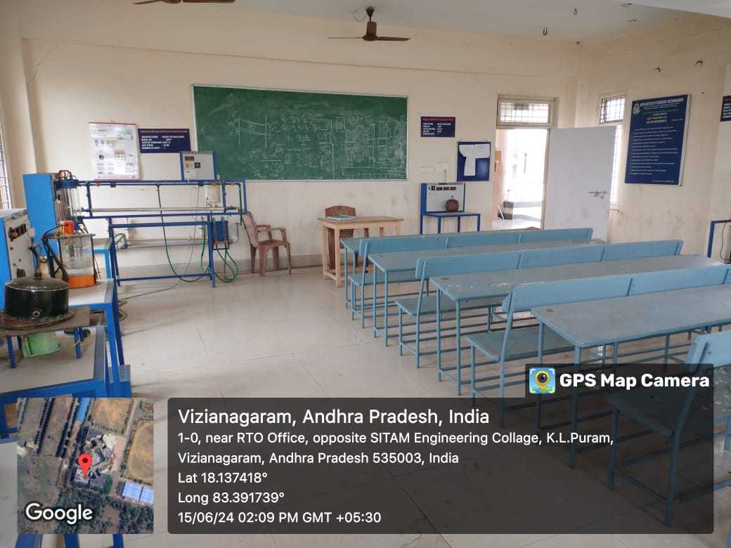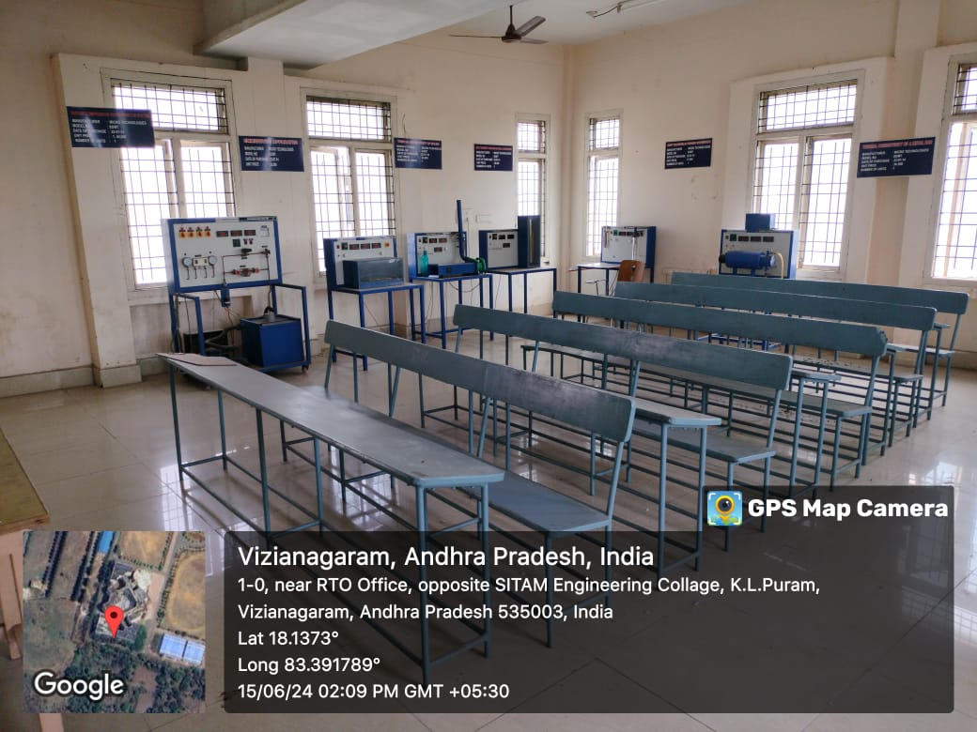
Machine Tools Lab  S101 A  Theory of Machines Lab  S101 B | 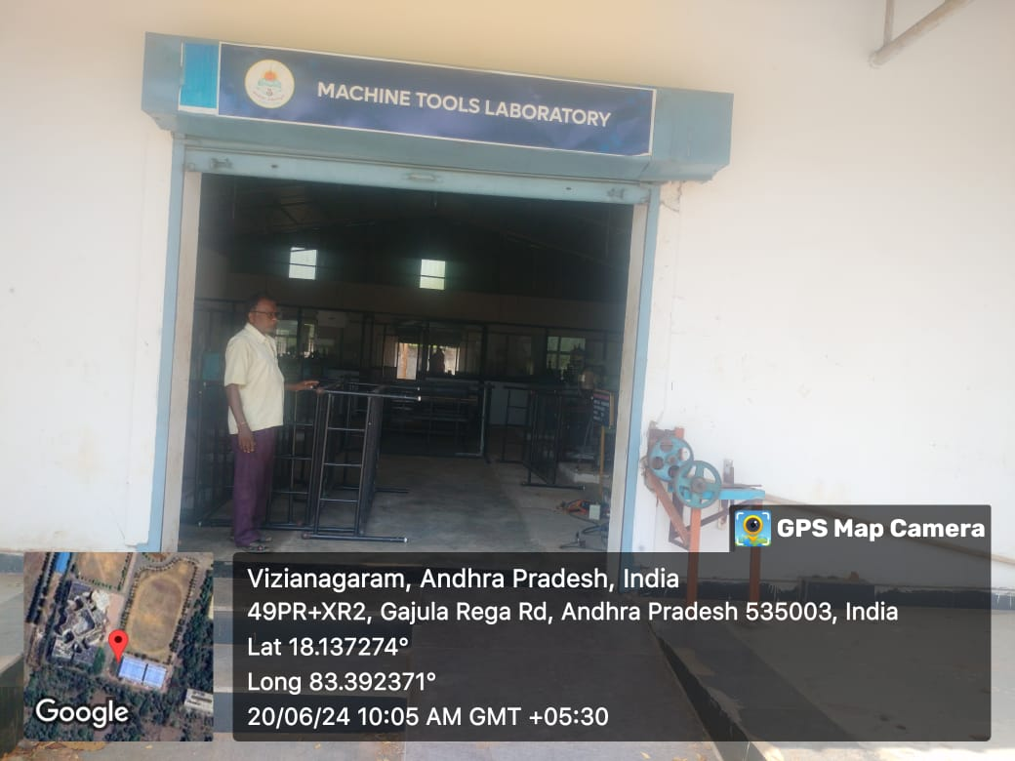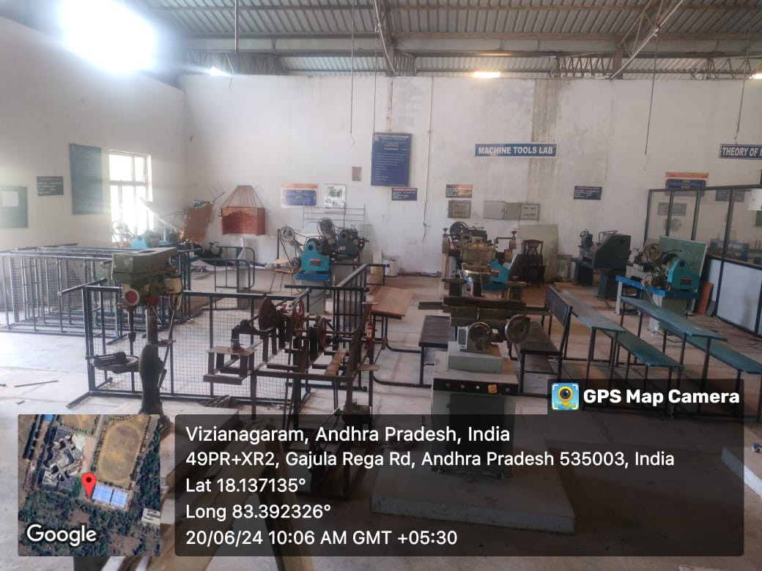  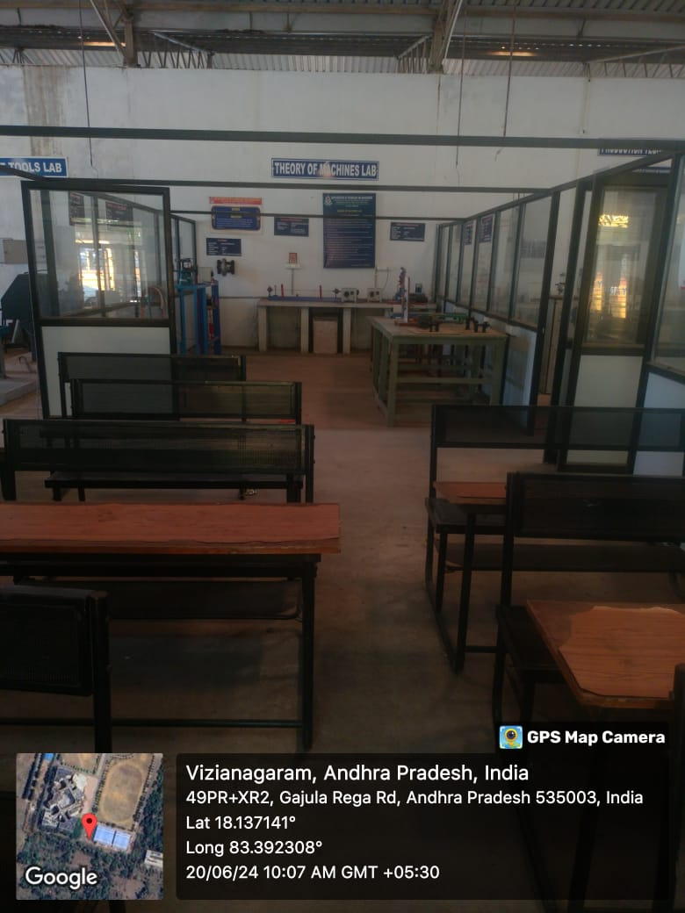

Production Technology Lab  S101 C | 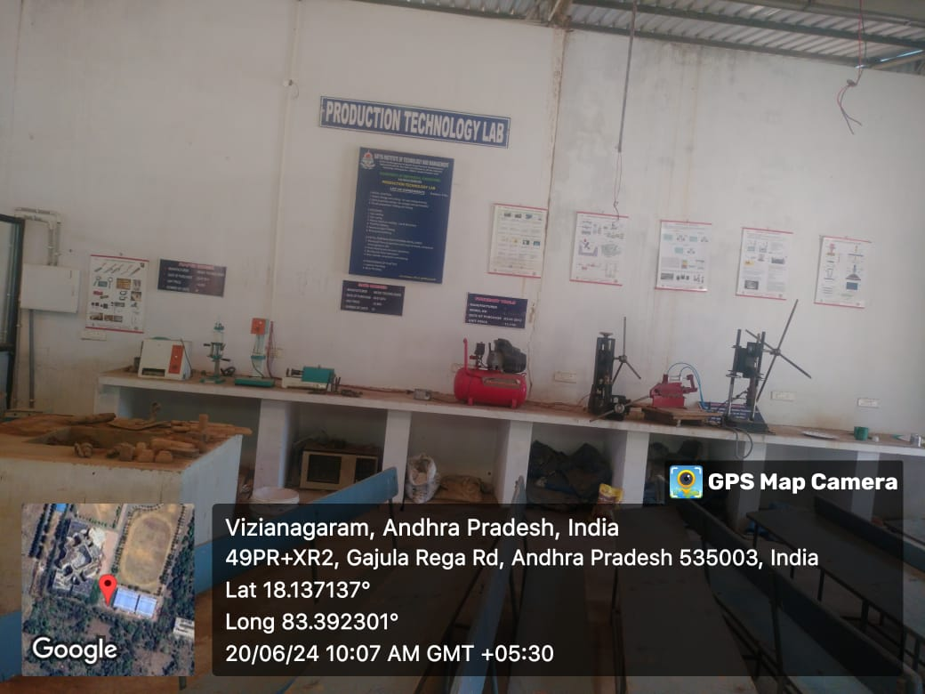
Thermal Engineering Lab  S101 D | 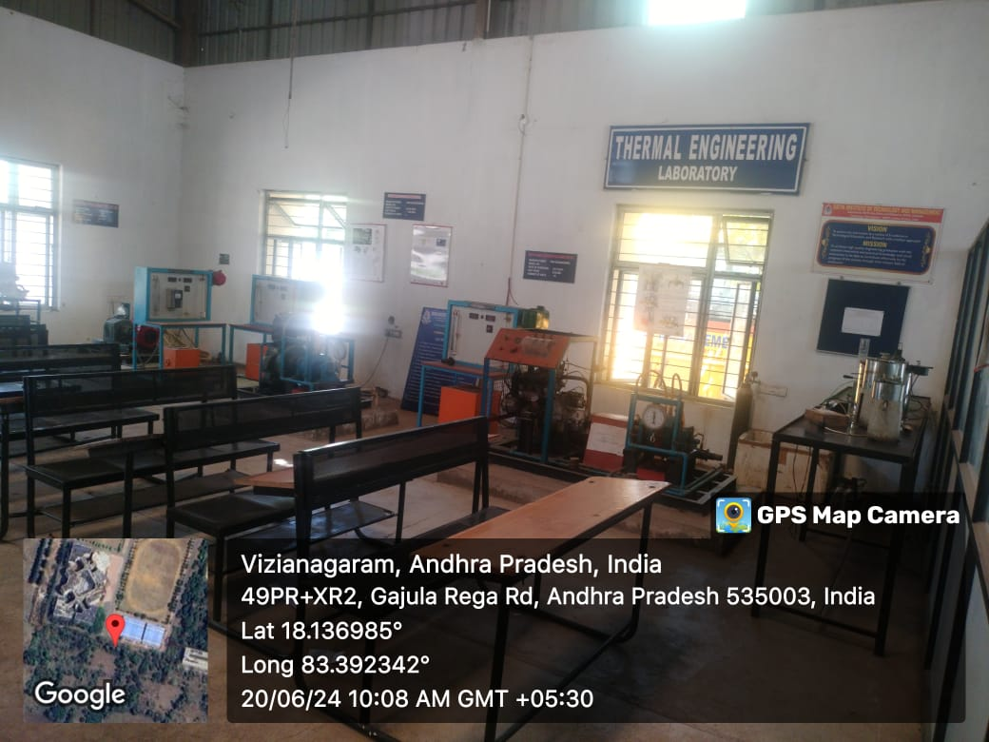
Mechanics of Solids Lab  S102 B | 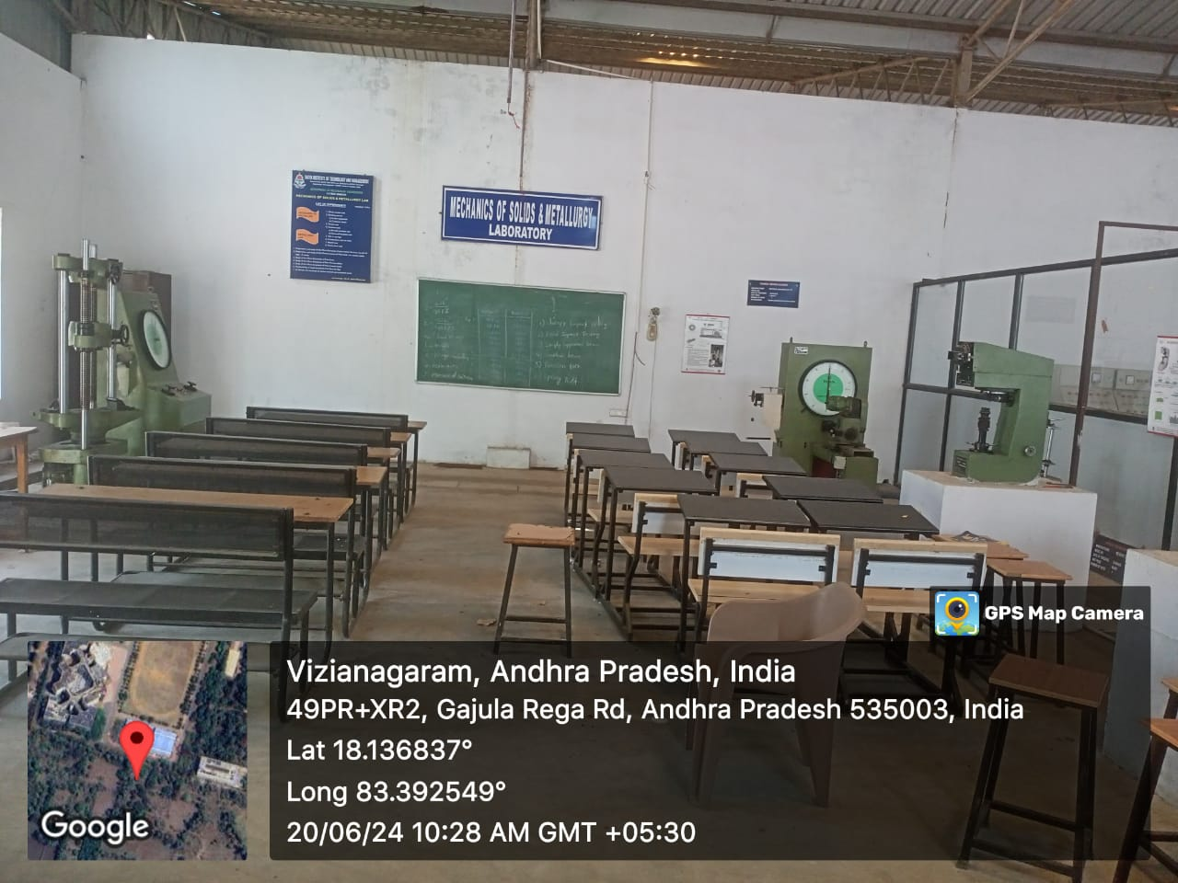

Engineering Workshop  S103-A | 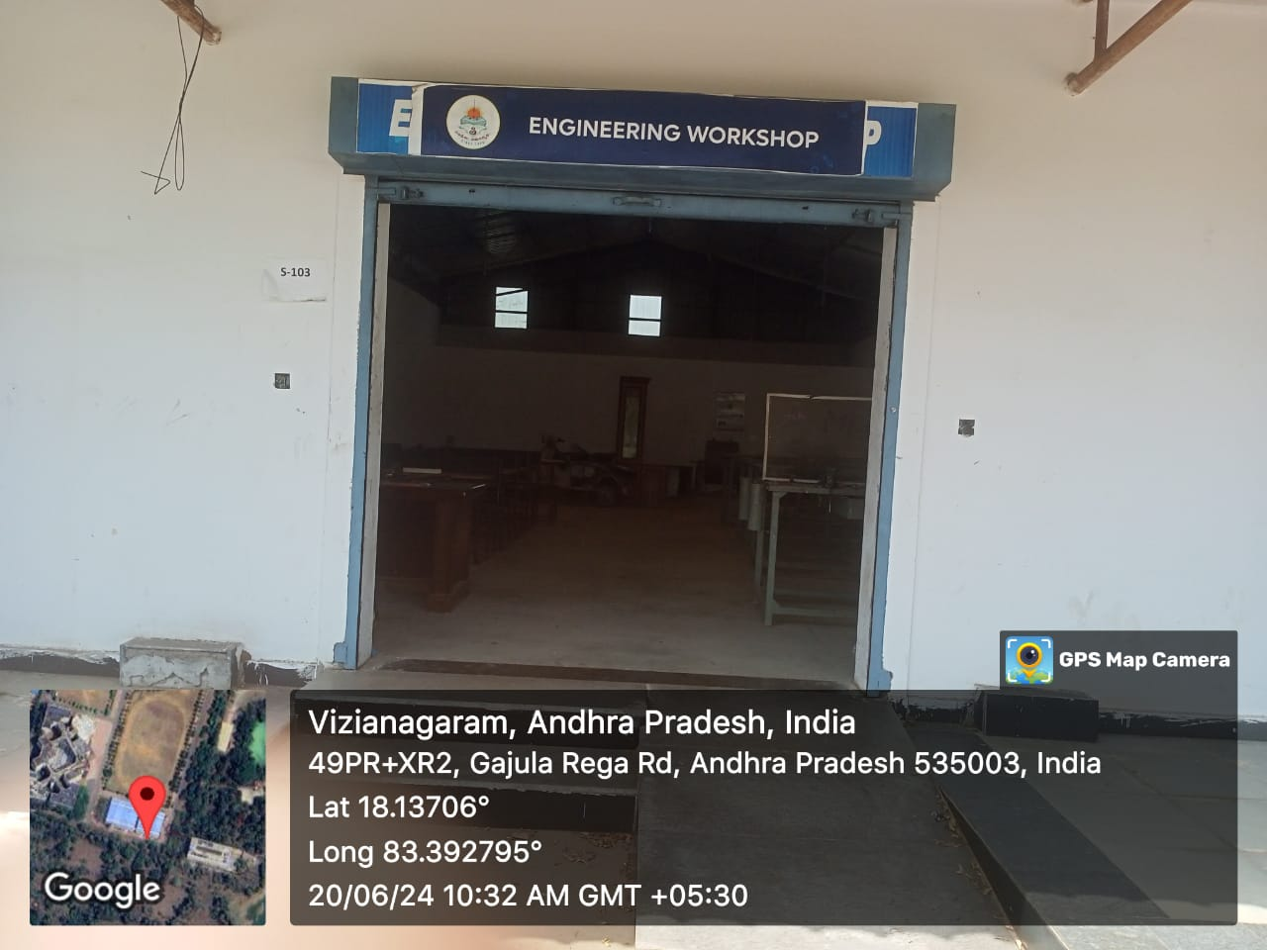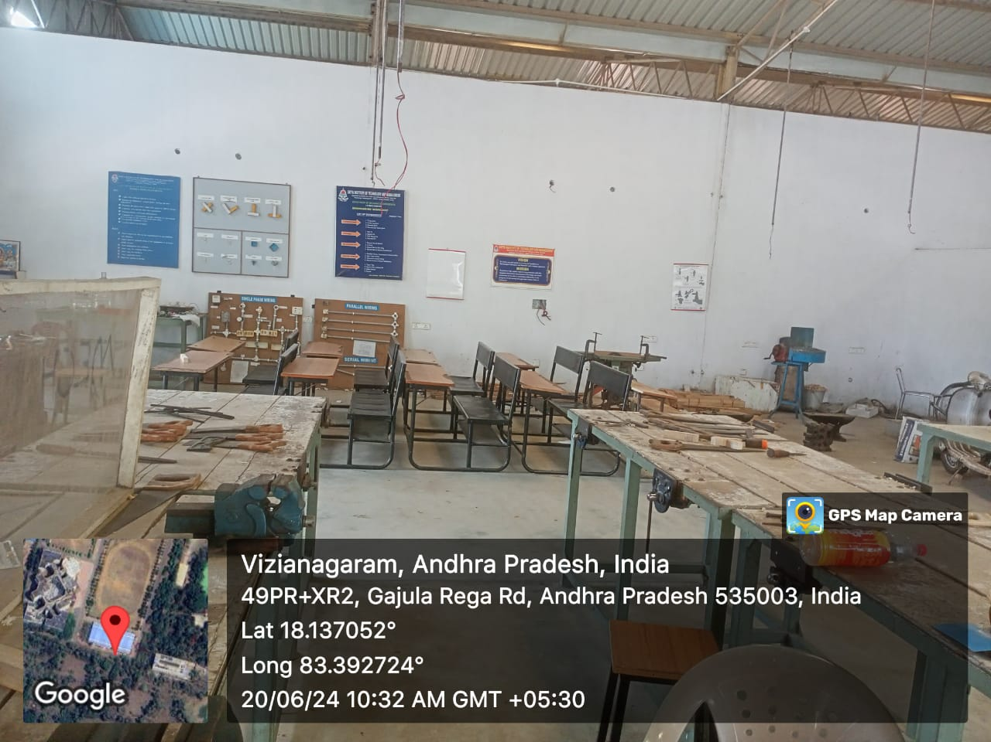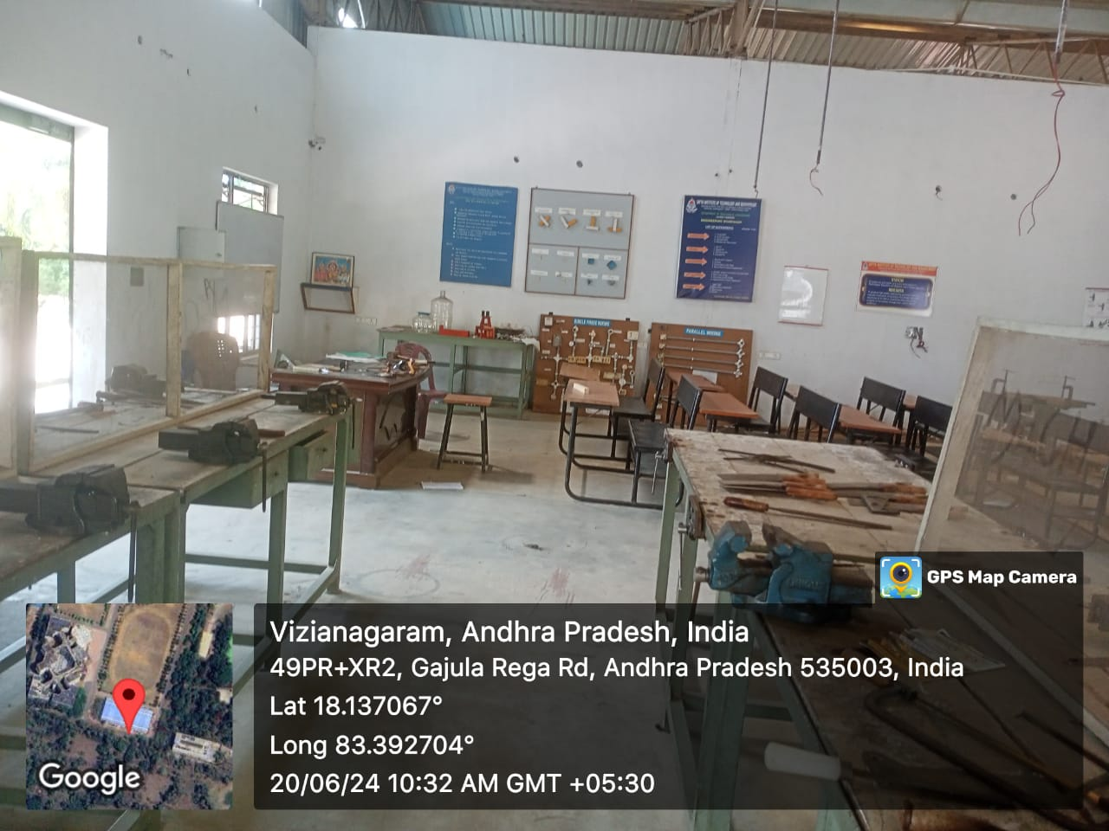

CAD / CAM Lab  F 302 | 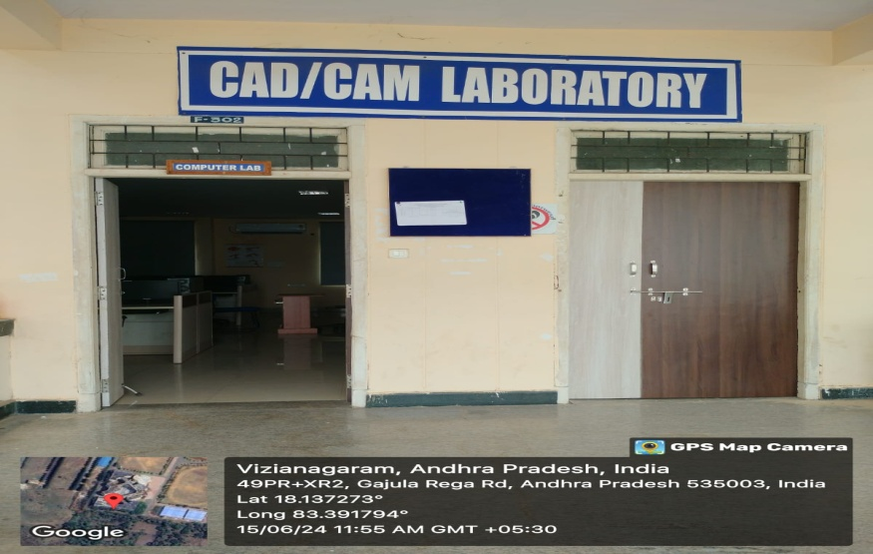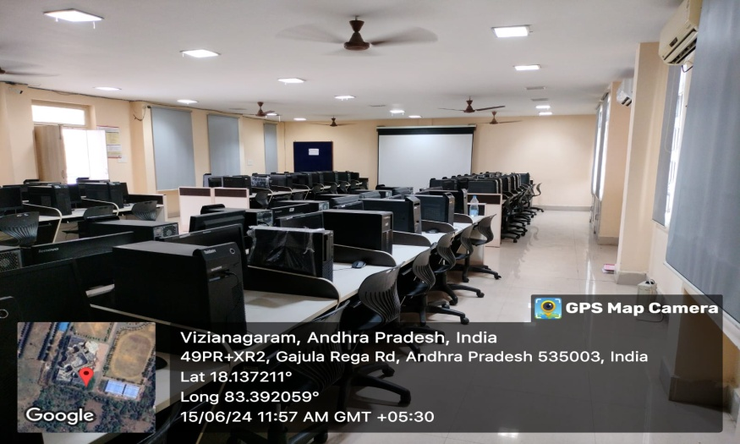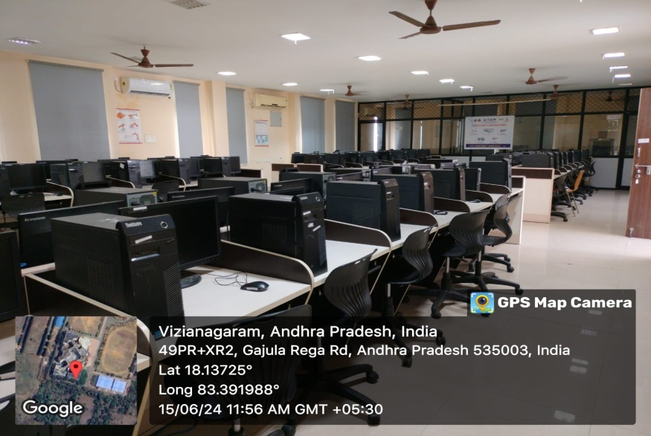

Department of Electronics and Communication Engineering
Sr. No | Name of the class room/ Lab No | Class Room/ Lab No | Size as per AICTE  Norms  (Sq.mtr) | Carpet Area (Sq.mtr)
1. | Class Room-I | D 201 | 66 | 72.83
2. | Class Room-II | D 203 | 66 | 75.43
3. | Class Room-III | D 205 | 66 | 75.43
4. | HOD Cabin | D 204 | 10 | 48.30
5. | Staff room | D 202 | 5 sq.m per room | 40.13
6. | Simulation Lab | F 201 | 66 | 67.72
7. | MPMC Lab | C 302 | 66 | 98.10
8. | Electronics Lab | C 303 | 66 | 140.46
9. | Microwave Engineering Lab | C 405 | 66 | 72.83

Geotagged Photos Department of Electronics and Communication Engineering
Class Room-I  D 201 | 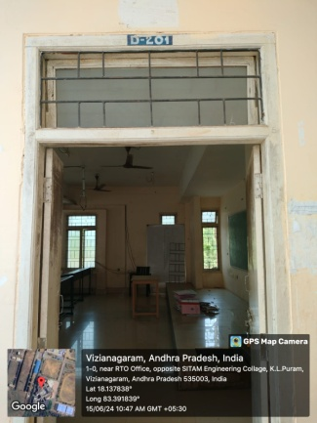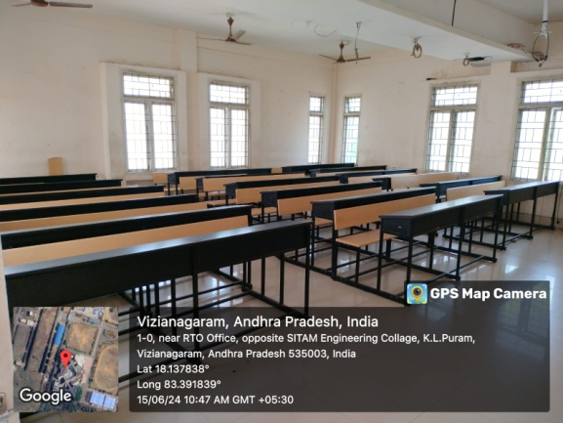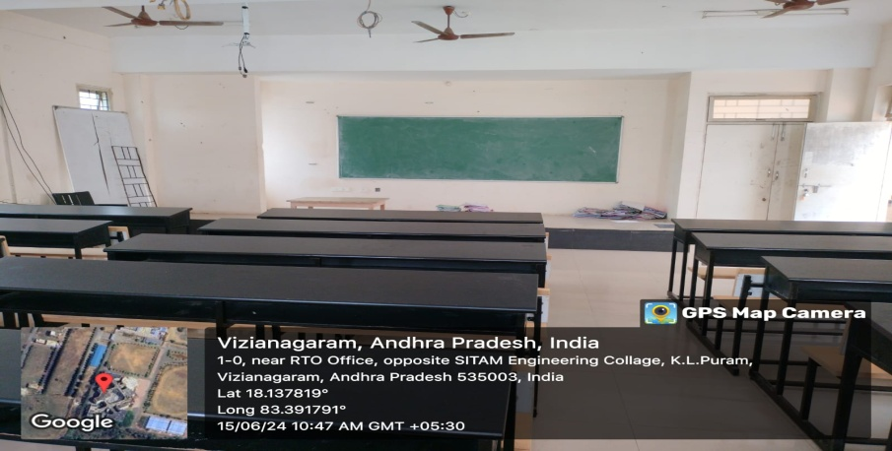

Class Room-II  D 203 | 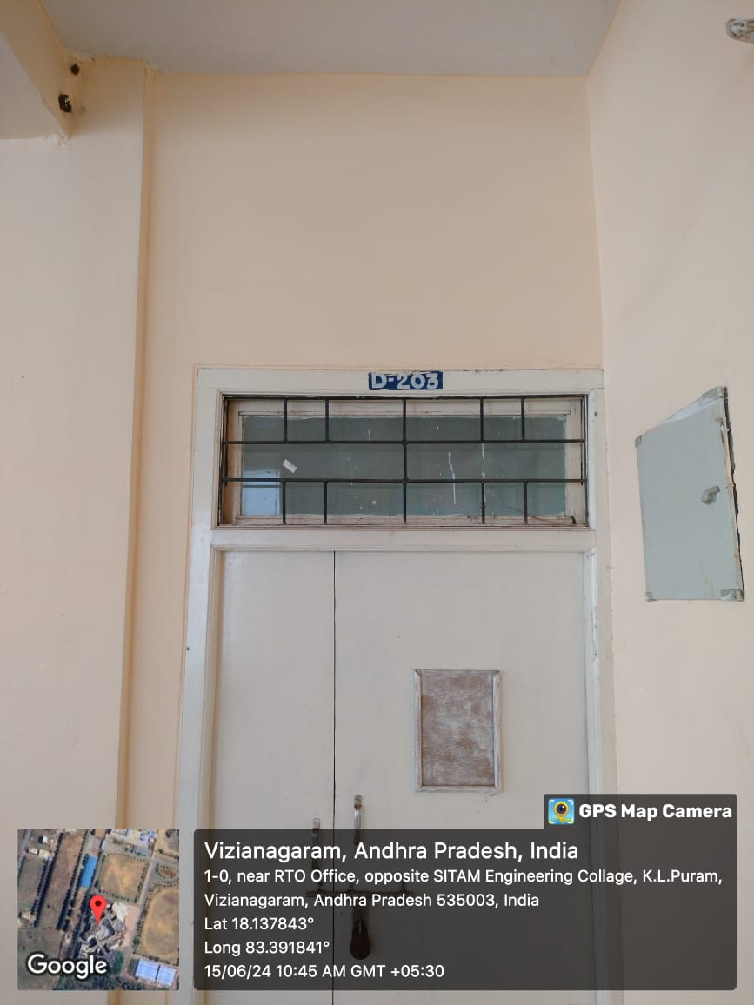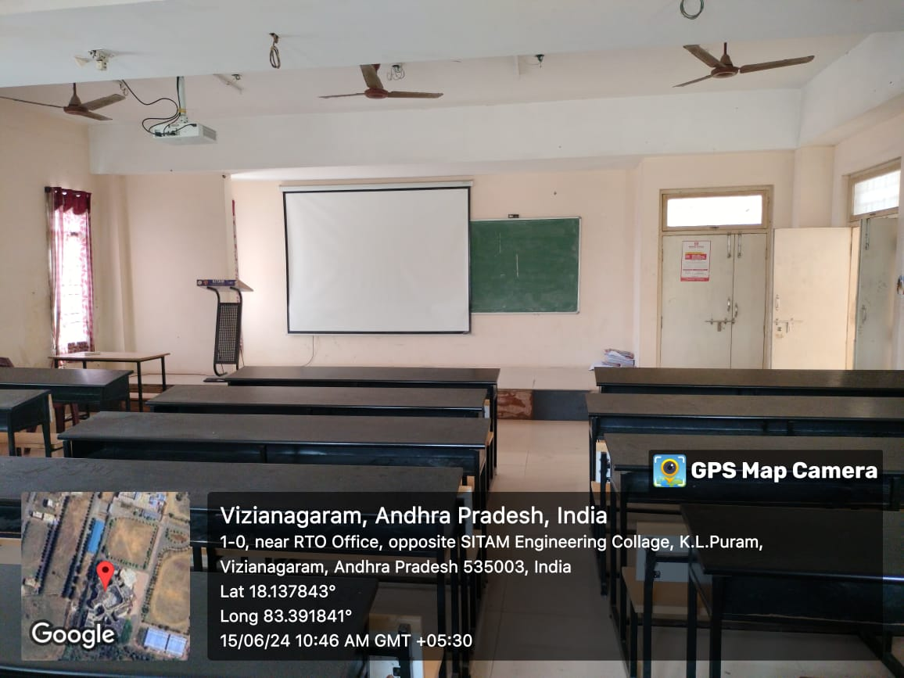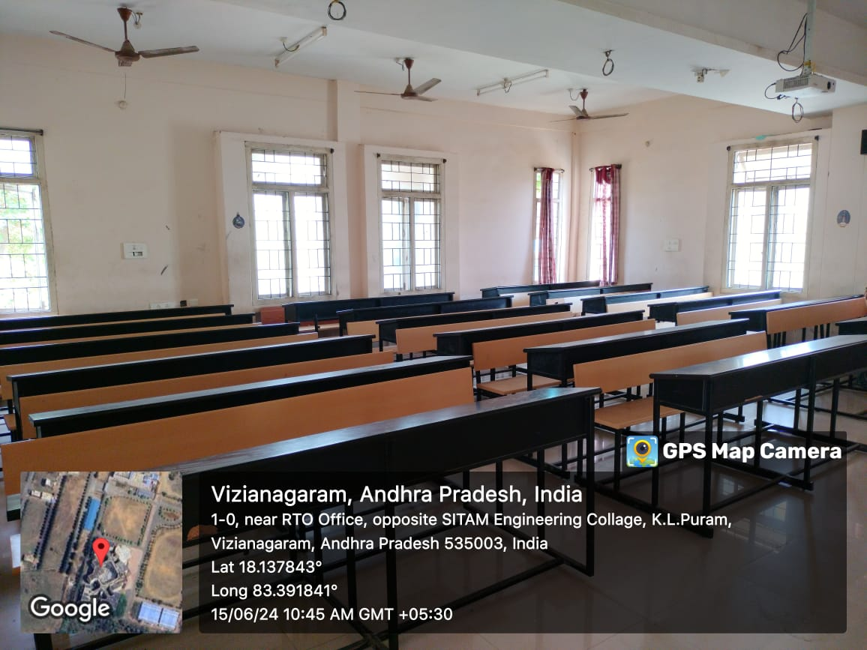

Class Room-III  D 205 | 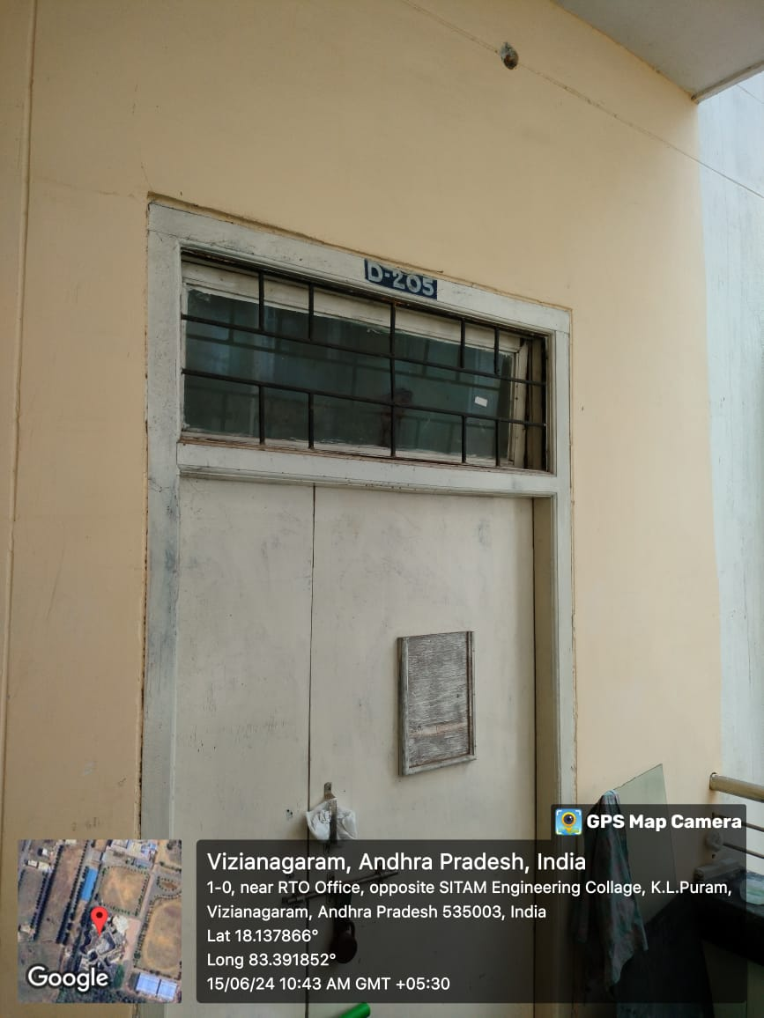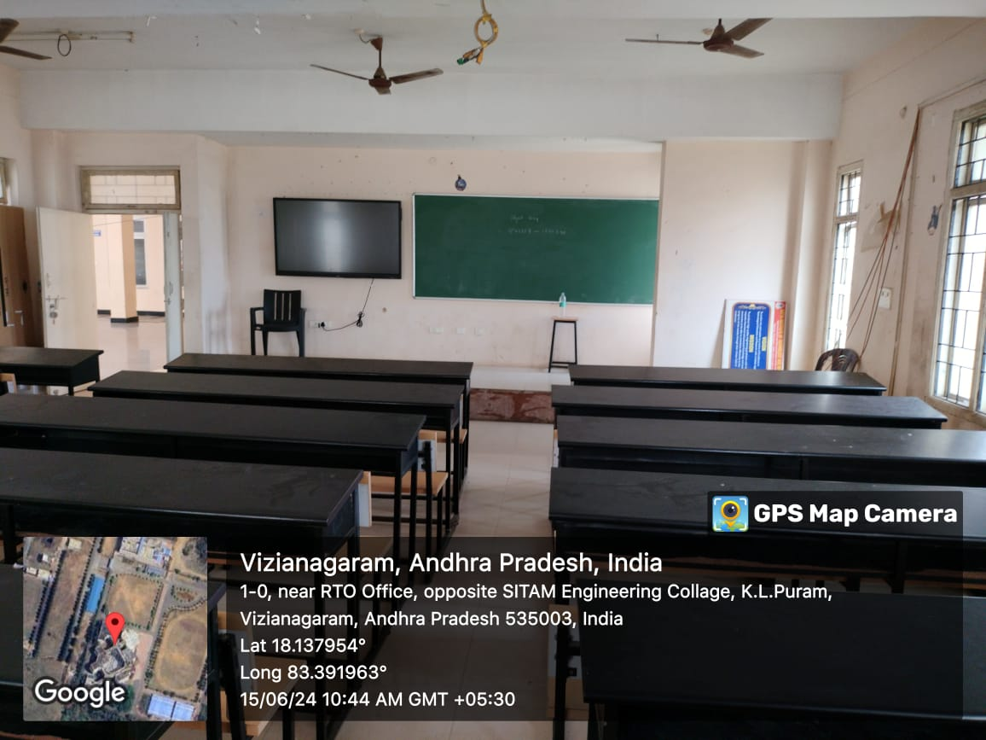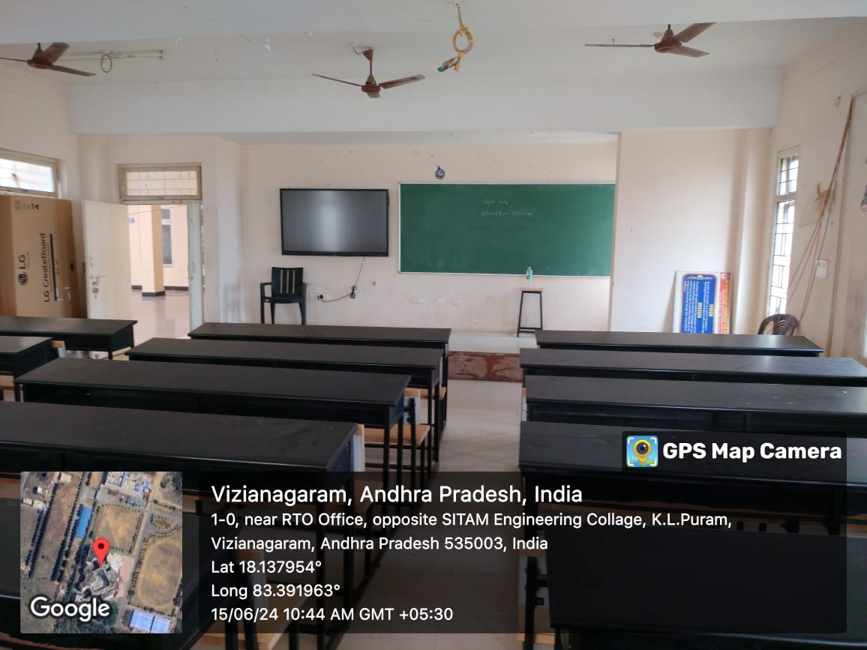

HOD Cabin  D 204 | 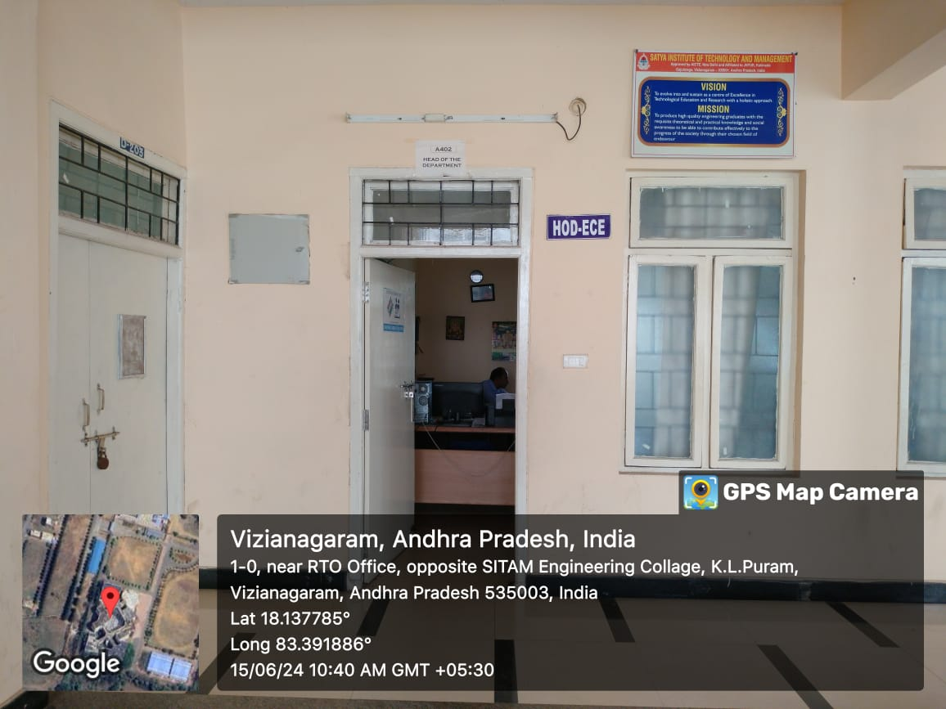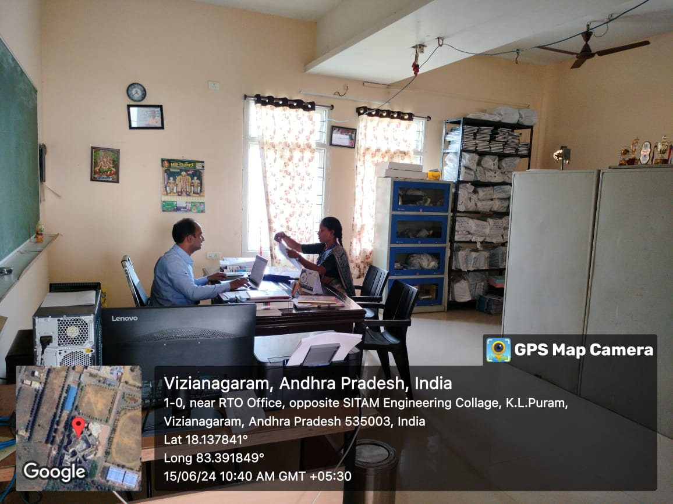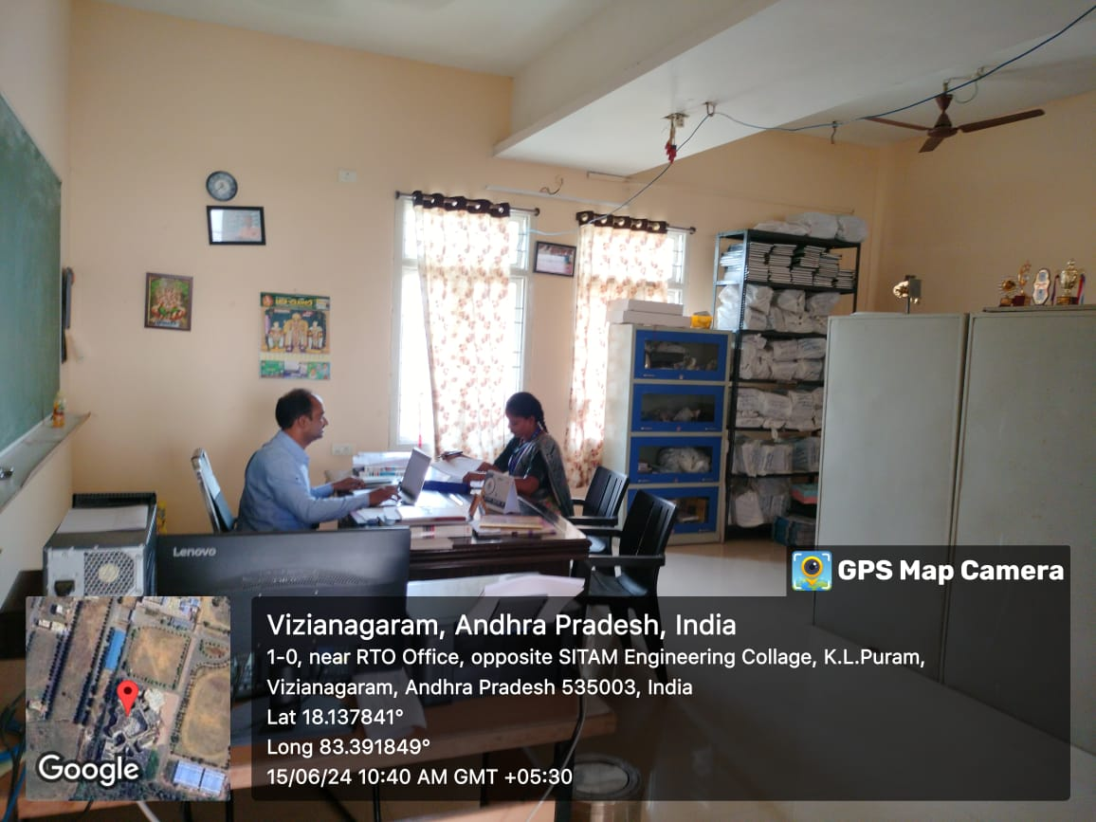

Staff room  D 202  Microwave Engineering Lab  C 405 | 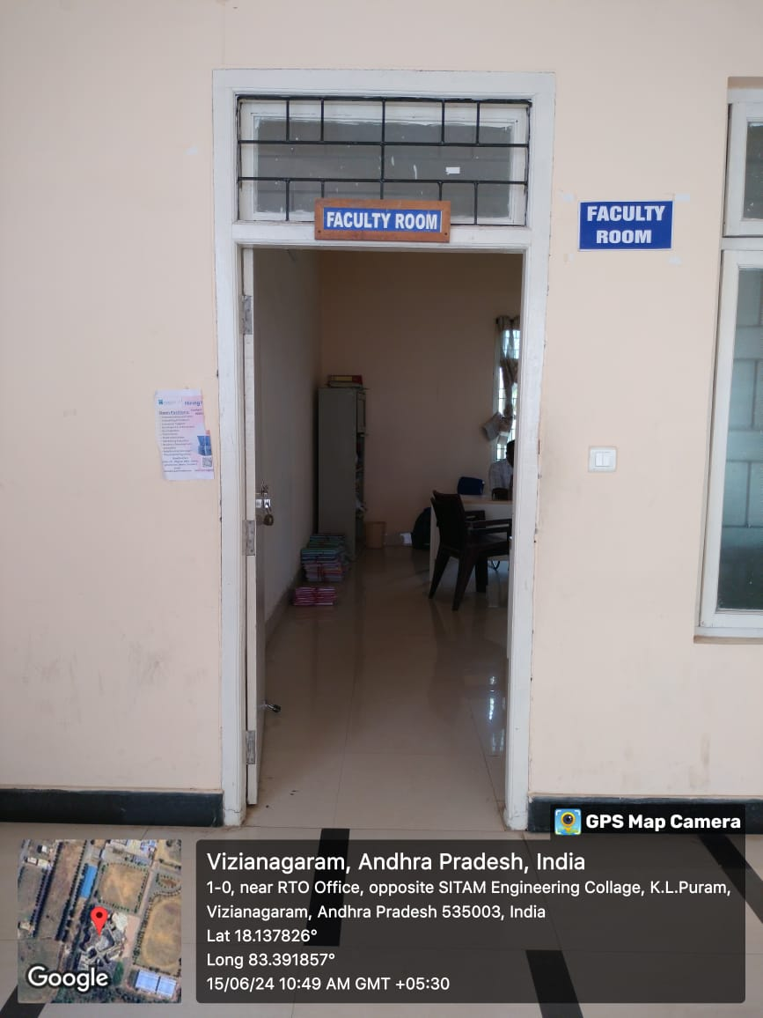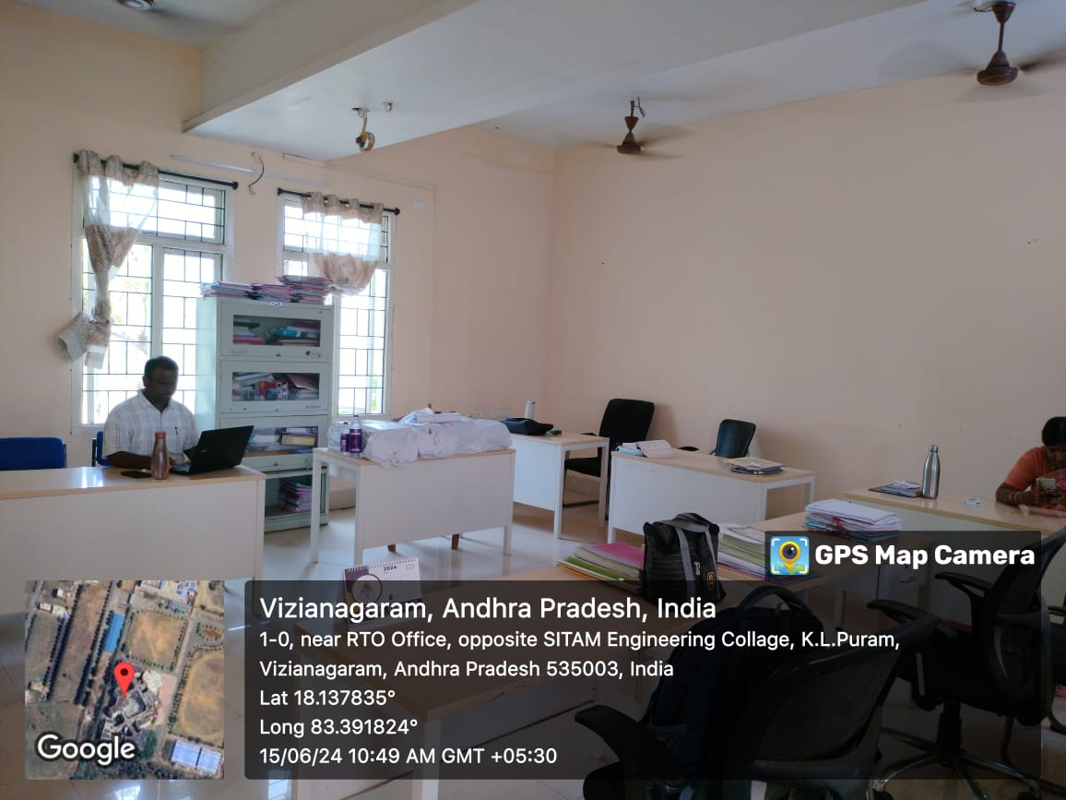  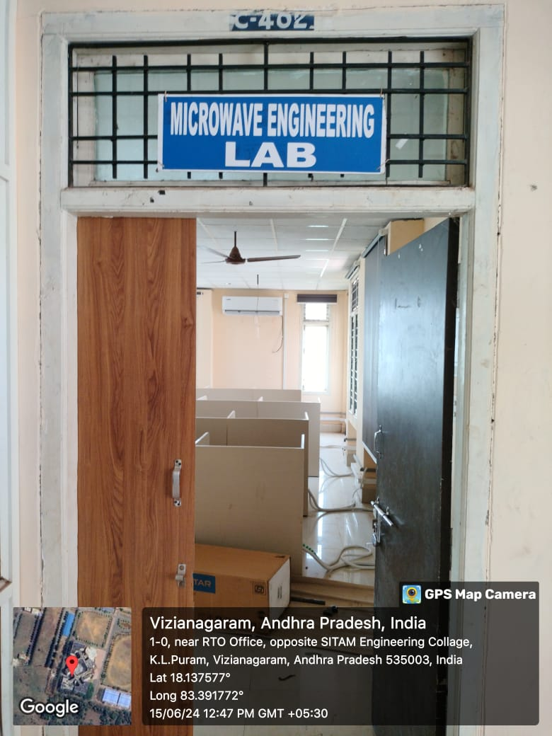

Simulation Lab  F 201 | 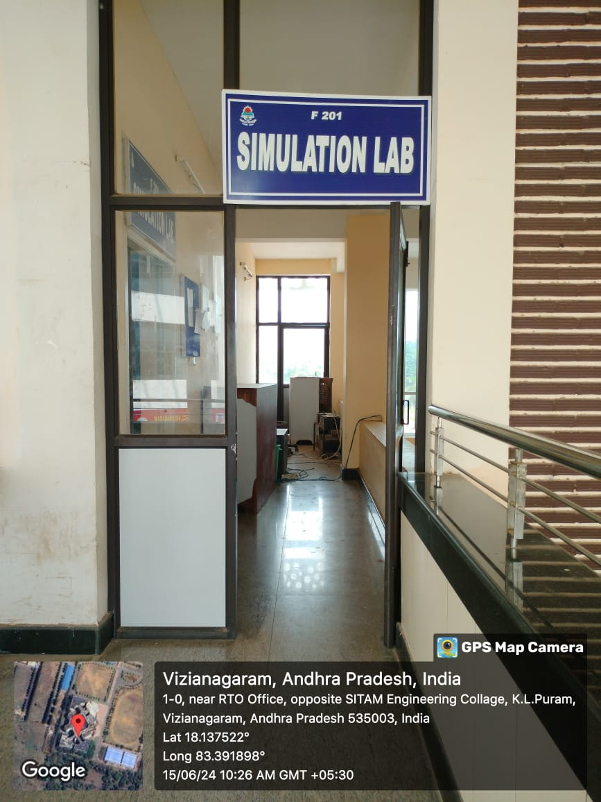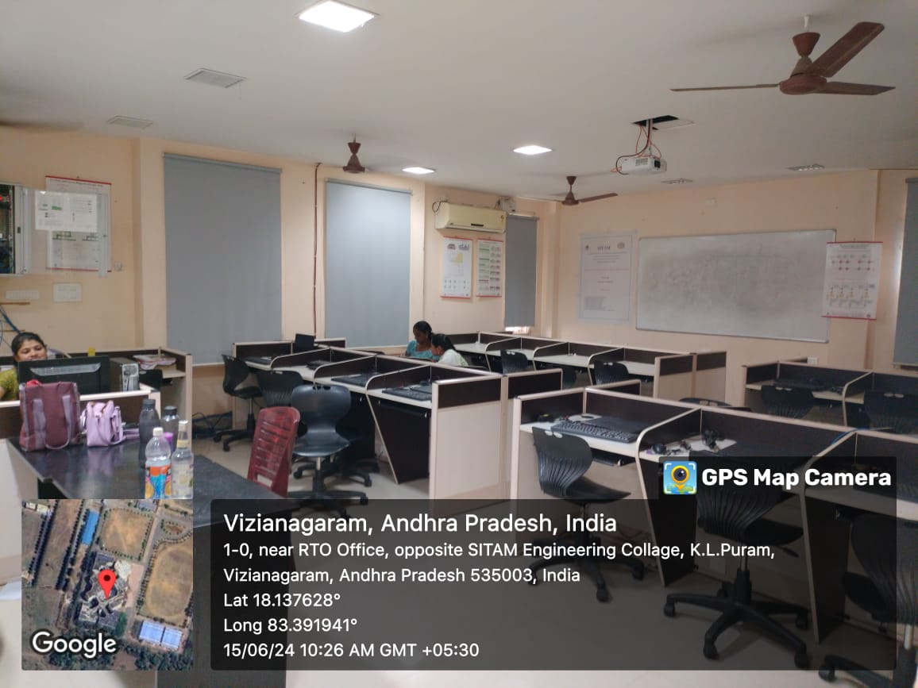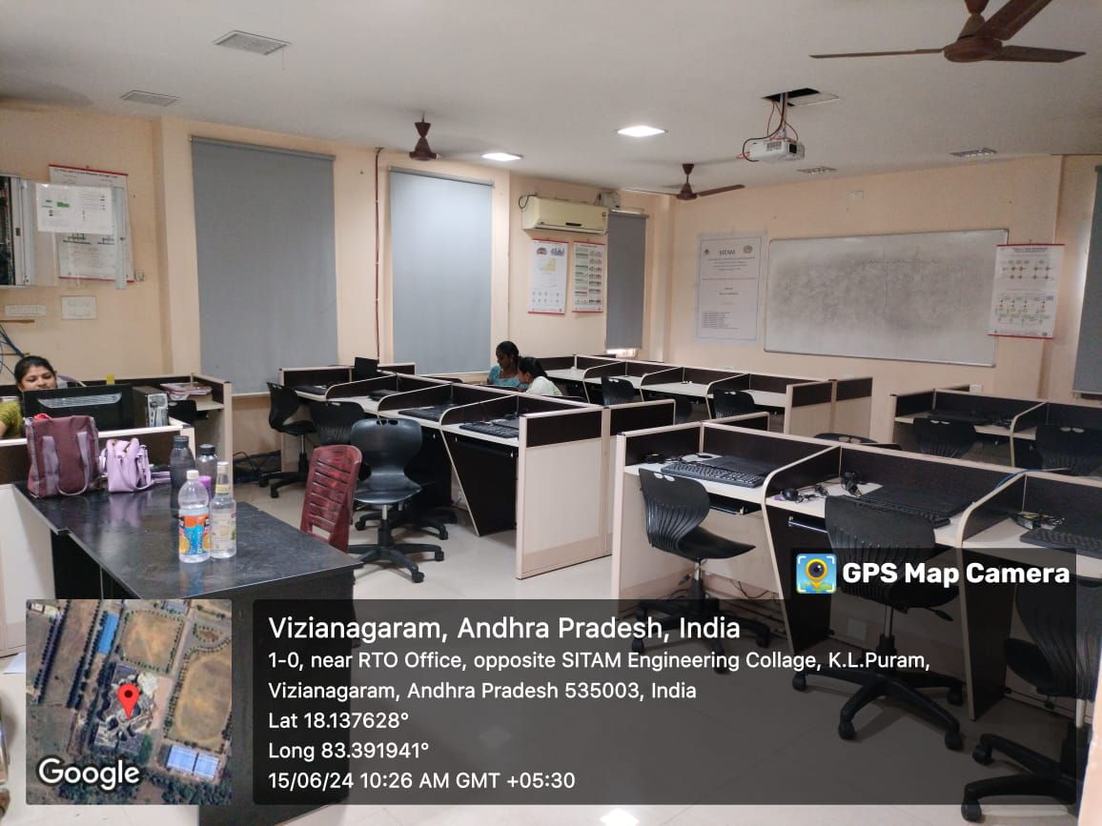

MPMC Lab  C 302 | 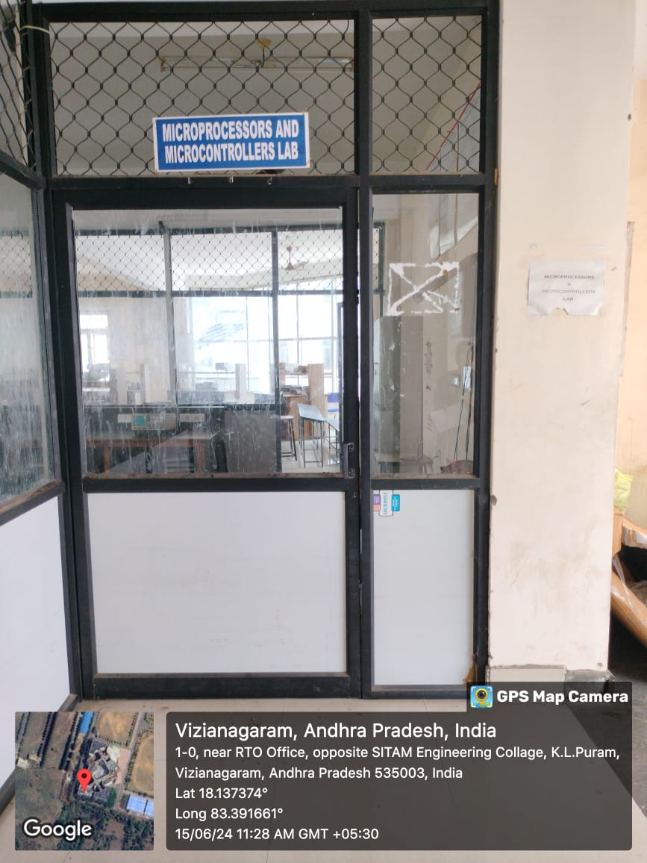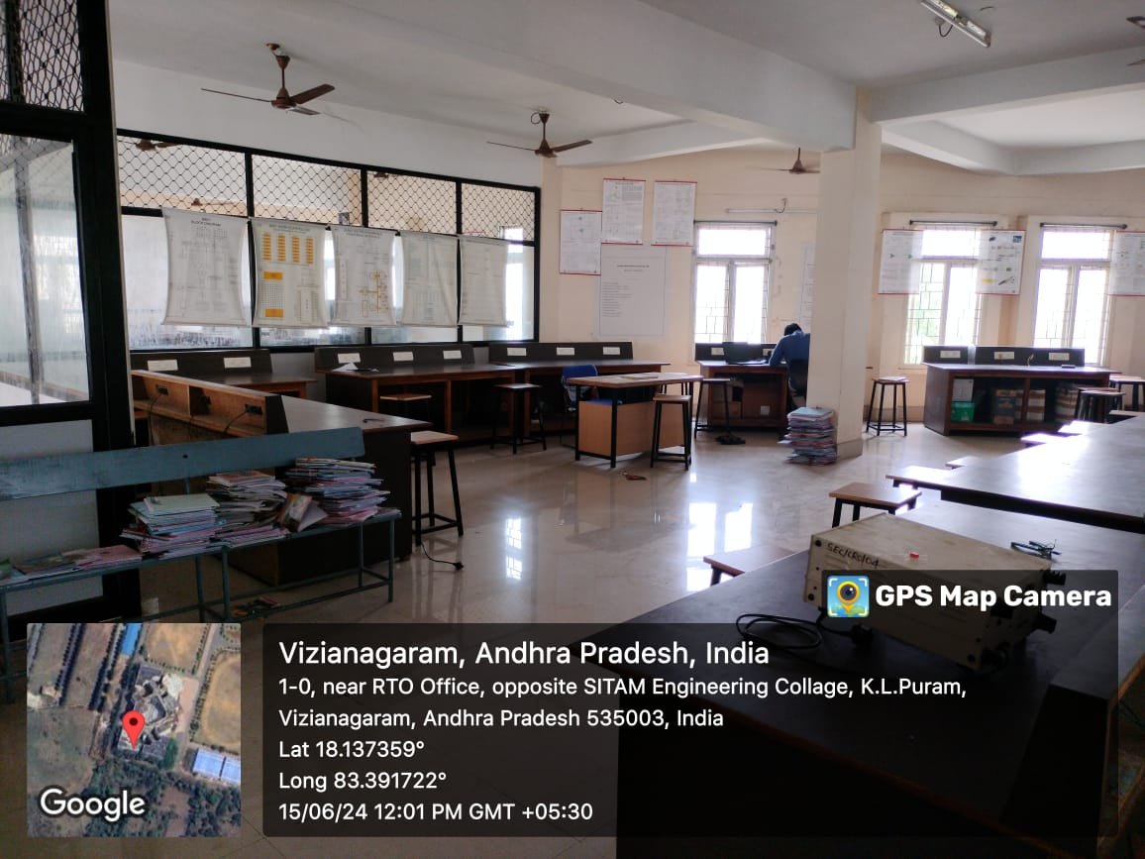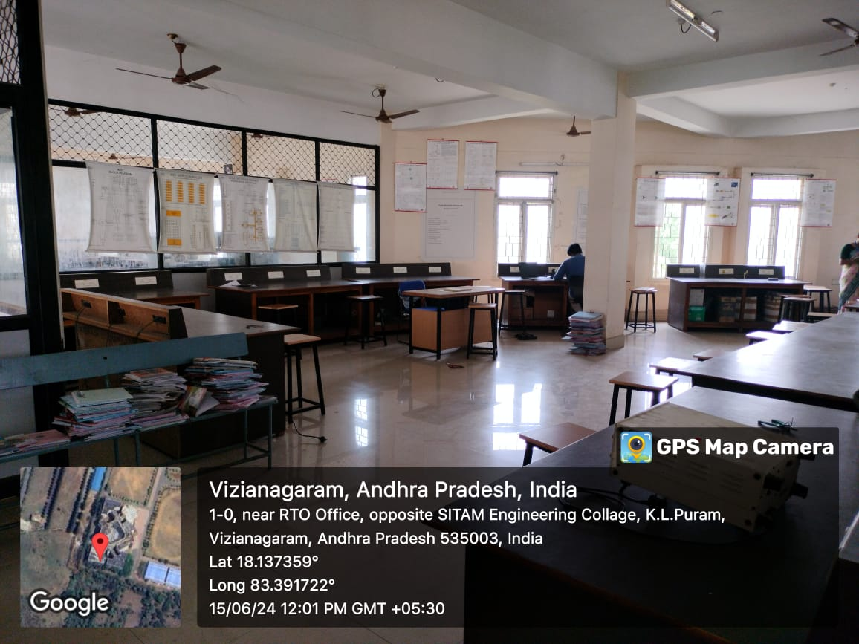

Electronics Lab  C 303 | 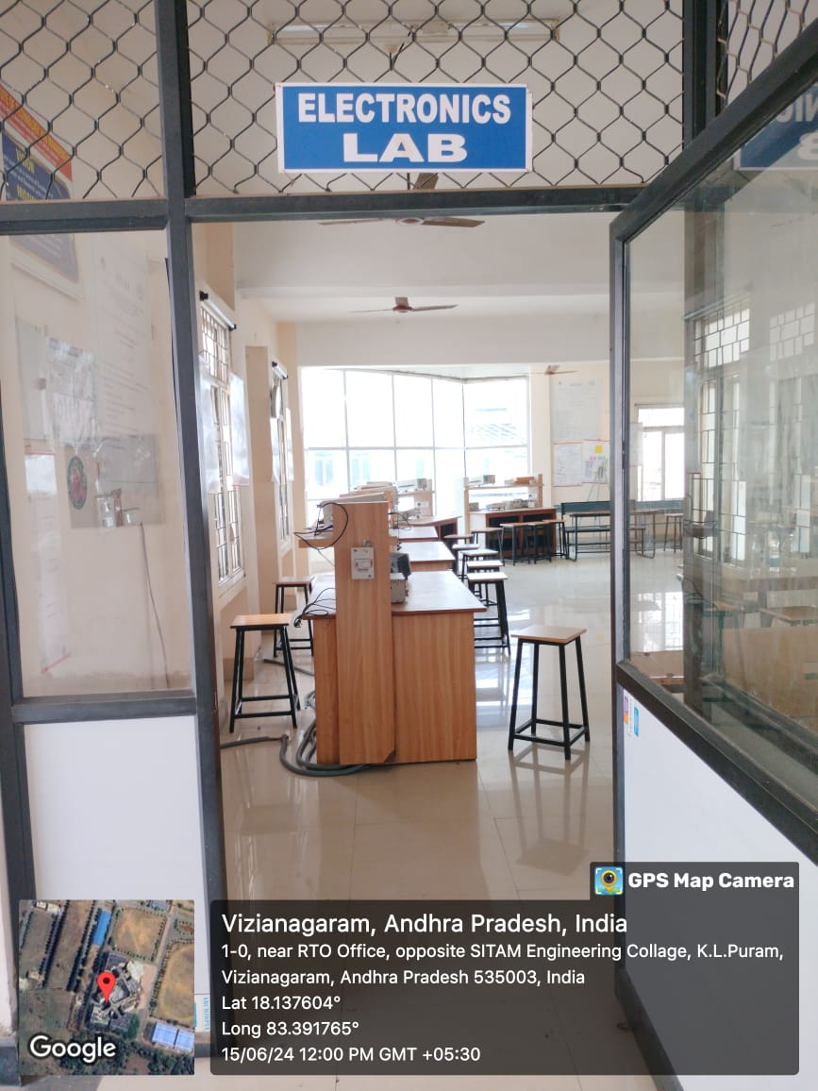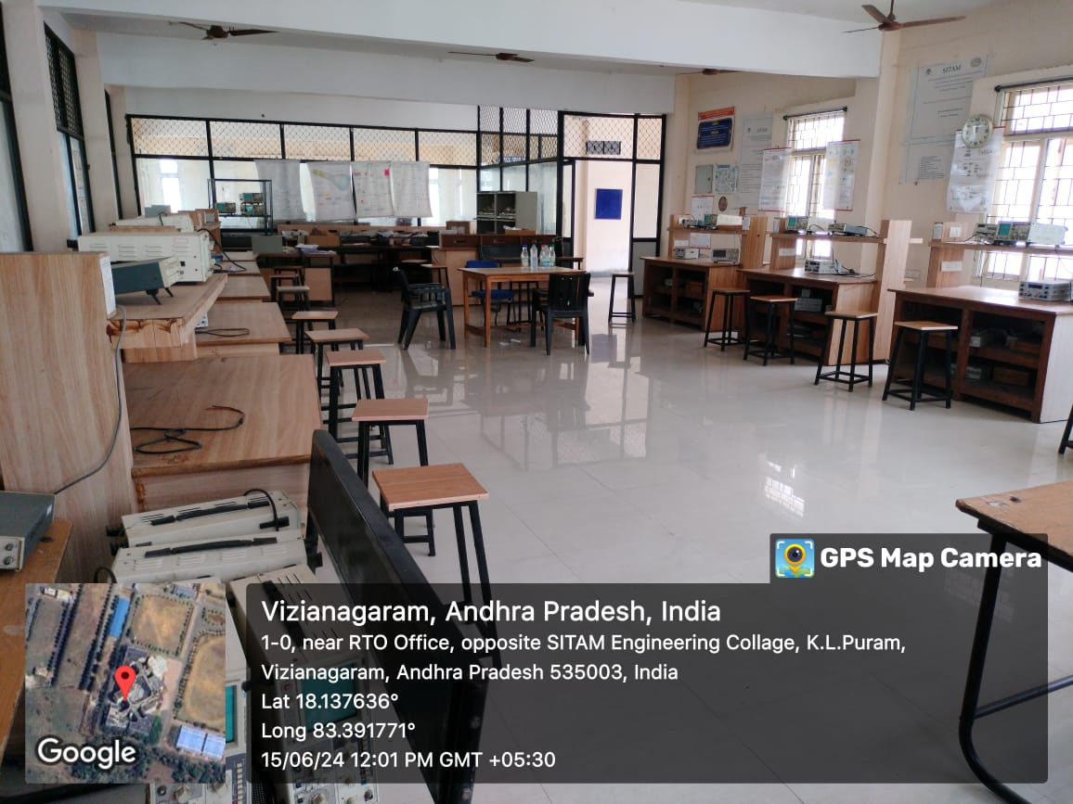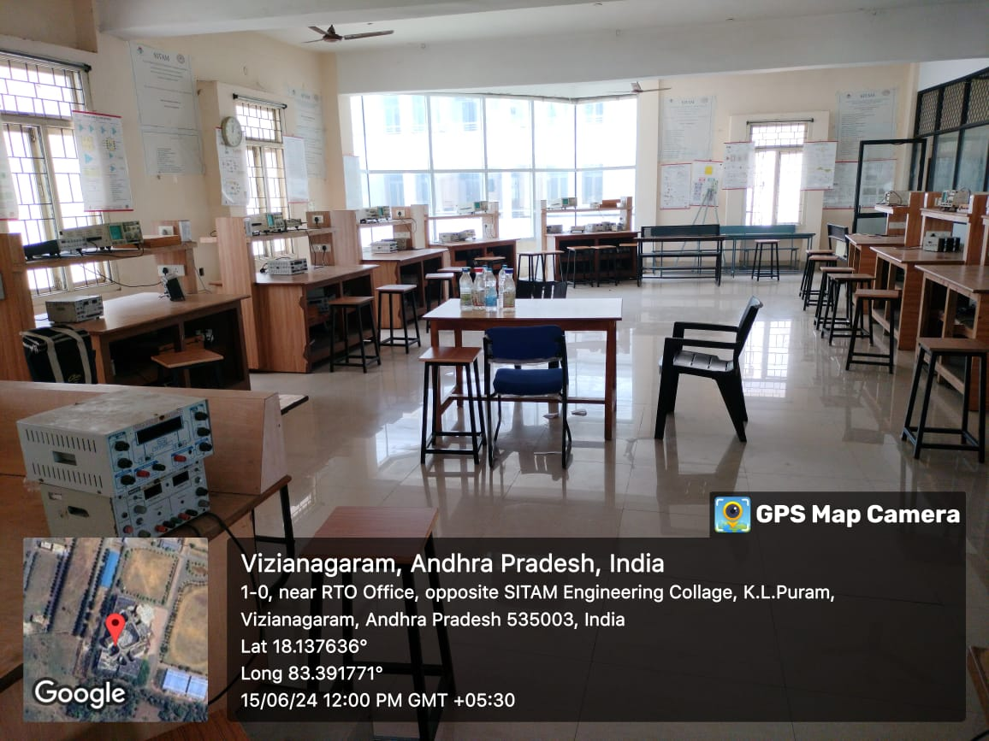

Department of Computer Science and Engineering
&
Department of Artificial Intelligence and Data Science
Sr. No | Name of the class room/ Lab No | Class Room/ Lab No | Size as per AICTE  Norms | Carpet Area (Sq.mtr)
1. | Class Room-I | D 401 | 66 | 72.83
2. | Class Room-II | D 403 | 66 | 72.83
3. | Class Room-III | D 405 | 66 | 78.03
4. | HOD Cabin | D 402 | 10 | 48.30
5. | Staff room | D 404 | 5 sq.m per room | 52.02
6. | Class Room-I | D 301 | 66 | 72.83
7. | Class Room-II | D 302 | 66 | 67.63
8. | Class Room-III | D 303 | 66 | 72.83
9. | Class Room-IV | D 305 | 66 | 78.03
10. | Staff room | F 301 | 5 sq.m per room | 140.46
11. | HOD Cabin | D 304 | 10 | 72.83
12. | Computer Center | - | - | 500

Geotagged Photos CSE & CSE(AI&DS)Department
Class Room-I  D 401  Class Room-II  D 403 | 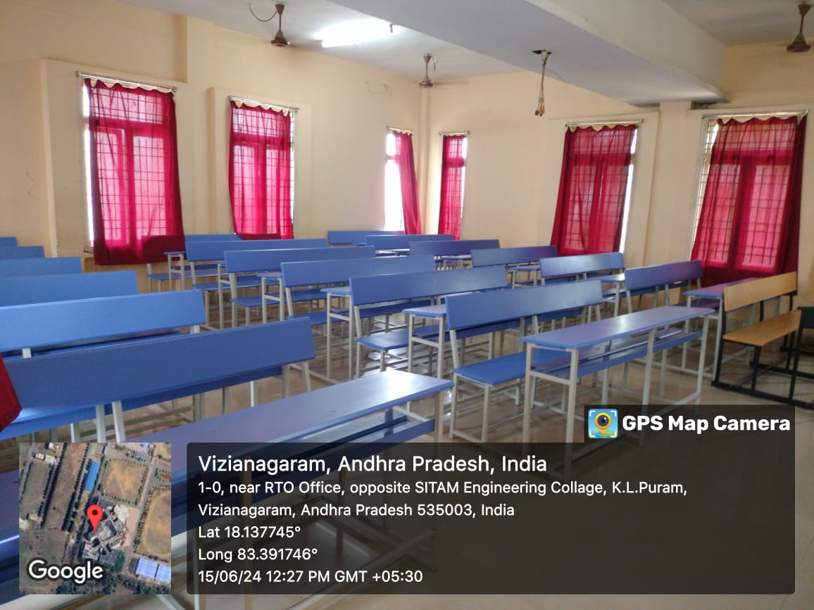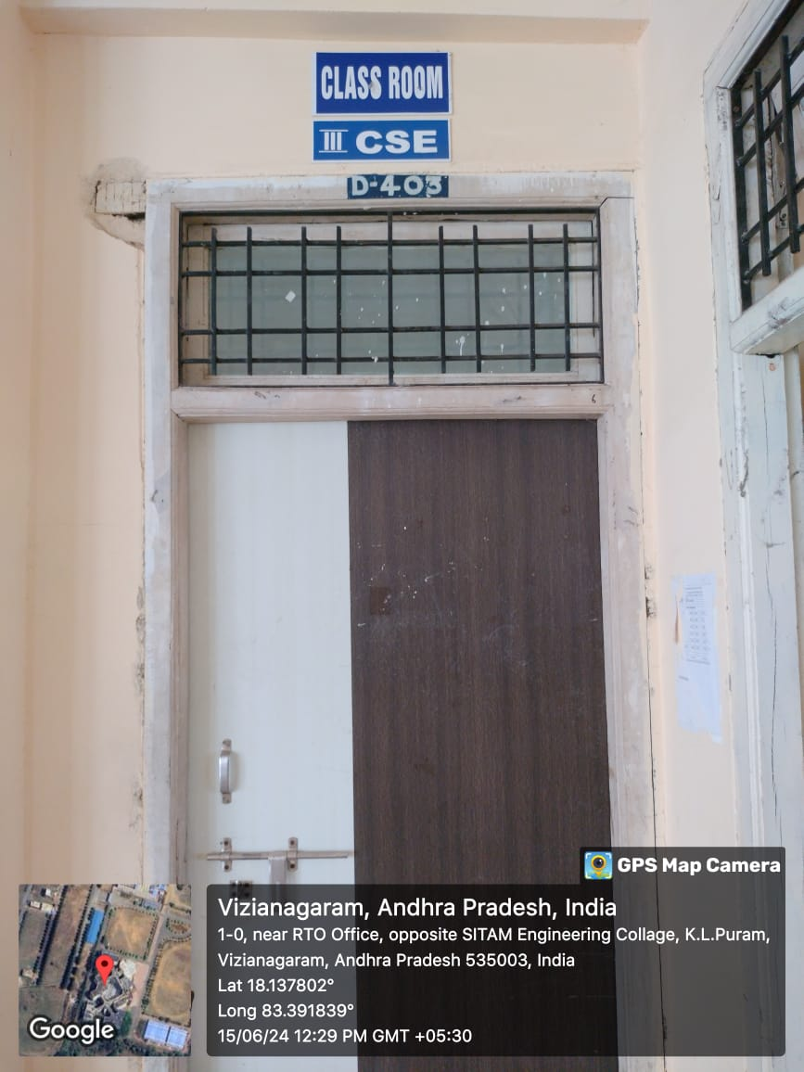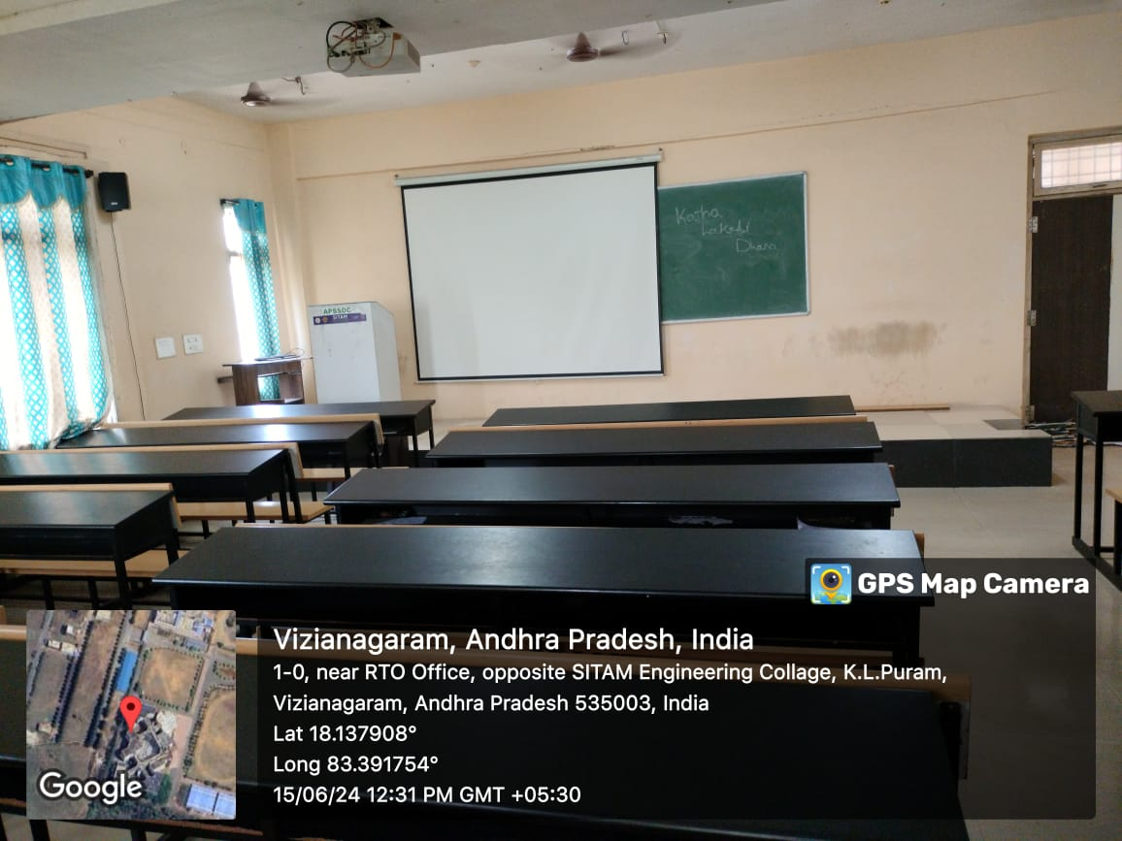

Class Room-III  D 405  HOD Cabin  D 402 | 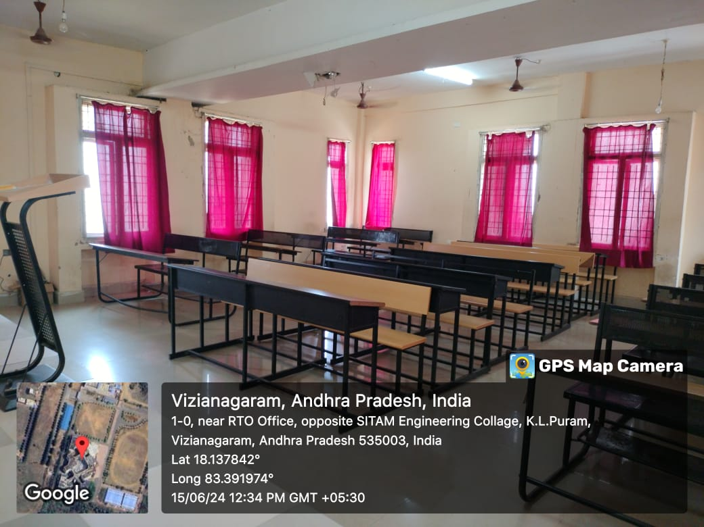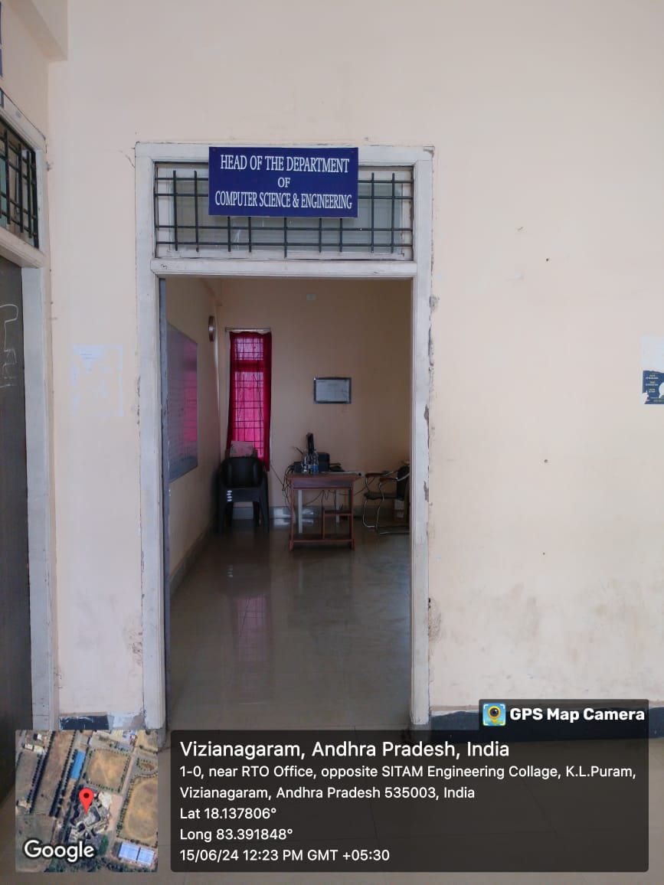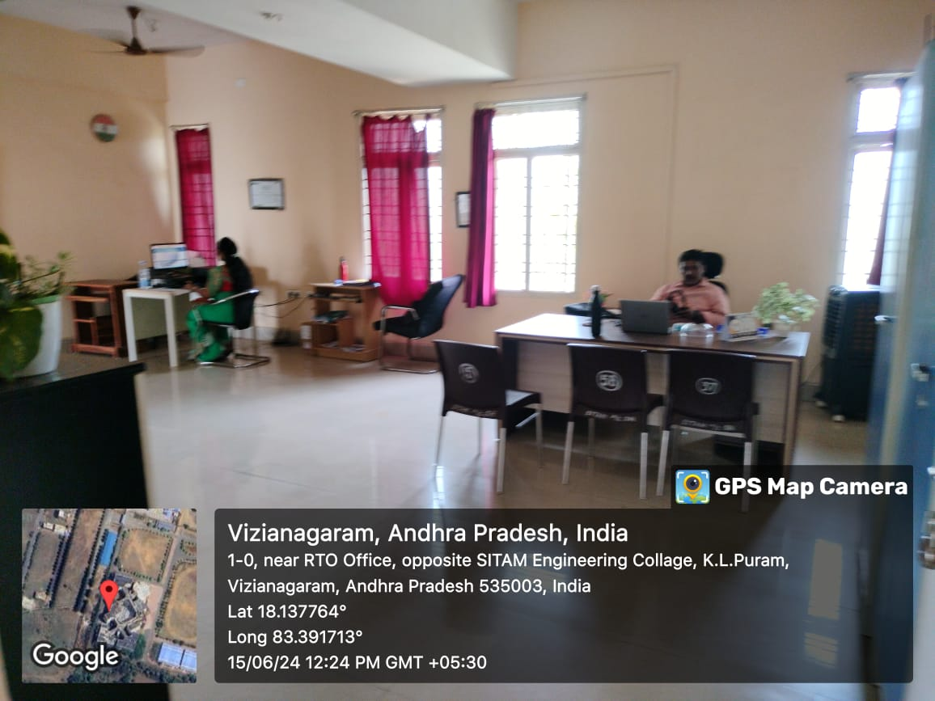

Staff room  D 404 | 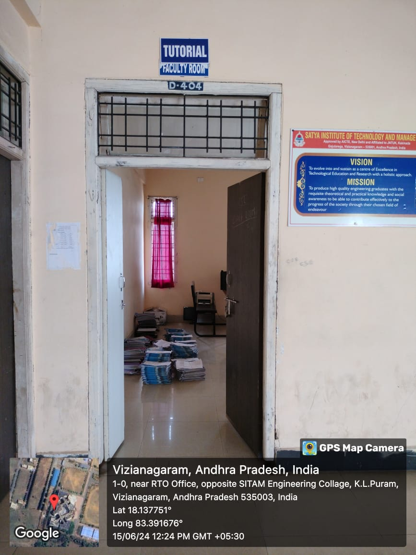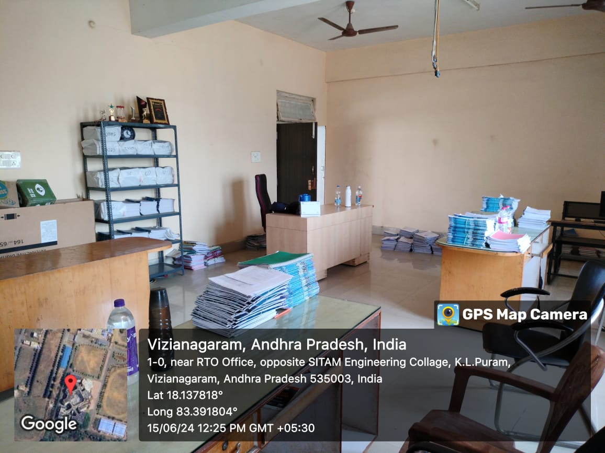  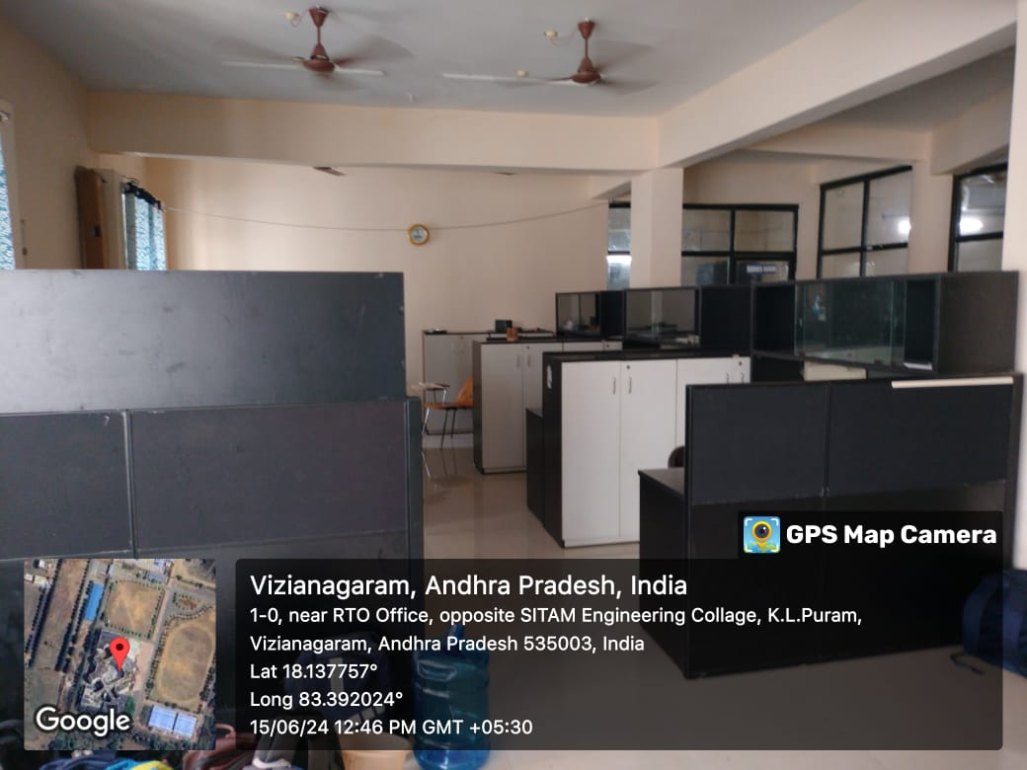

Class Room-I  D 301 | 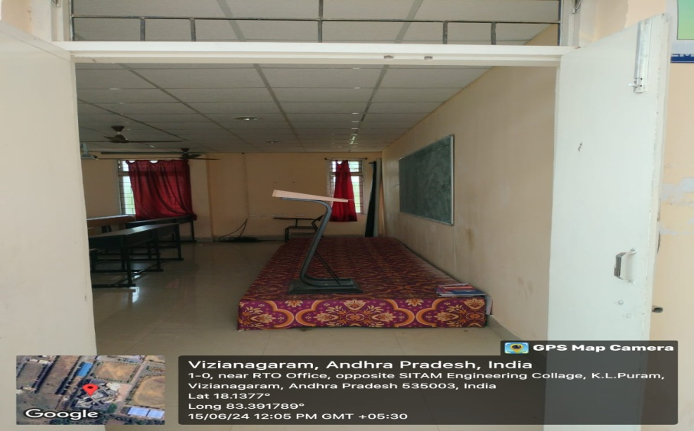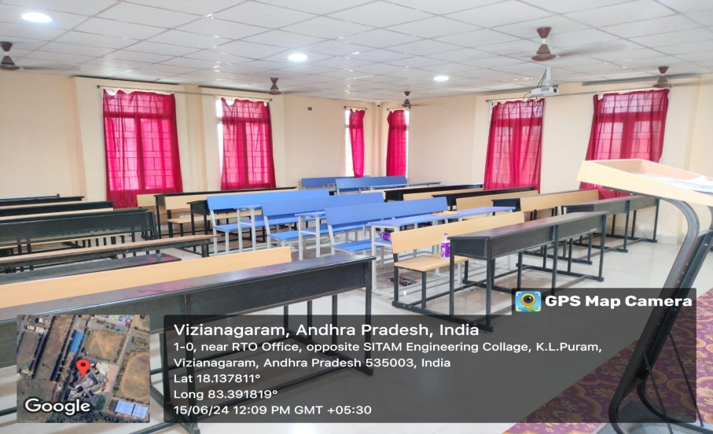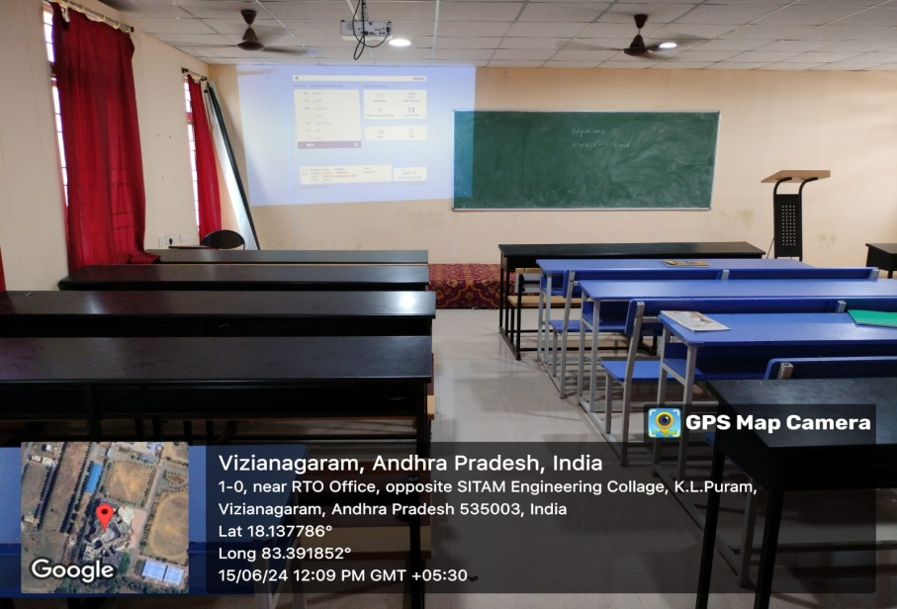

Class Room-II  D 302  Class Room-III  D 303 | 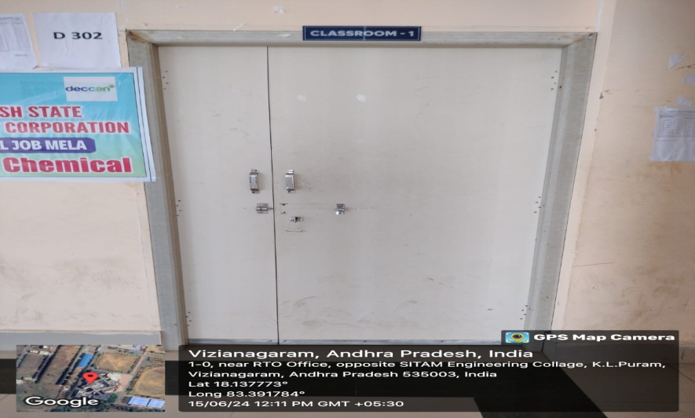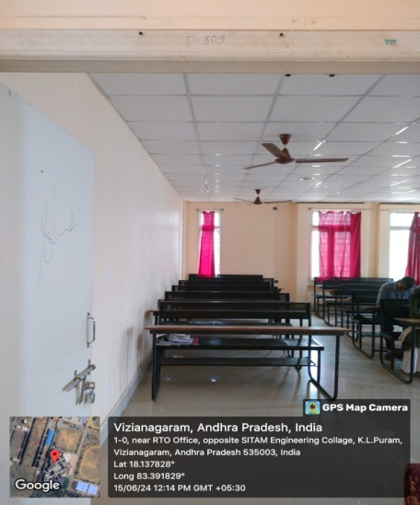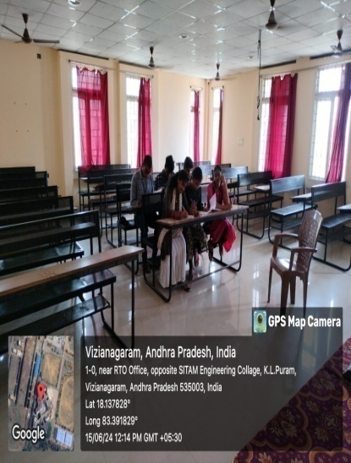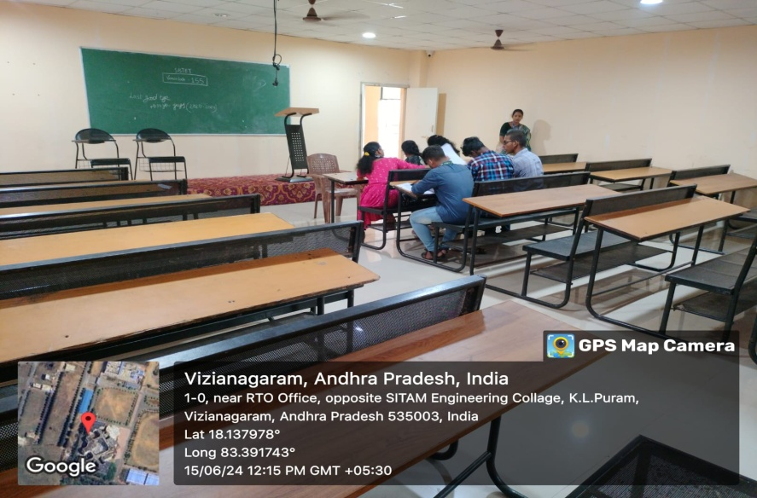

Class Room-IV  D 305 | 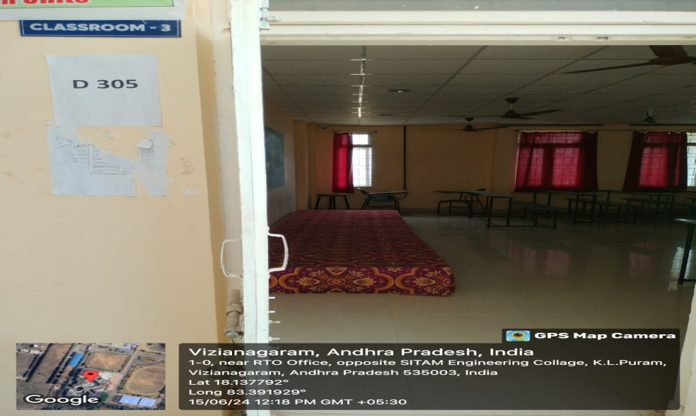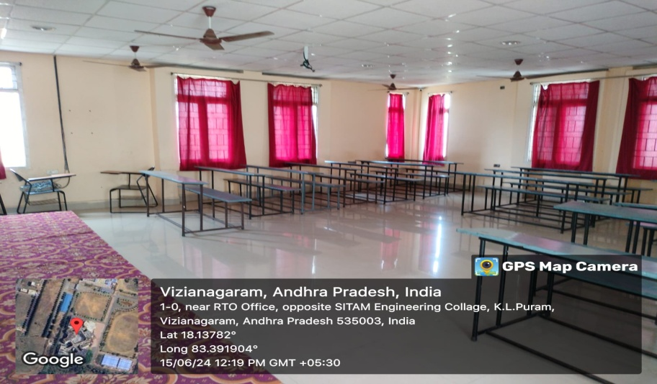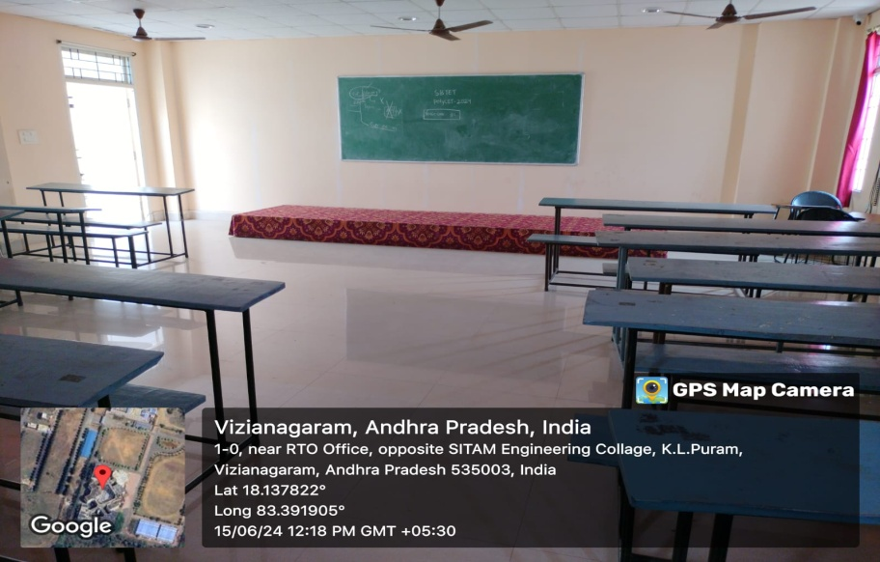

Staff room  F 301 | 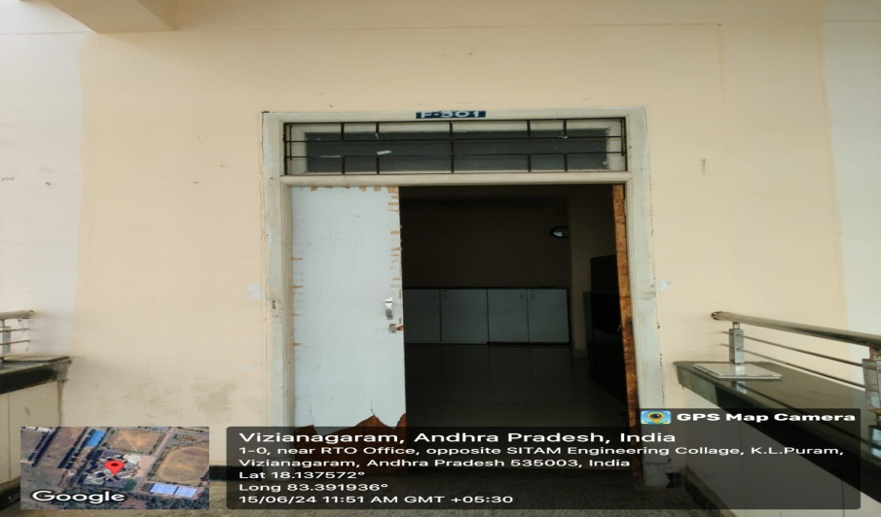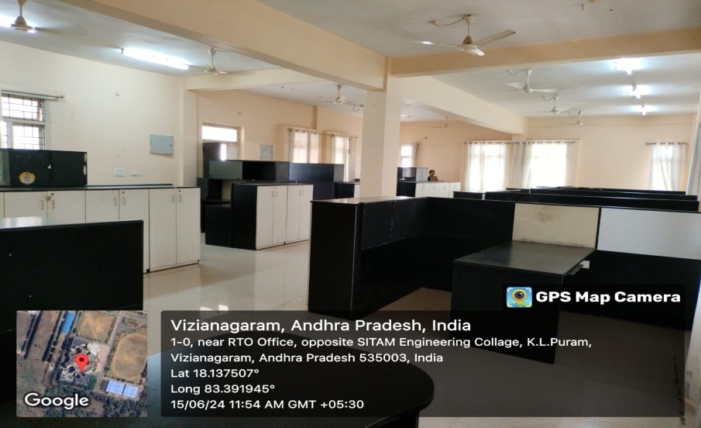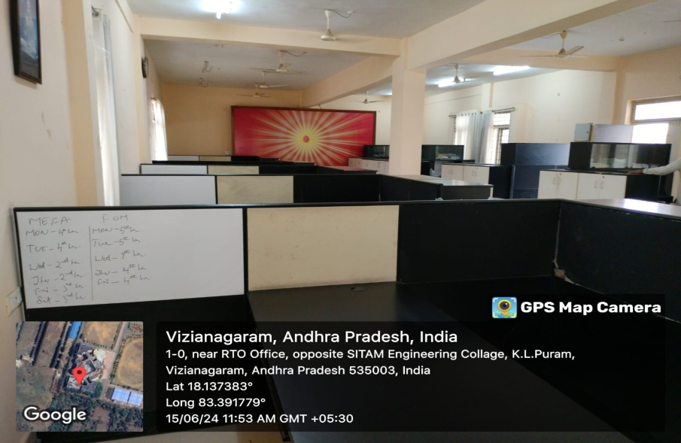

Computer Center | 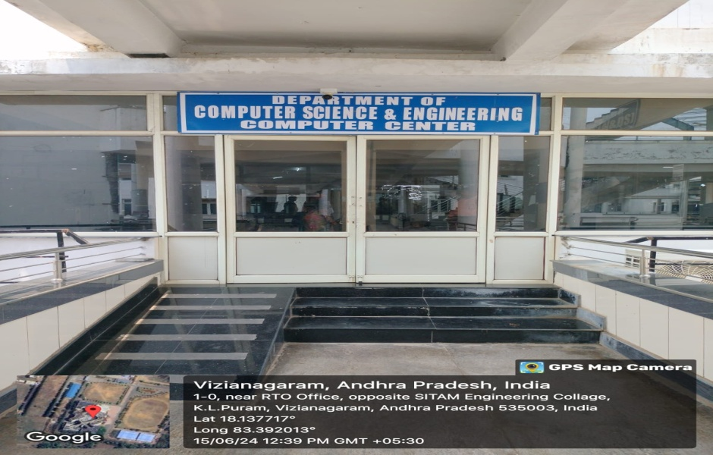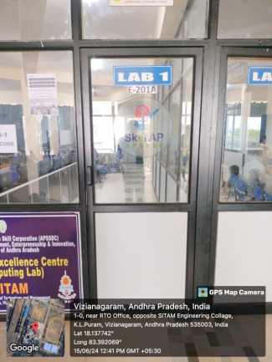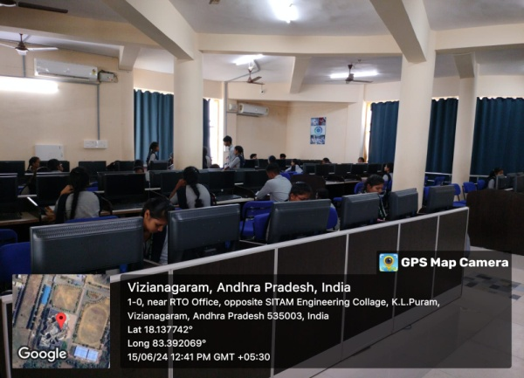  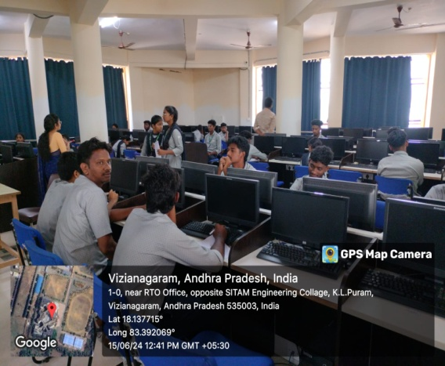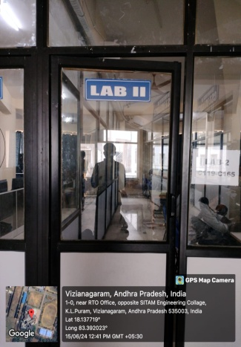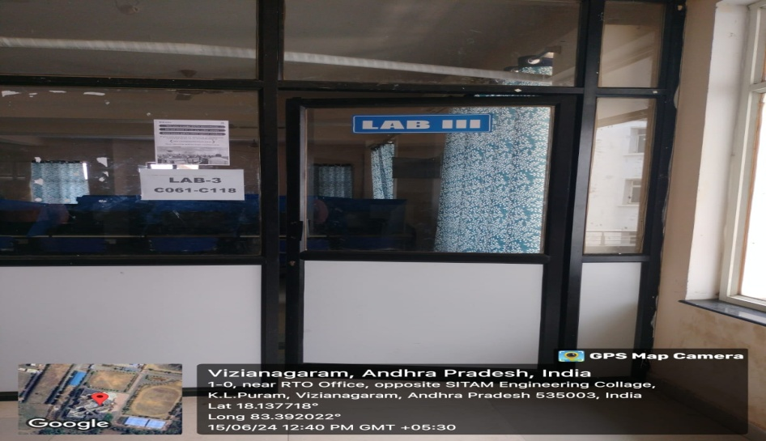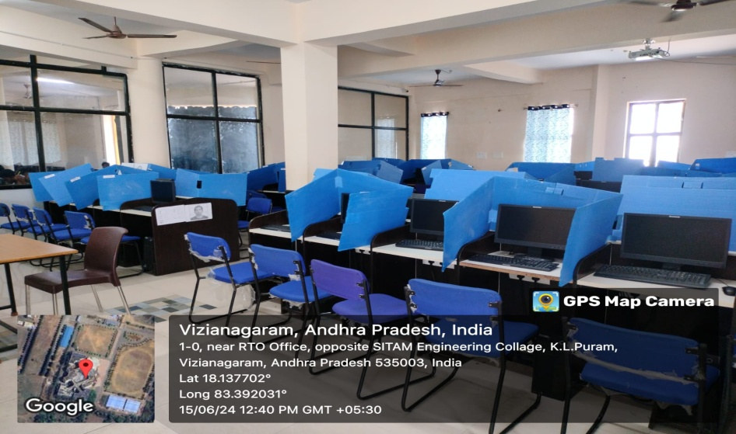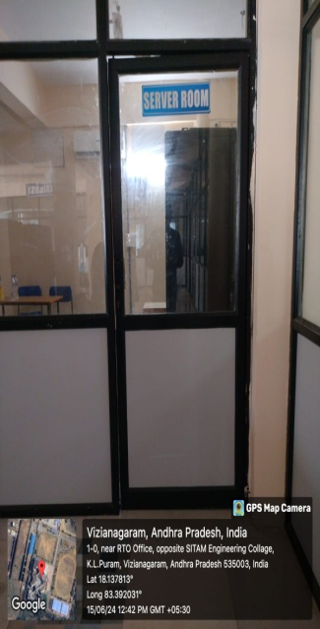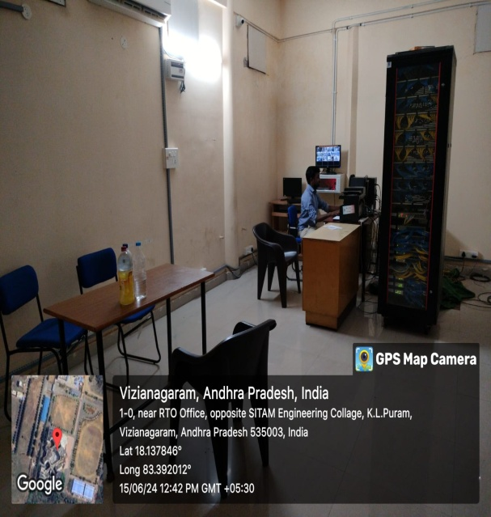

Department of Management Studies

Sr. No | Name of the class room/ Lab No | Class Room/ Lab No | Size as per AICTE  Norms | Carpet Area (Sq.mtr)
1. | Class Room-I | B 402 | 66 | 67.00
2. | Class Room-II | B 403 | 66 | 72.83
3. | Class Room-III | B 405 | 66 | 72.83
4. | HOD Cabin | B 404 | 10 | 48.30
5. | Staff room | B 401 | 5 sq.m per room | 67.63

Geotagged Photos Department of Management Studies
Class Room-I  B 402  Class Room-II  B 403  Class Room-III  B 405 | 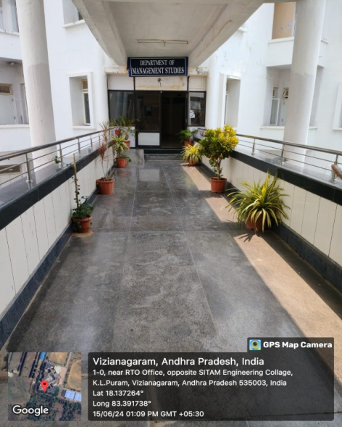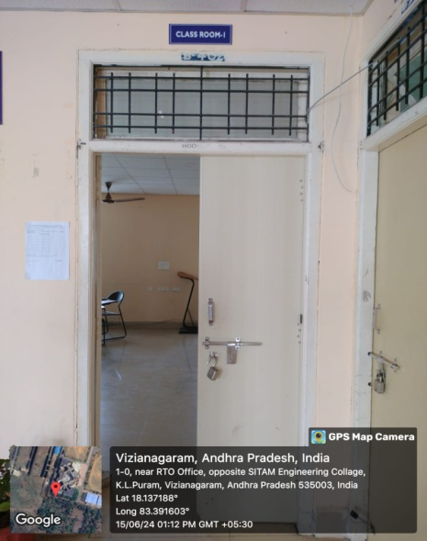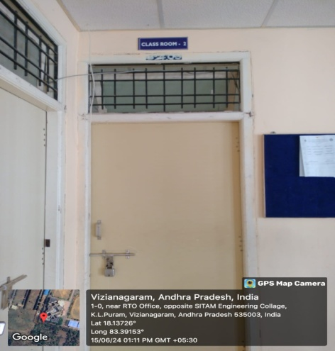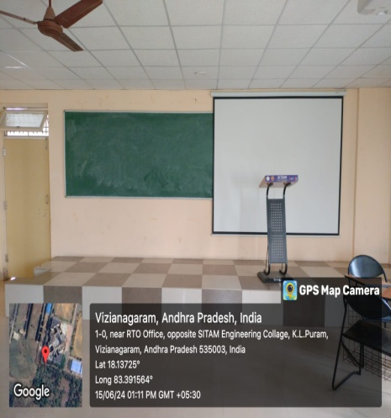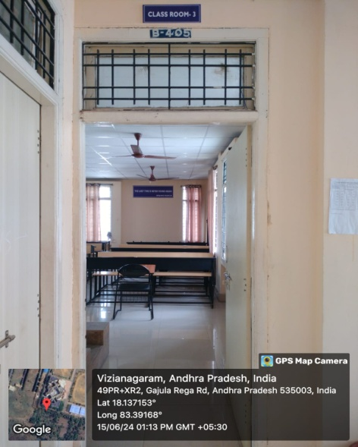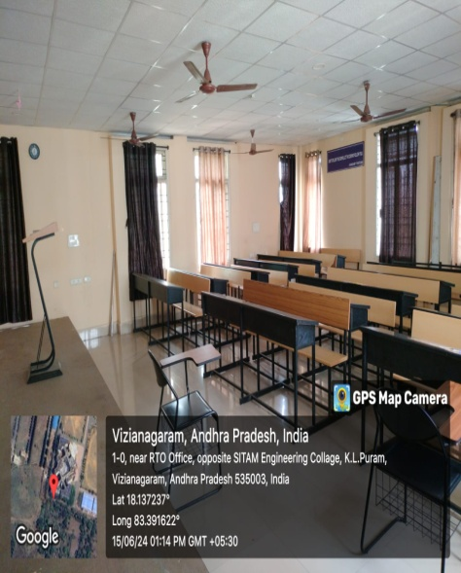

HOD Cabin  B 404 | 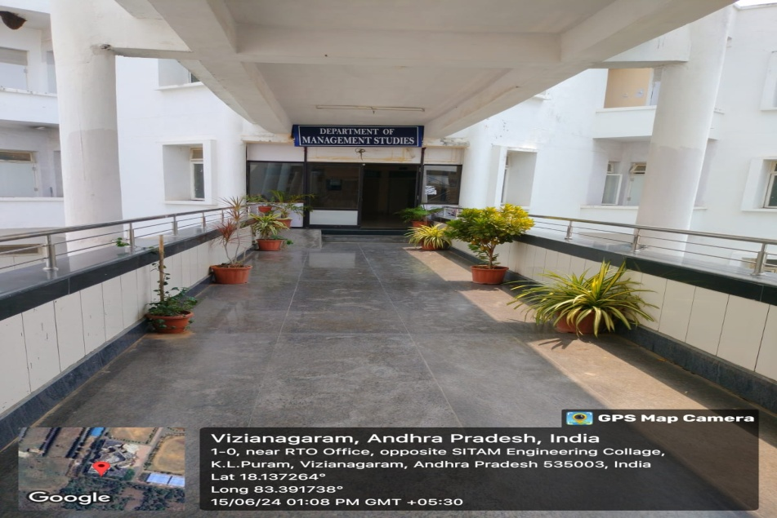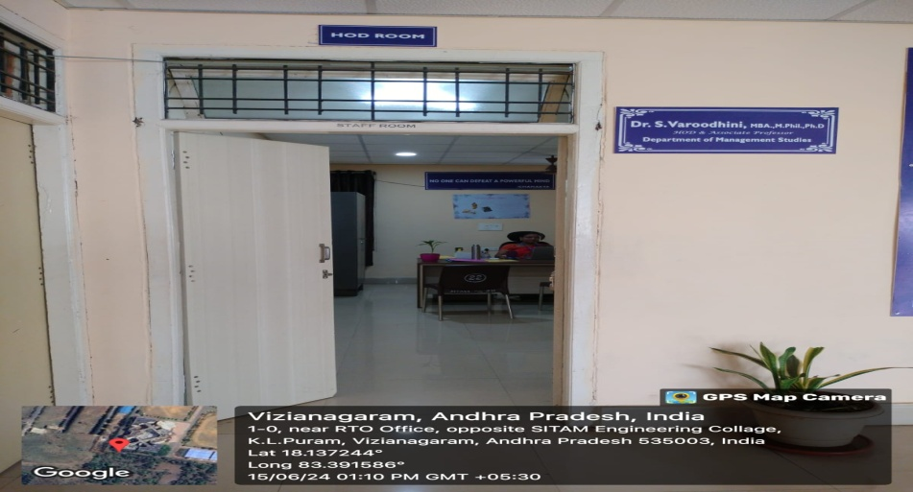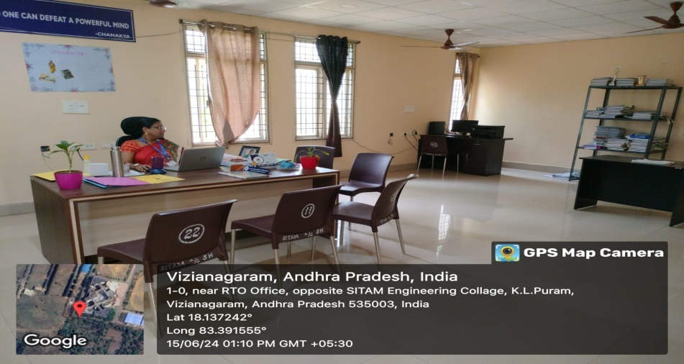

Staff room  B 401 | 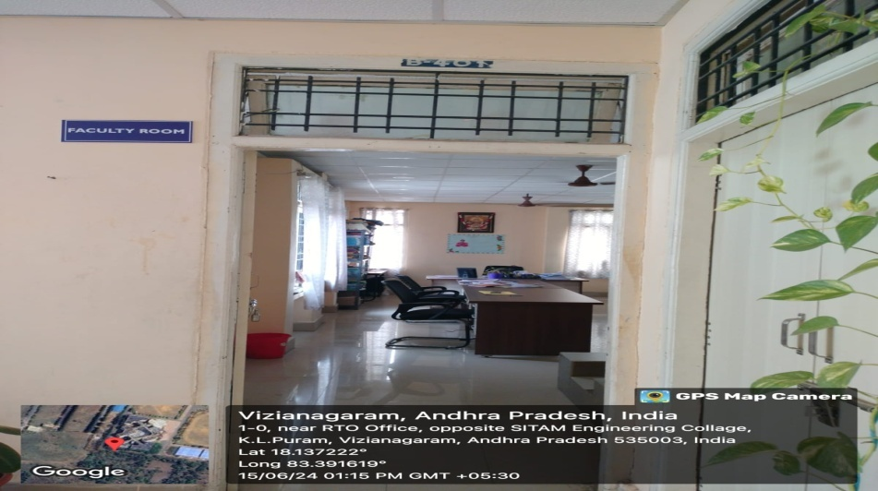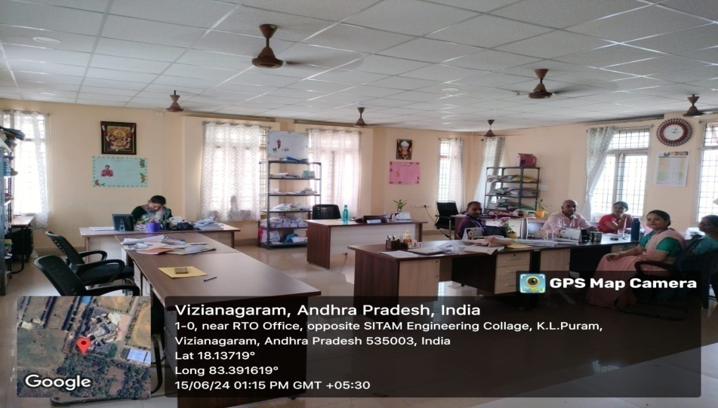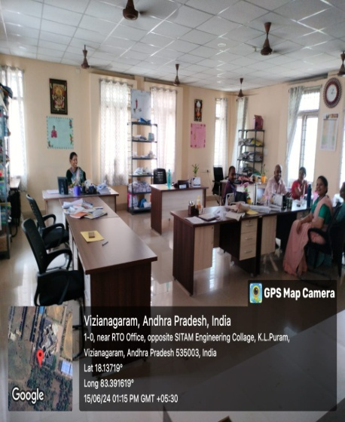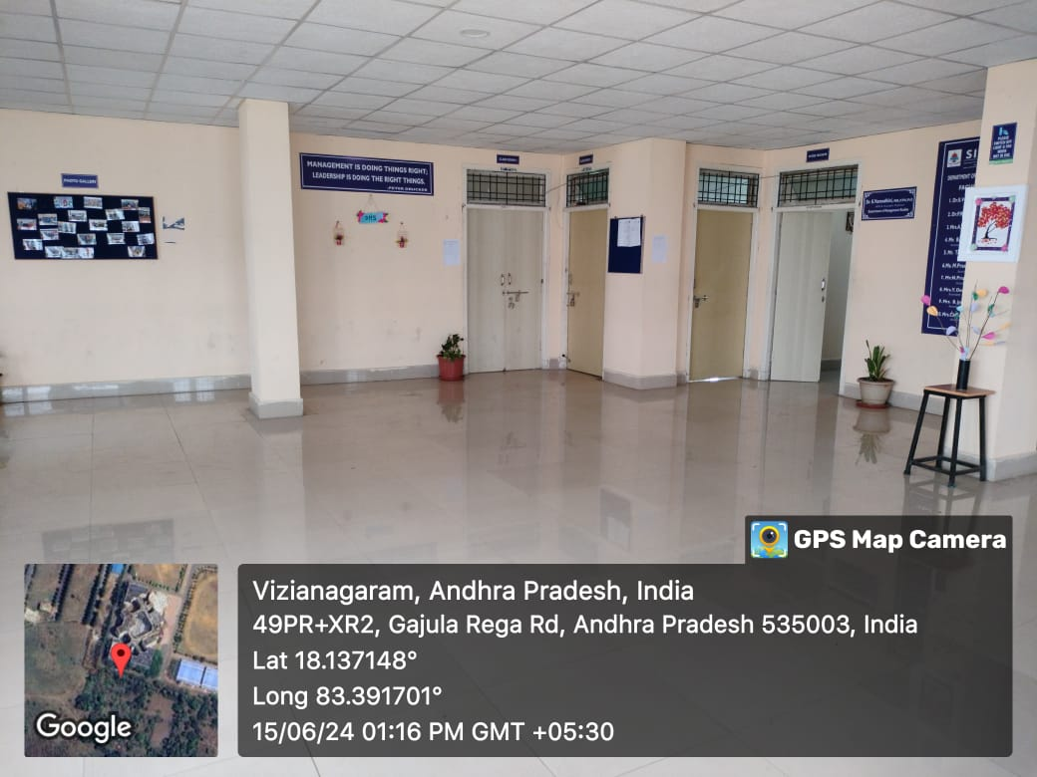

Department of Humanities and Basic Science
Sr. No | Name of the class room/ Lab No | Class Room/ Lab No | Size as per AICTE  Norms | Carpet Area (Sq.mtr)
1. | Class Room-I | A 301 | 66 | 72.83
2. | Class Room-II | A 302 | 66 | 67.63
3. | Class Room-III | A 303 | 66 | 72.83
4. | Class Room-IV | A 305 | 66 | 83.61
5. | Class Room-V | B 303 | 66 | 78.03
6. | Class Room-VI | B 305 | 66 | 78.03
7. | HOD Cabin | B 404 | 10 | 57.97
8. | Staff room | A 304 | 5 sq.m per room | 62.43
9. | Physics Lab & Dark Room | E101E  &  E101C | 66 | 107.56
10. | Chemistry Lab | E101D | 66 | 114.45
11. | Communications Skills Lab | F 402 | 66 | 145.67

Class Room-I  A 301  Class Room-II  A 302  Class Room-III  A 303 | 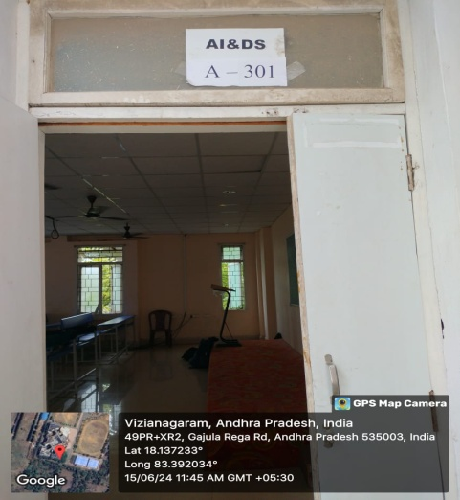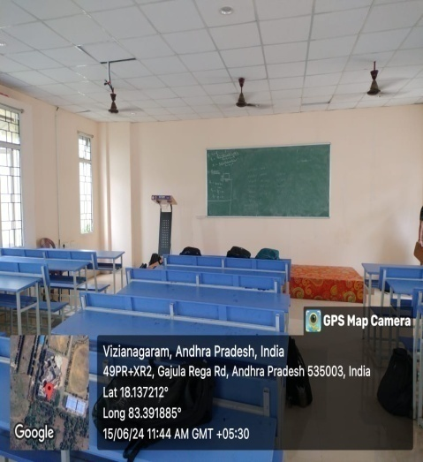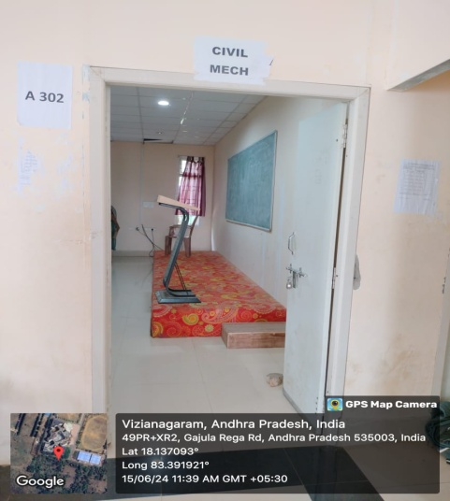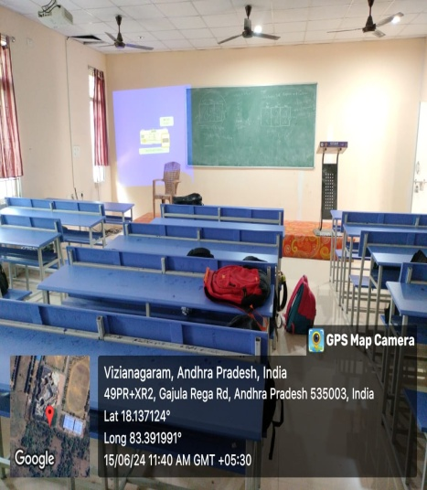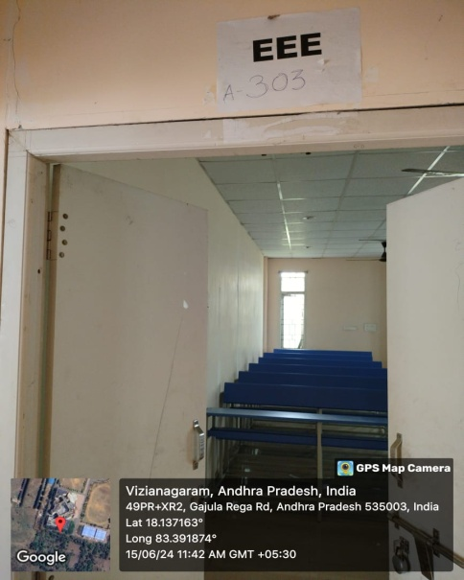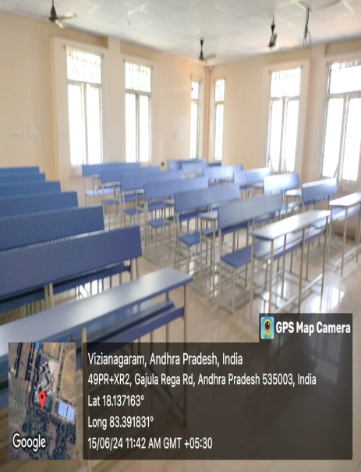

Class Room-IV  A 305 | 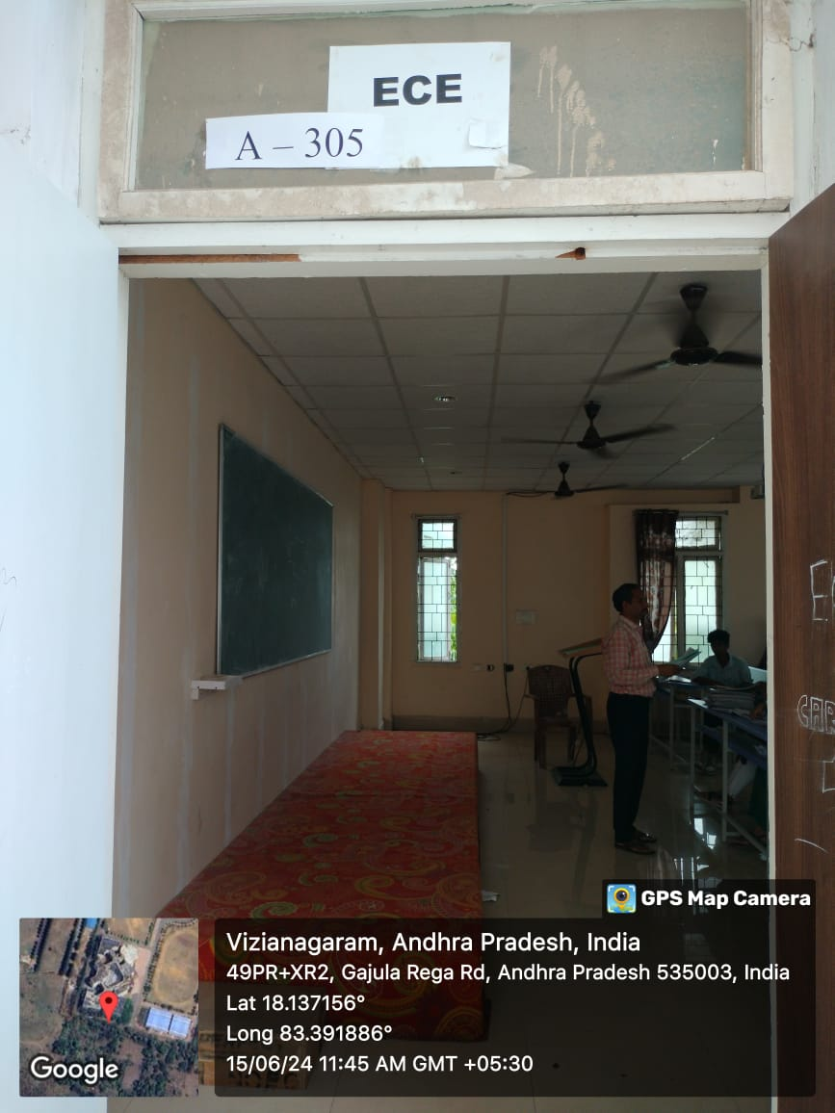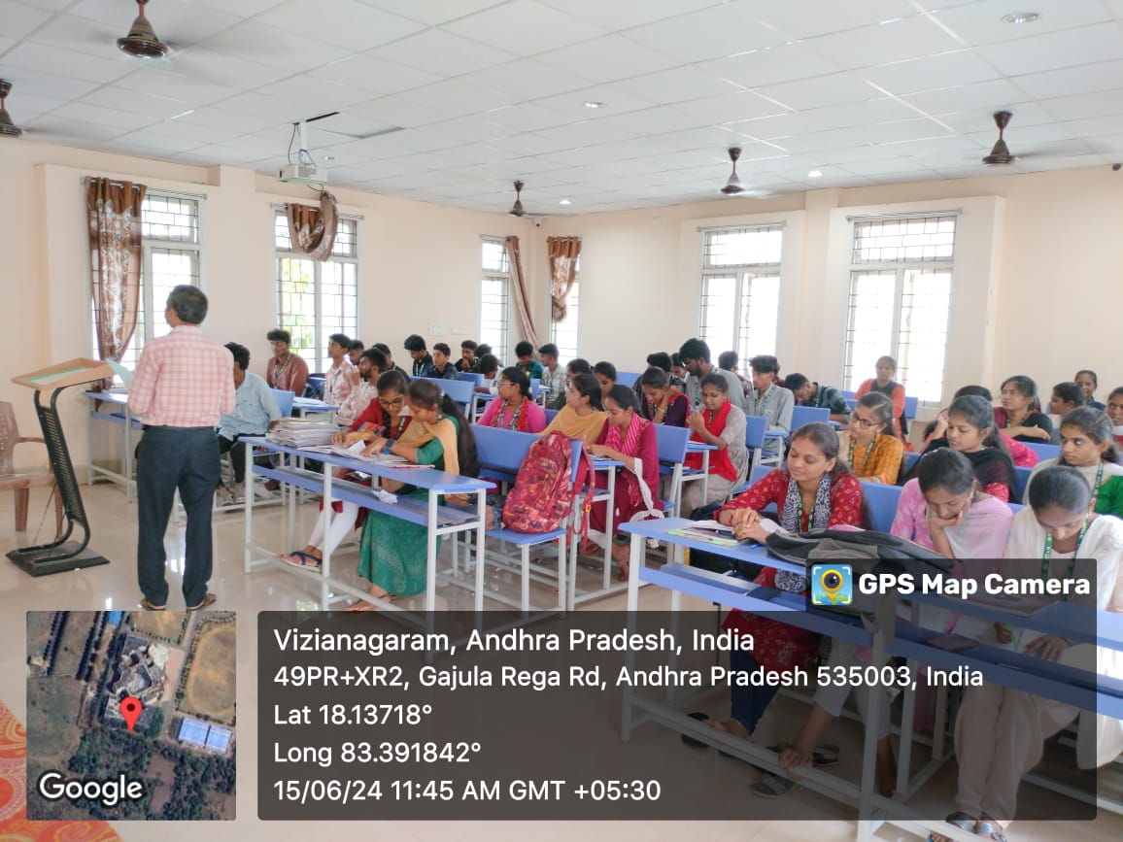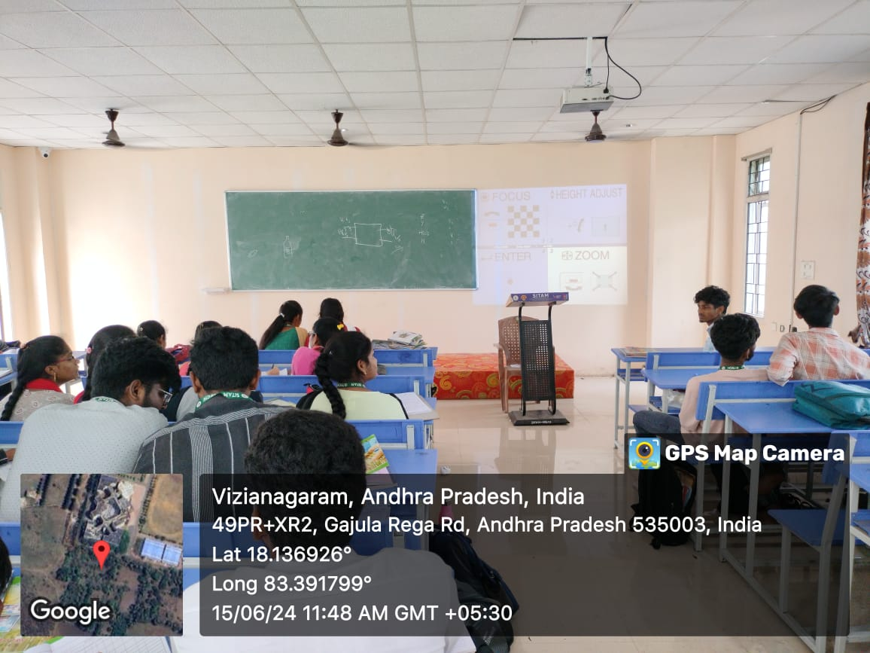

HOD Cabin  B 404 | 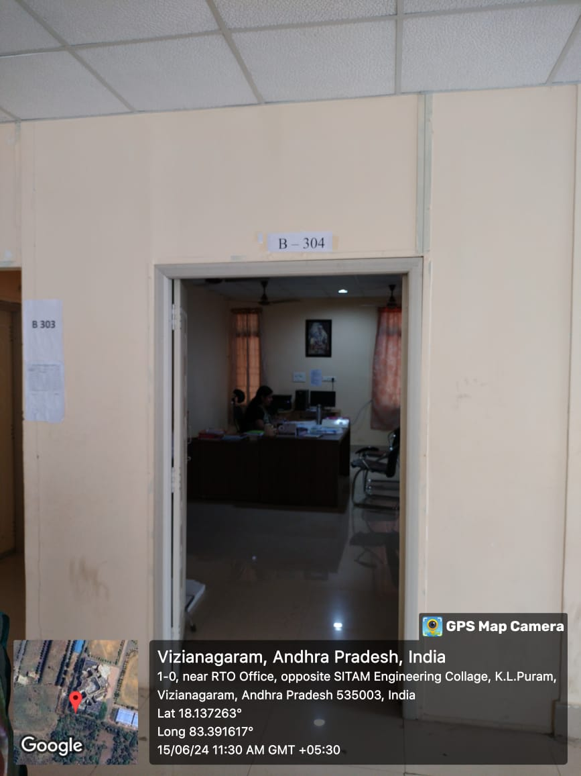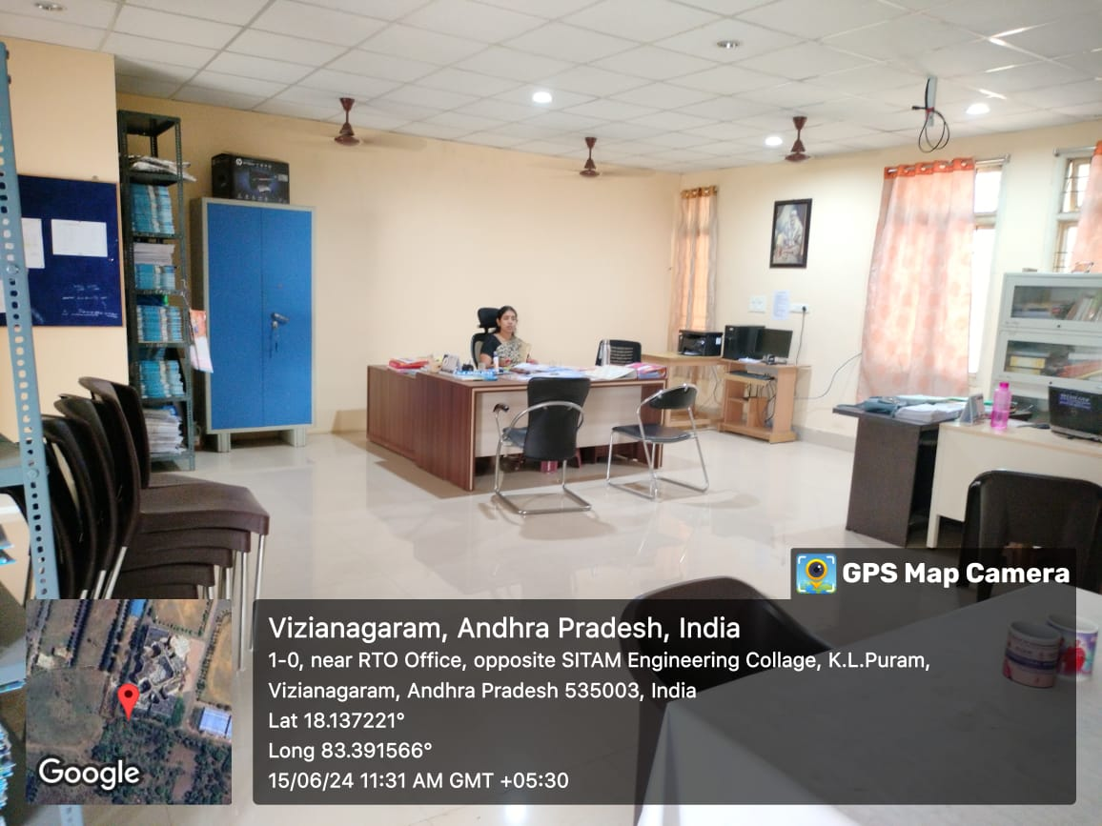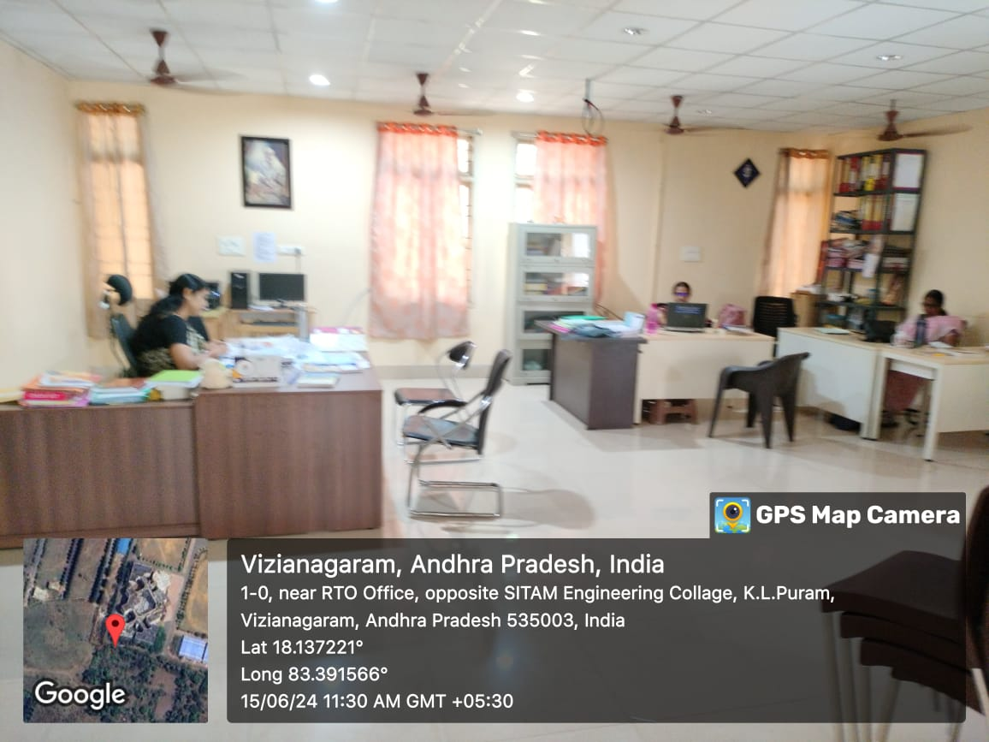

Staff room  A 304 | 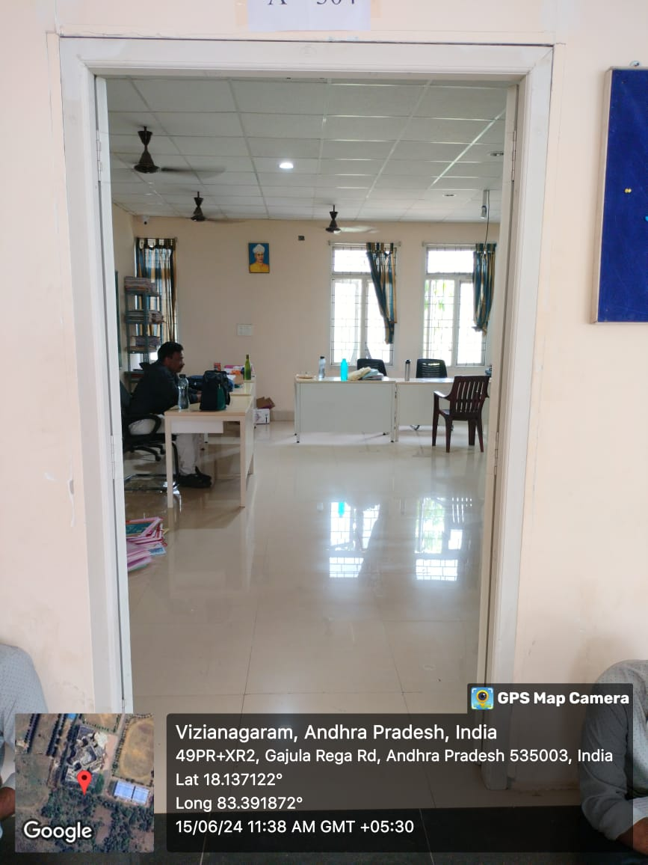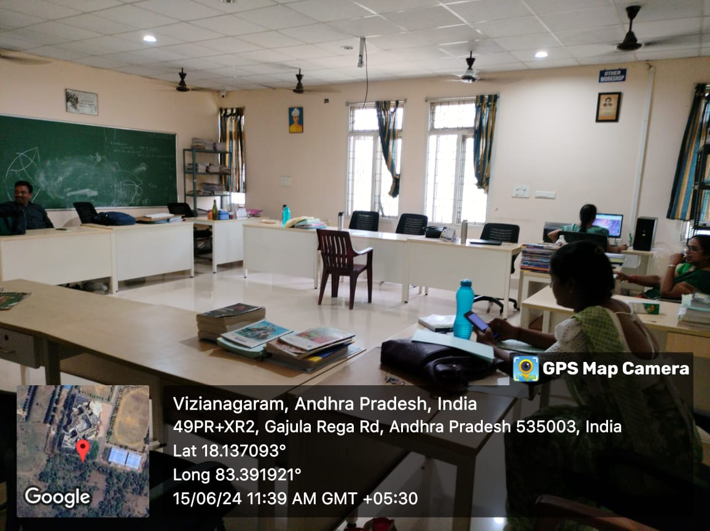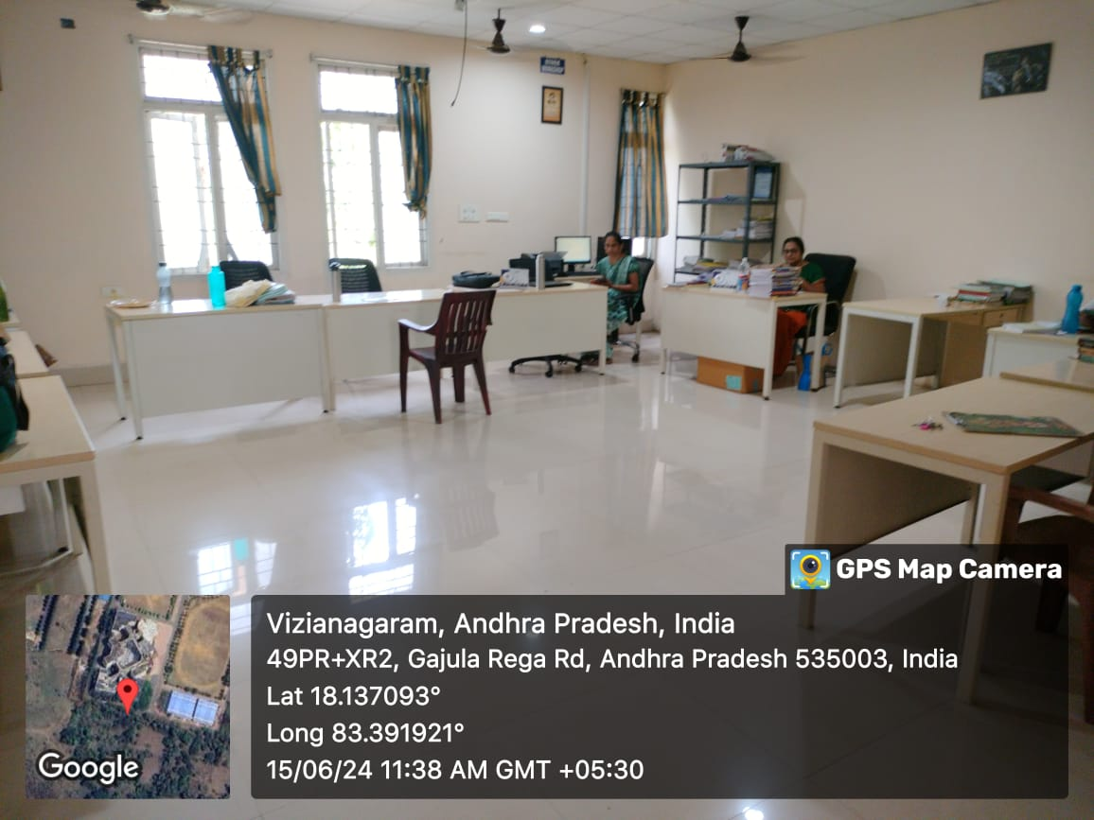

Physics Lab & Dark Room  E101E  &  E101C  Chemistry Lab  E101D | 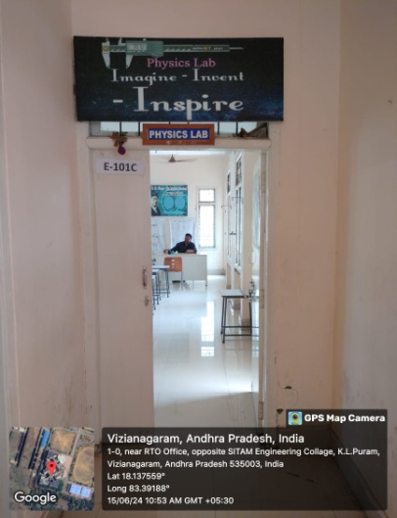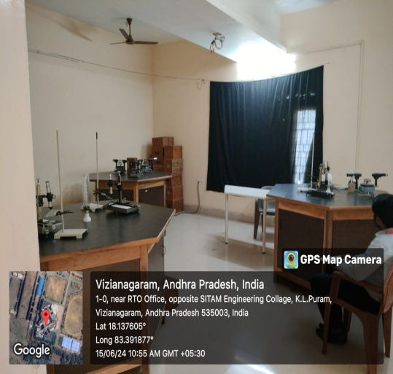  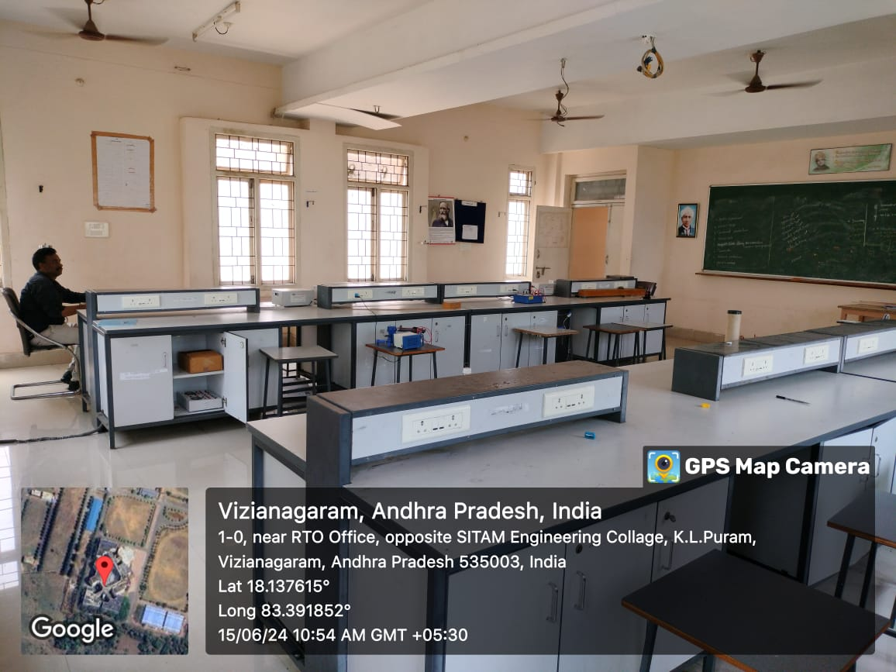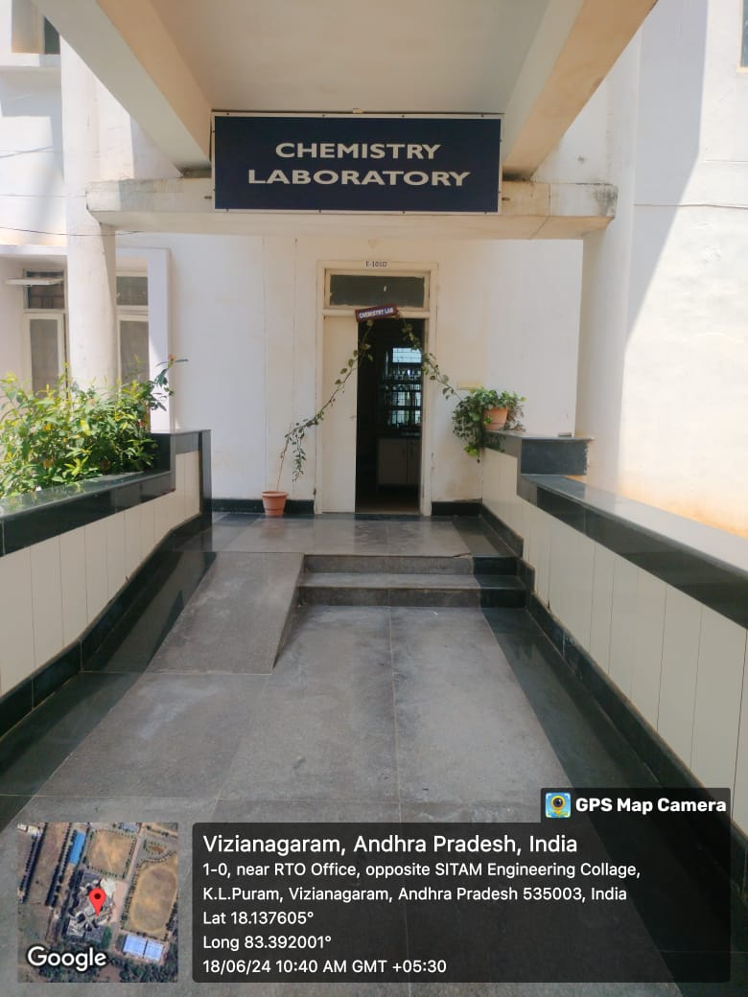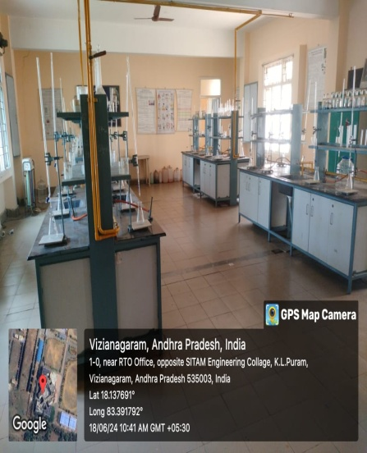

Communications Skills Lab  F 402 | 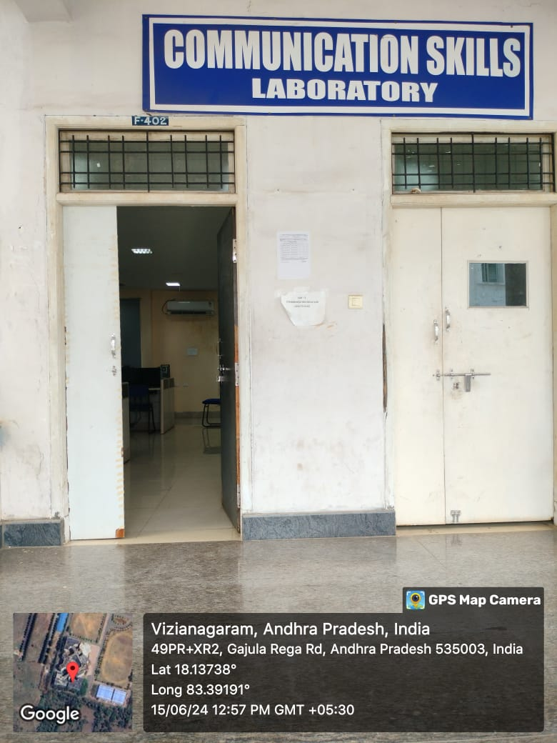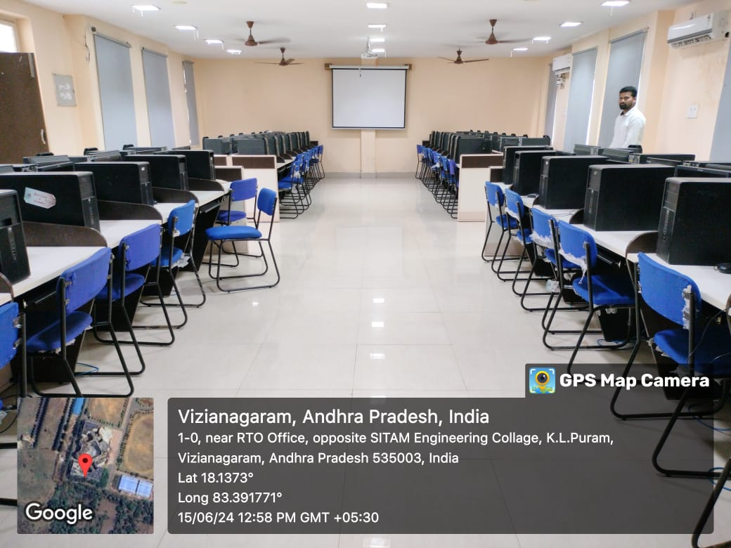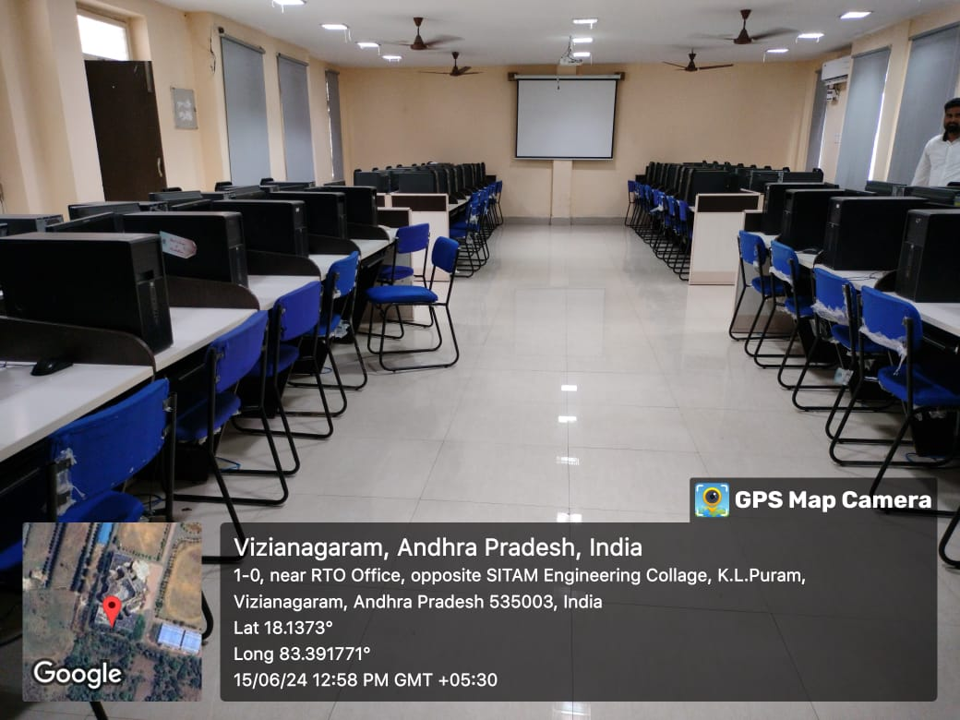

Details of Administrative Area
Sr. No | Particulars | Available | AICTE  Requirement | Size as per AICTE  Norms (m²) | Average Carpet Area(m2)
1. | Principal Office | 01 | 01 | 30 | 31
2. | Board Room | 02 | 01 | 20 | 88.43
3. | Office Area | 01 | 01 | 300 | 300.00
4. | Director Office | 01 | - | - | 170.00
5. | Examination control office | 01 | 01 | 30 | 46.82
6. | Placement office | 01 | 01 | 30 | 31.21
7. | Central Store | 01 | 01 | 30 | 37
8. | Maintenance | 01 | 01 | 10 | 10
9. | Security | 01 | 01 | 10 | 10
10. | Housekeeping | 01 | 01 | 10 | 10

Principal Office | 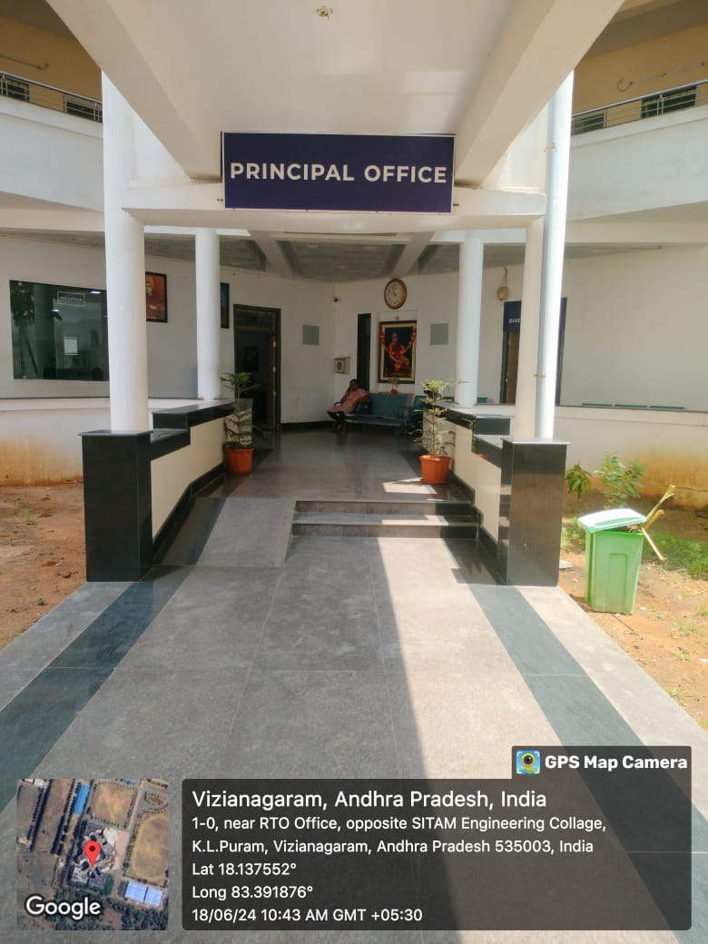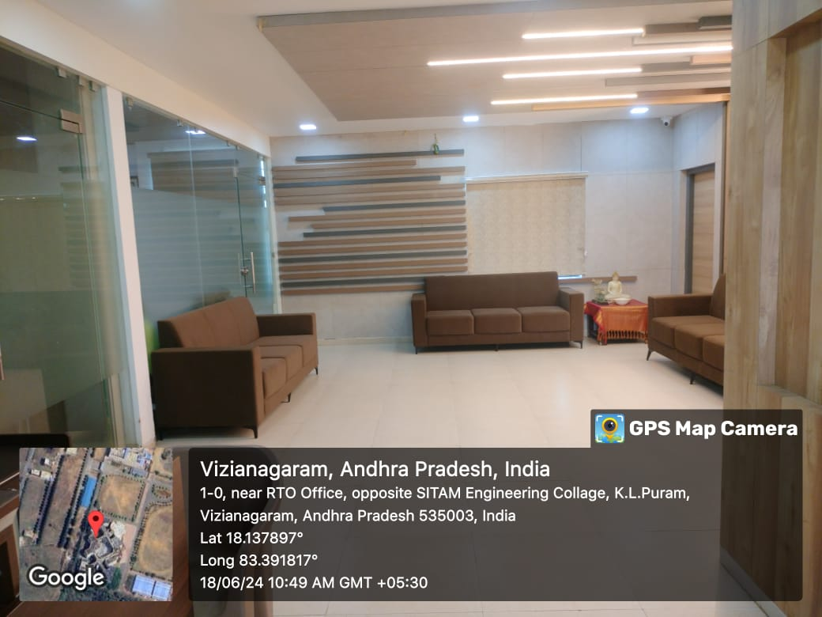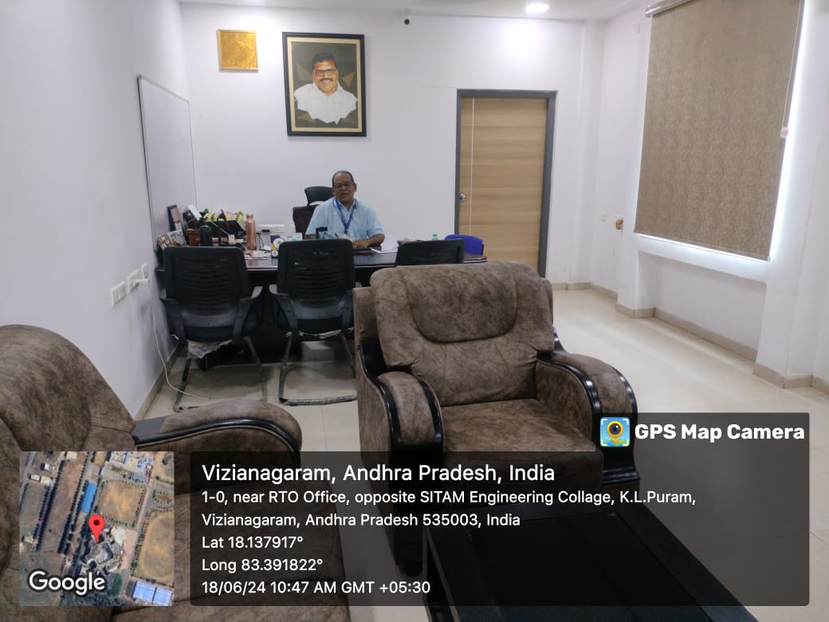

Board Room | 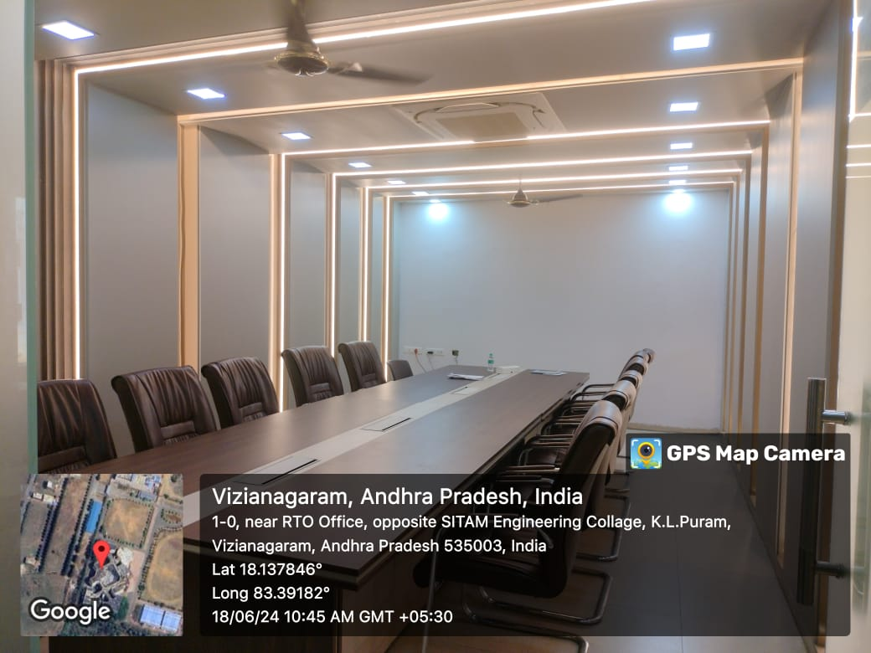  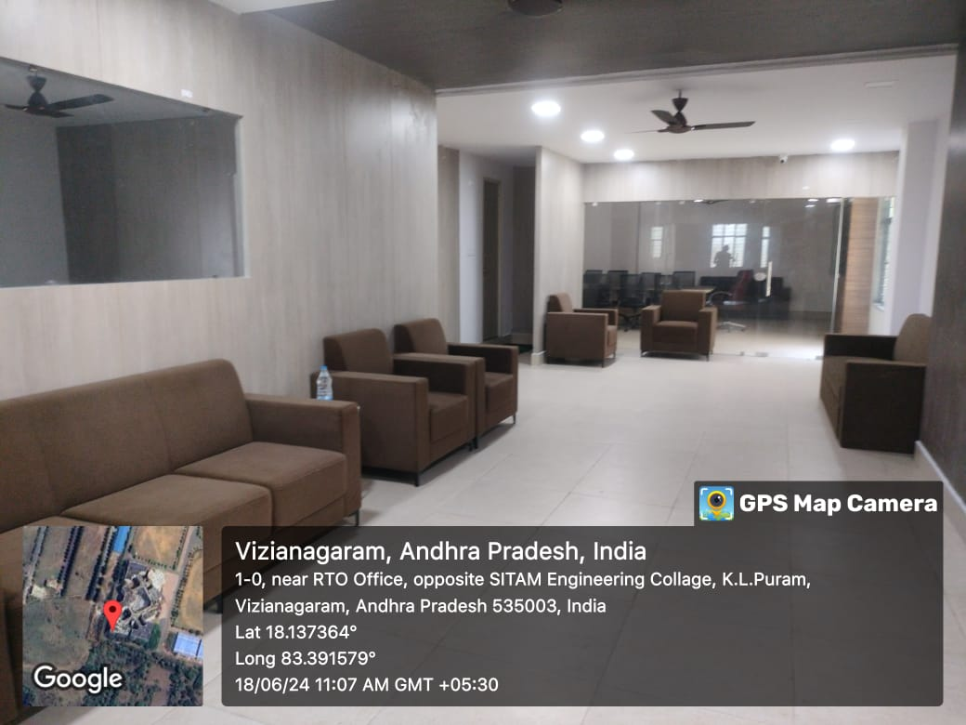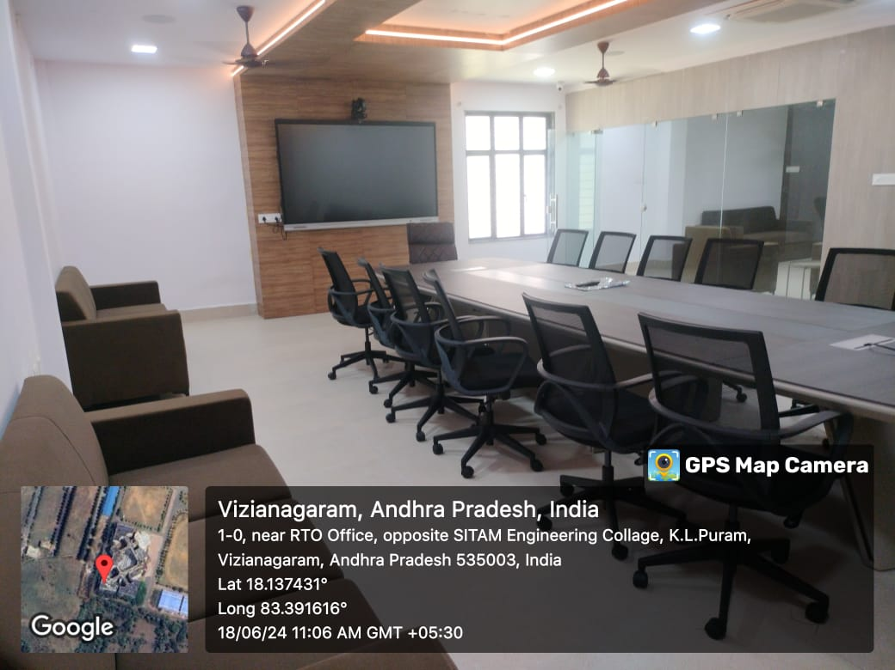

Office Area | 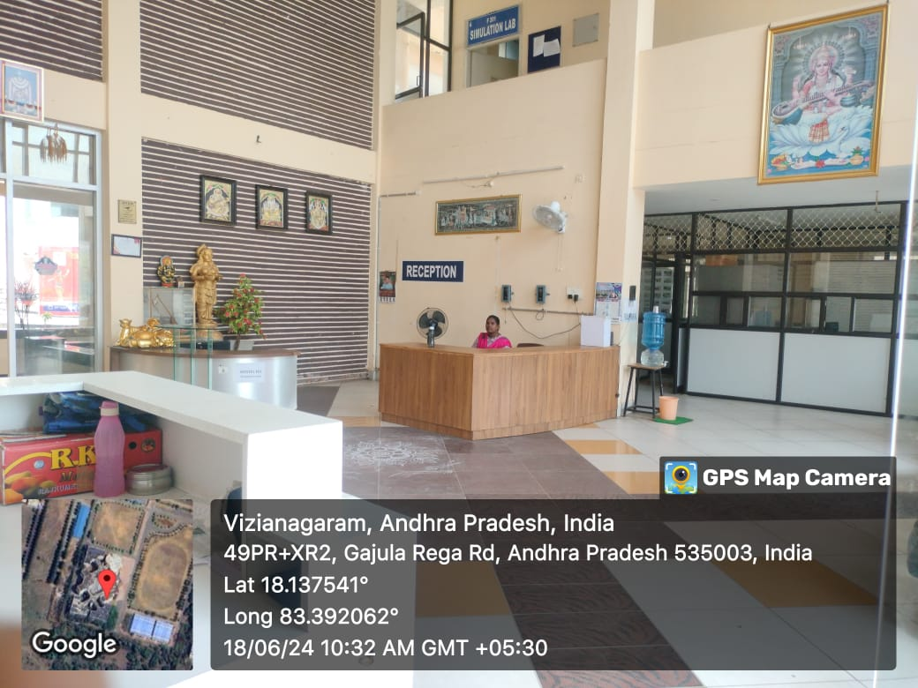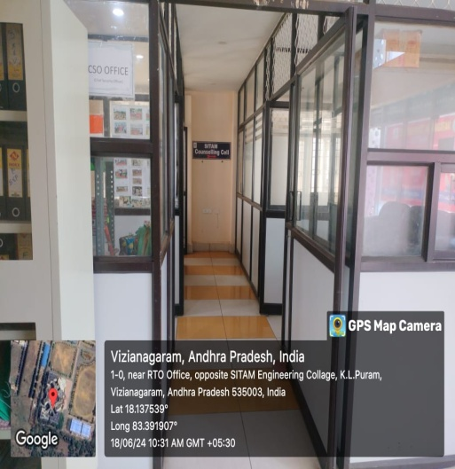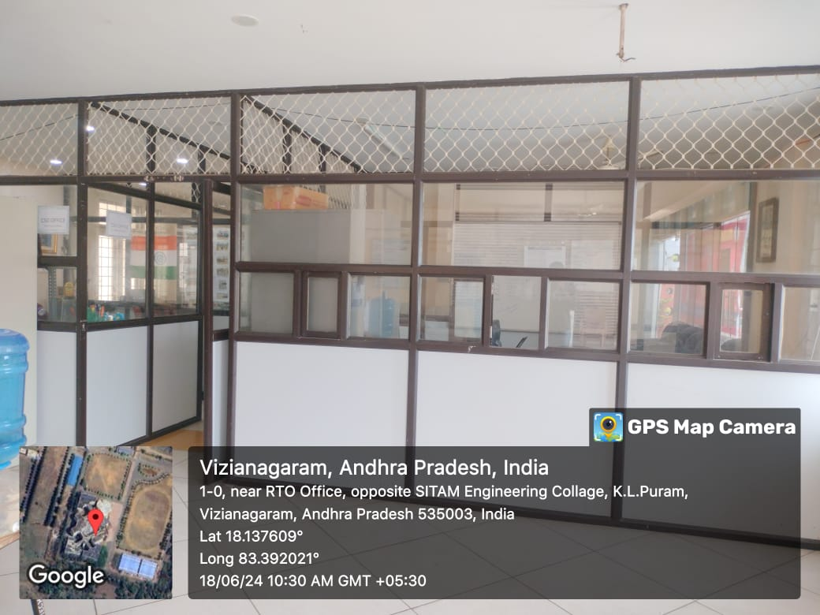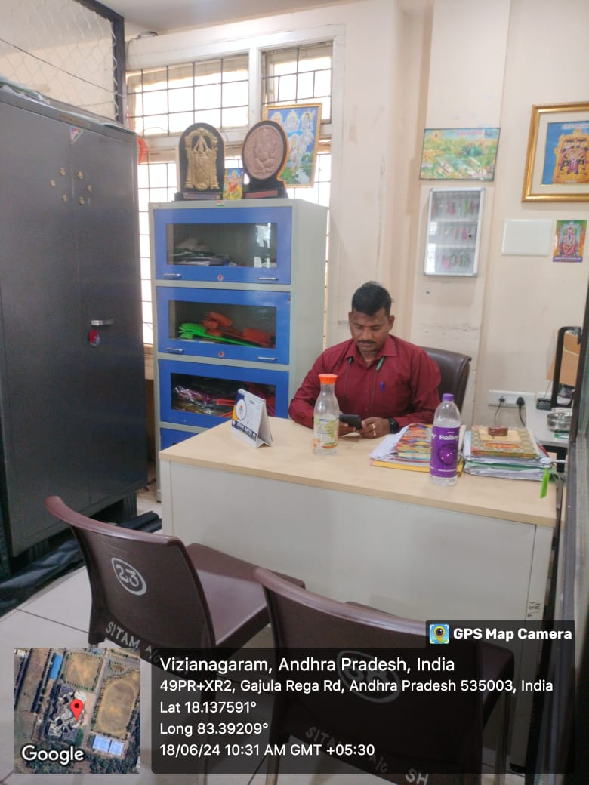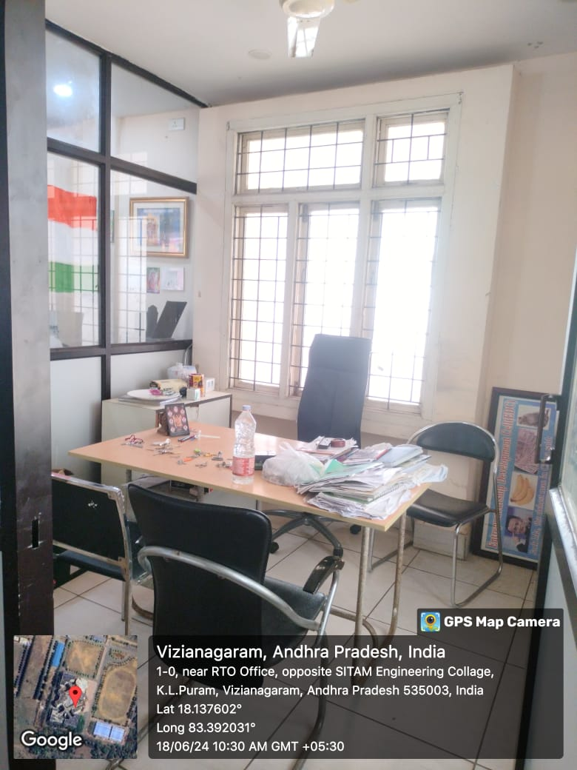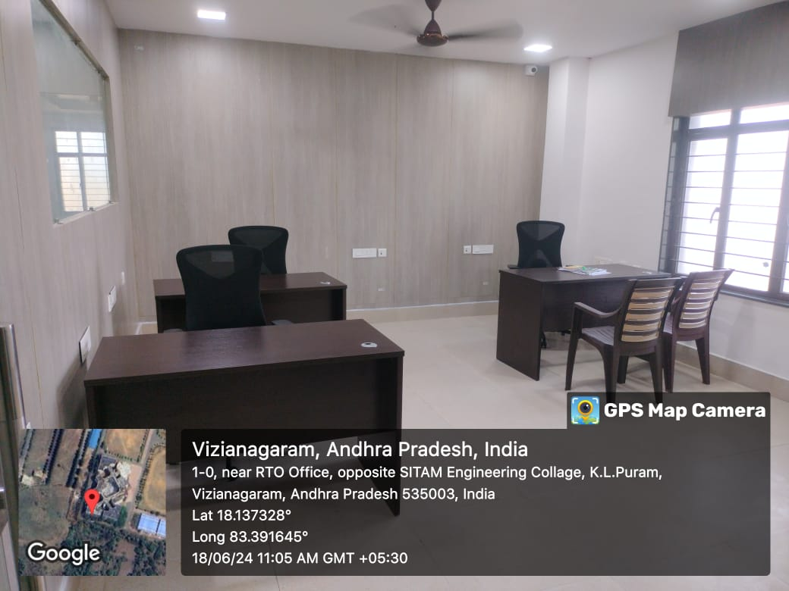  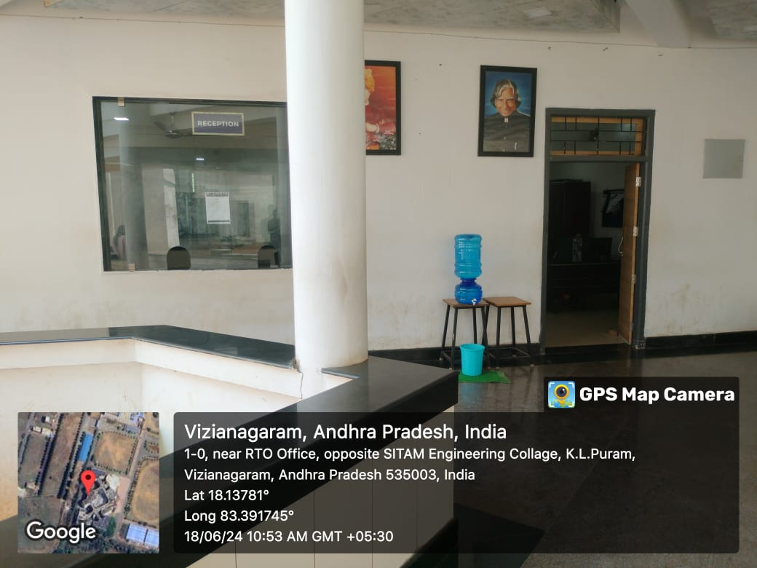  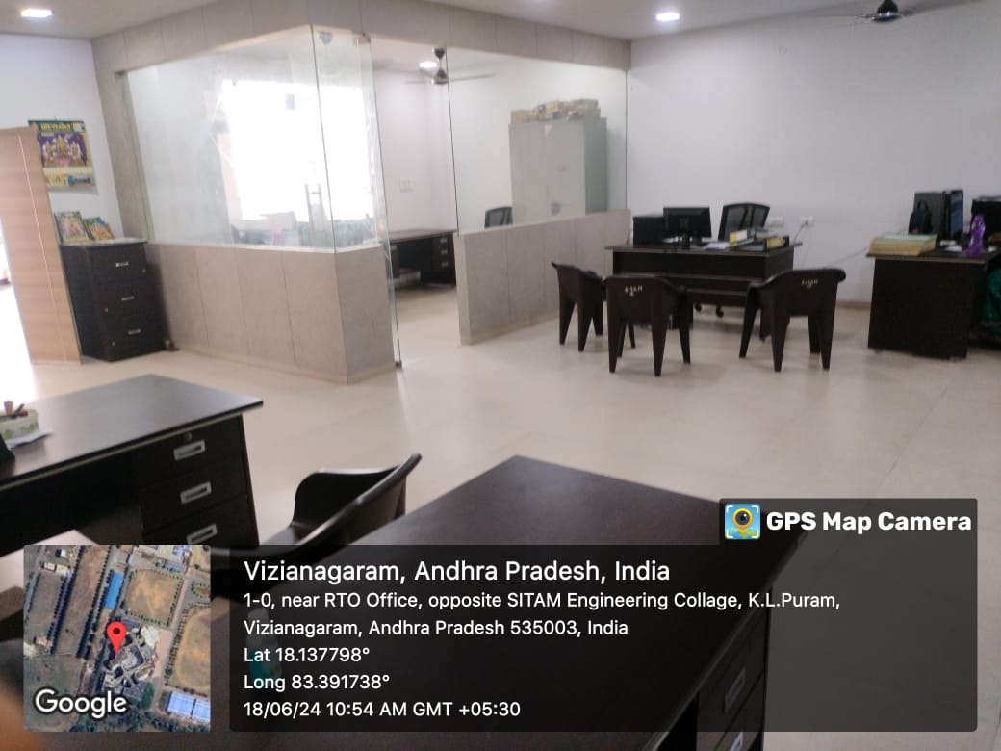  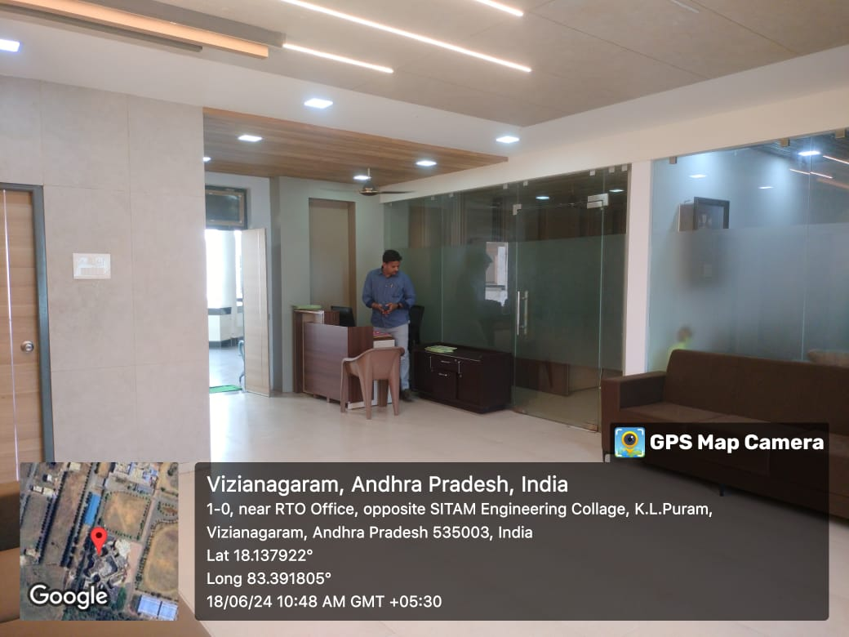

Director Office | 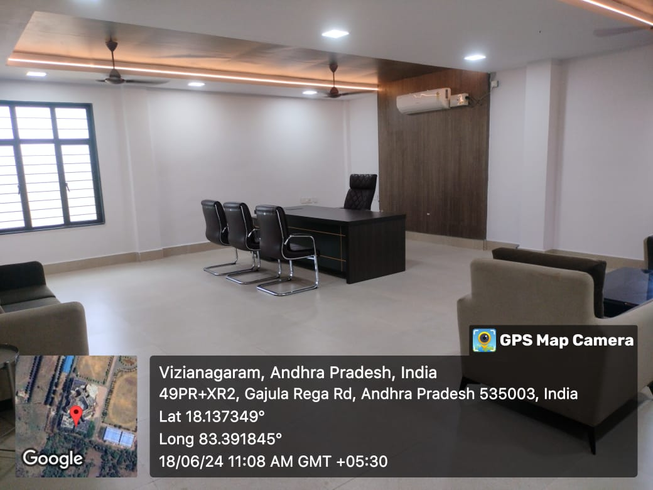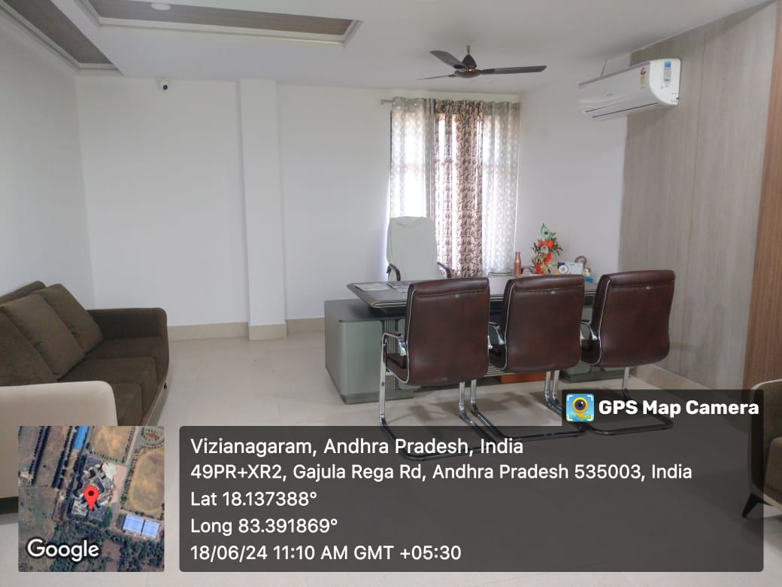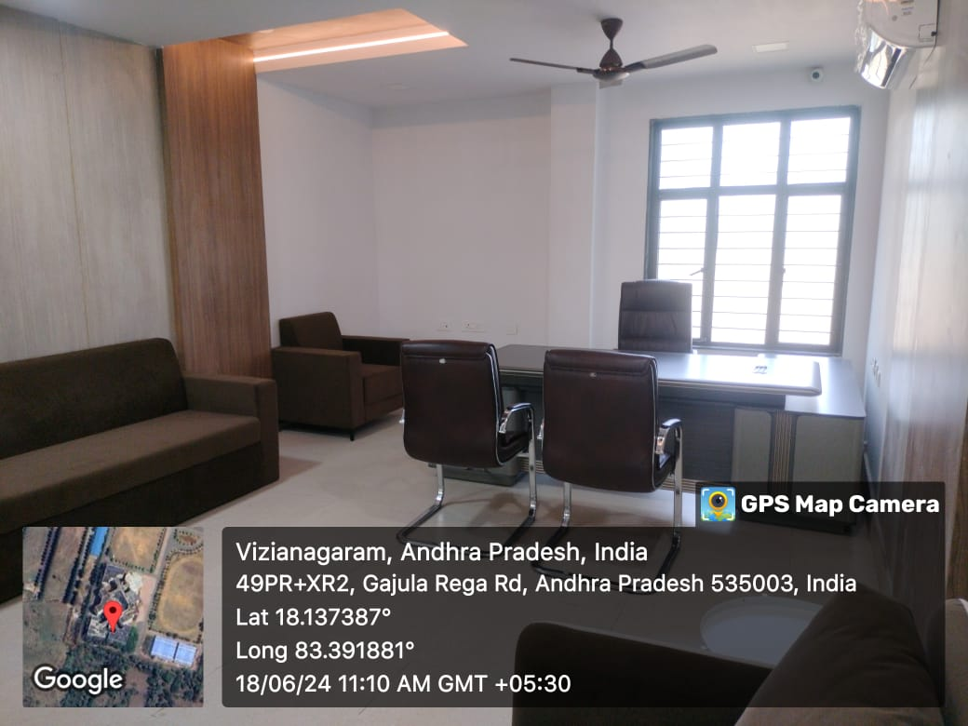

Examination control office | 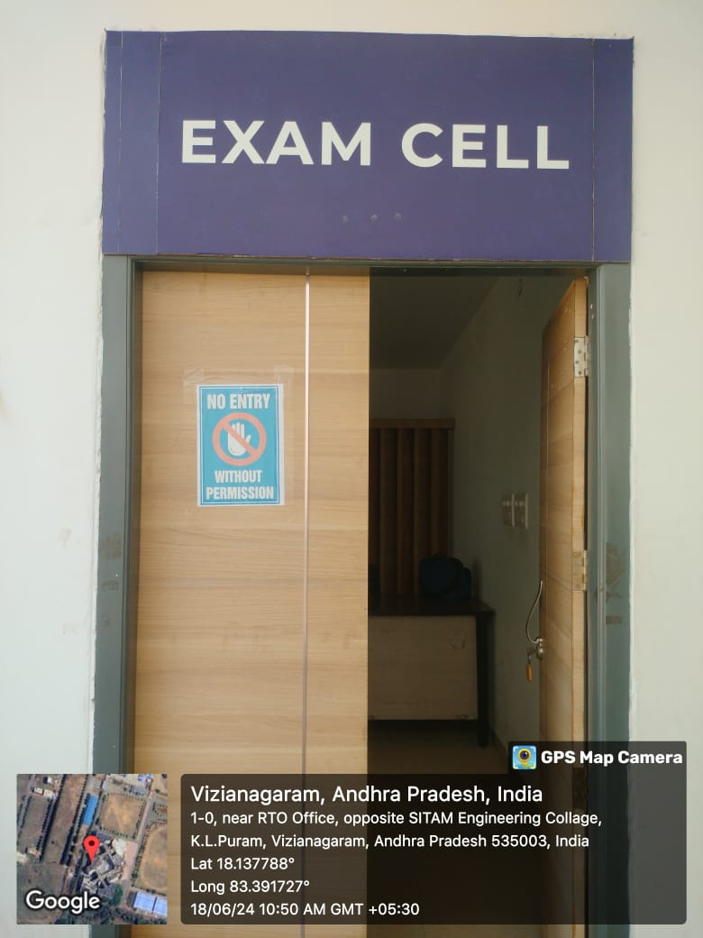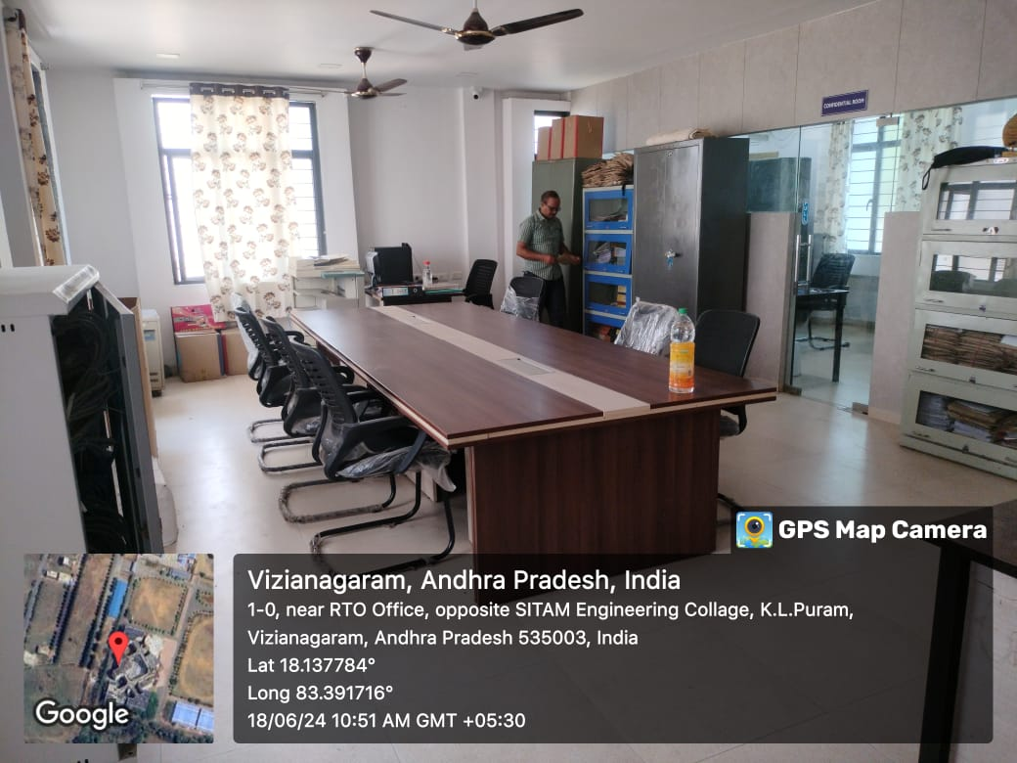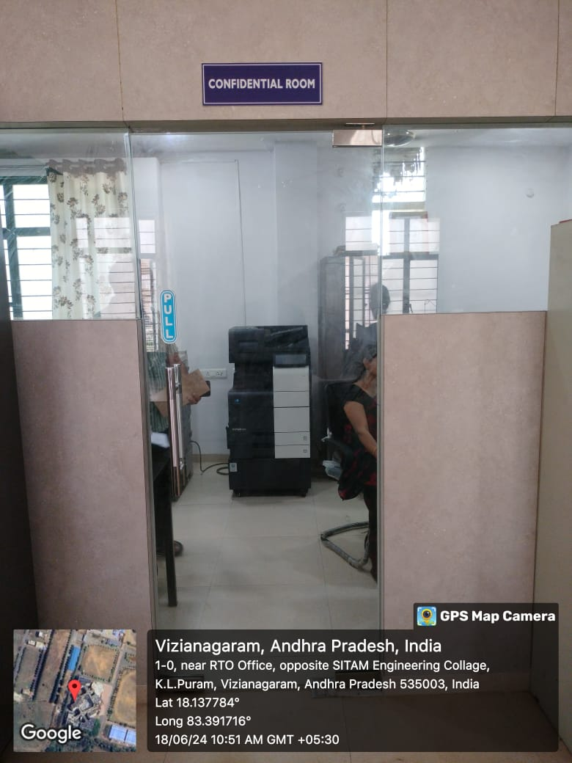

Placement office  &  Server Room | 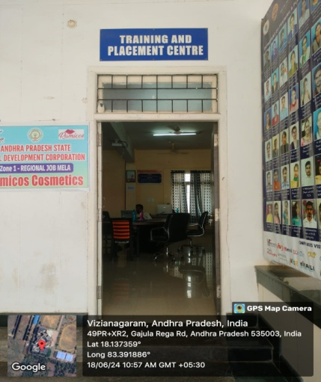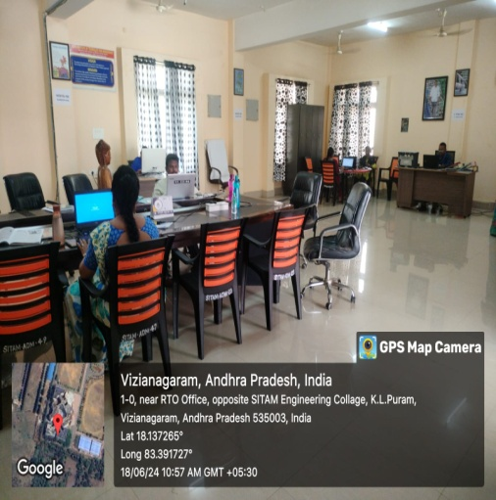  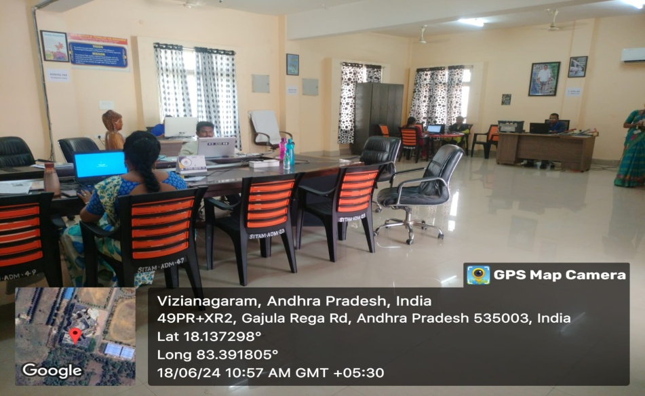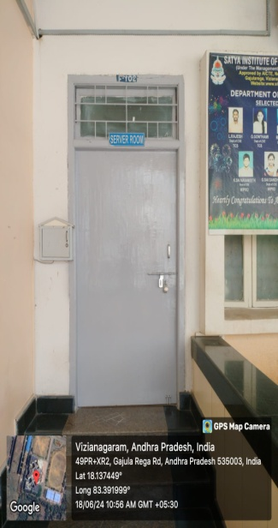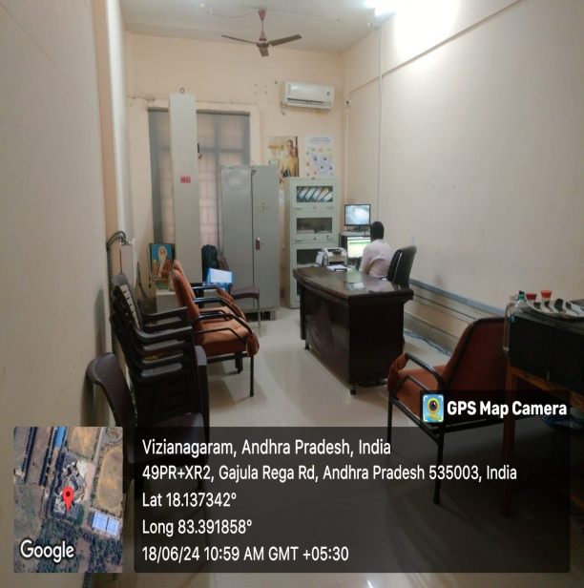

Details of Instructional Area
Sr. No | Particulars | Available | Size as per AICTE  Norms | Average Carpet Area(m²)
 | A/C Seminar(F 202) Hall | 01 | 132 | 140.46
 | Ranganadhan seminar Hall | 01 | 132 | 500.00
 | Chandrayan Seminar Hall | 01 | 132 | 234.11
 | Abdul Kalam Seminar Hall(C 101) | 01 | 132 | 150.00
 | Library & Reading  Room | 01 | 400 | 500
 | Digital Library | 01 | 400 | 500
 | Open Auditorium | 01 | - | 418

A/C Seminar Hall (F 202) | 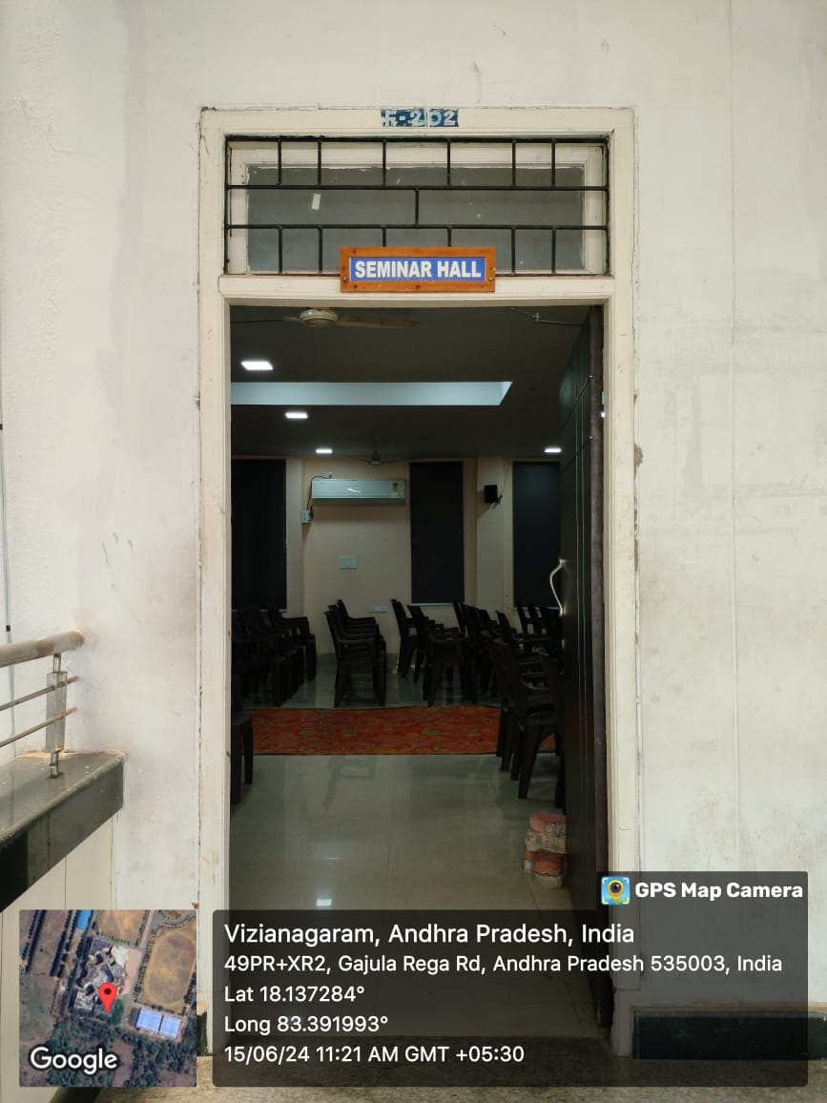  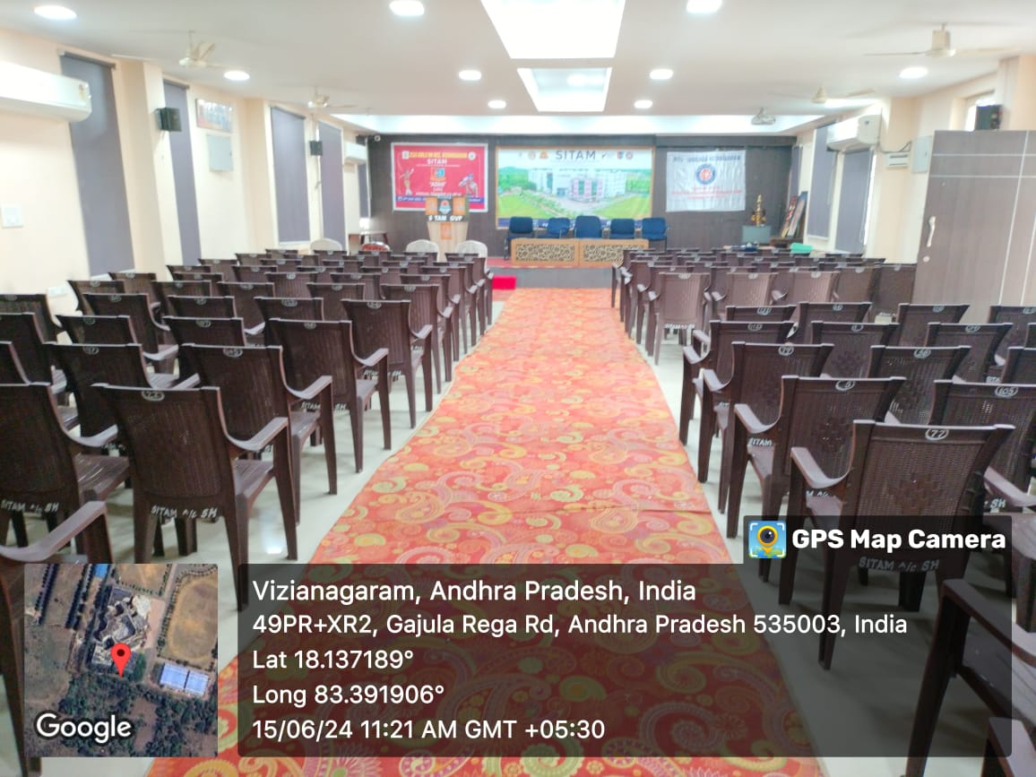

Abdul Kalam Seminar Hall(C 101)  Ranganadhan seminar Hall  Chandrayan Seminar Hall | 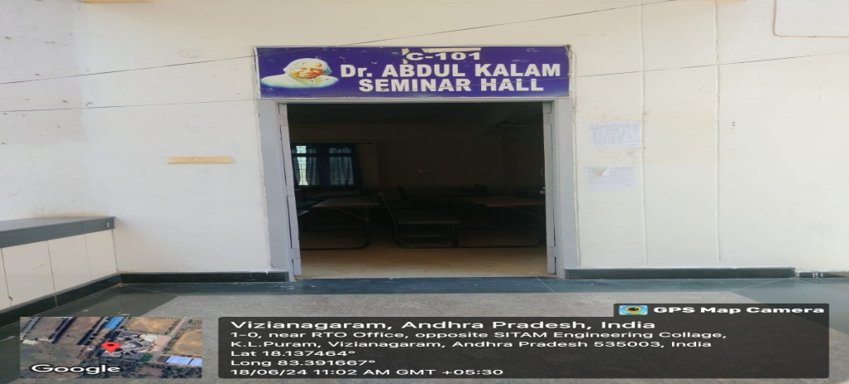  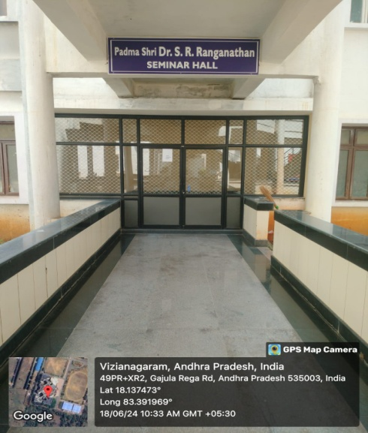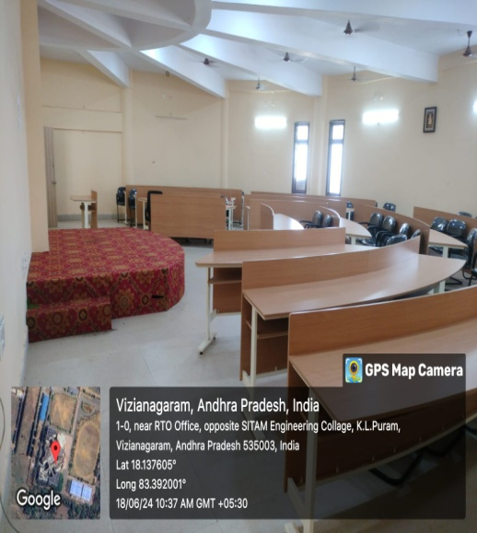  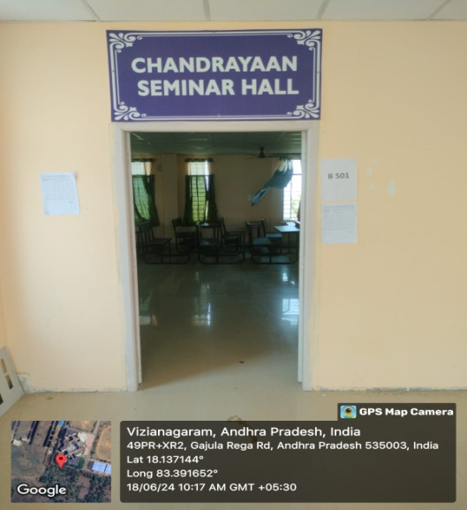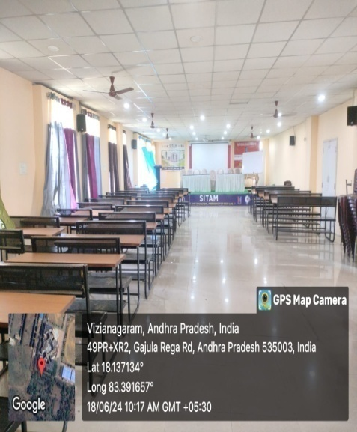

Library & Reading  Room  Digital Library  Open Auditorium | 